# SQL Nanodegree Program – Udacity March 7 2021

## What you will learn

In this Nanodegree program, you will acquire the necessary skills to advance your career in today’s data-driven workplace through hands-on practice building manipulating and analyzing every database and data related, you'll learn to:

1. leverage the power of SQL to pull insights from relational databases.
2. about the difference between relational and non-relational databases.
3. differentiate the use of relational databases versus non-relational databases like MongoDB and Redis.
4. execute core SQL commands to define, manipulate, aggregate, and join data and data tables.
5. write advanced SQL queries (such as subqueries, window functions) to complete complex tasks.
6. clean data, optimize SQL queries and enhance analysis performance.
7. apply the results from queries to address business problems.

As part of the **Management of Relational & Non-Relational Databases** course, you will learn:

1. to build normalized, consistent, and performant relational data models using SQL Database Definition Language (DDL) and Database Manipulation Language (DML).
2. about the tradeoffs between relational databases and their non-relational counterparts,
3. distinguish and justify the choice of relational databases vs. non-relational counterpart for different scenarios,
4. learn about MongoDB and Redis to get an understanding of the differences in behaviors and requirements for non-relational databases.
5. to apply all of this knowledge to build the supporting data structures for a social news aggregator website.

# Getting Help

As questions come up during your Nanodegree program, click on the Help button on the left sidebar your classroom. You’ll see four options, each for a separate type of support:

* **Technical Mentor Help**: is available on Knowledge, our expert Q&A platform, by clicking on "Mentor Help". You can search for answers to questions similar to yours or post new questions related to your project or lessons. Udacity’s expert technical mentors answer all new questions.
* **Peer Chat**: is available by clicking on the option for "Peer Chat". You can chat with other students in the student lounge or work with other students through the lessons and projects.
* **Career Support**: is available for all students and alumni including expert feedback on your application materials profiles, and lessons on “How to Network Successfully” to “Rehearsing for Interviews” and more. Click on “Career Services” to get started.
* **General Account Help**: This is where you can get details on non-technical issues such as billing, deadlines, or reach out to our support team with specific questions. Just click on “[Account Help](https://udacity.zendesk.com/hc/en-us)” to get started.

If you want career support during you program, career coaches provide personalized feedback on your LinkedIn profile and GitHub as optional projects.

If you are actively looking for a new role, you can also get submit your resume and cover letter in the sidebar under Help > Career Services.

7

# Entity Relationship Diagrams

An **entity relationship diagram** (ERD) is a common way to view data in a database. Below is the ERD for the database we will use from Parch & Posey. These diagrams help you visualize the data you are analyzing including:

1. The names of the tables.
2. The columns in each table.
3. The way the tables work together.

# Types of Databases

### SQL Databases

There are many different types of SQL databases designed for different purposes. In this course we will use [**Postgres**](https://www.postgresql.org/) within the classroom, which is a popular open-source database with a very complete library of analytical functions. (Note: You do not need to install PostgreSQL on your computer, unless you really want to. We provide SQL environments in the classroom for you to work in.)

Some of the most popular databases include:

1. MySQL
2. Access
3. Oracle
4. Microsoft SQL Server
5. Postgres

### Small Differences

Each of these SQL databases may have subtle differences in syntax and available functions -- for example, MySQL doesn’t have some of the functions for modifying dates as Postgres. **Most** of what you see with Postgres will be directly applicable to using SQL in other frameworks and database environments. For the differences that do exist, you should check the documentation. Most SQL environments have great documentation online that you can easily access with a quick Google search.

The article [here](https://www.digitalocean.com/community/tutorials/sqlite-vs-mysql-vs-postgresql-a-comparison-of-relational-database-management-systems) compares three of the most common types of SQL: SQLite, PostgreSQL, and MySQL.

#11 Video

Here you were introduced to the SQL command that will be used in every query you write: SELECT ... FROM ....

1. **SELECT** indicates which column(s) you want to be given the data for.
2. **FROM** specifies from which table(s) you want to select the columns. Notice the columns need to exist in this table.

# Formatting Your Queries

If you want to be provided with the data from all columns in the table, you use "*", like so:

* SELECT * FROM orders
* SQL queries can be run successfully whether characters are written in upper- or lower-case. In other words, SQL queries are not case-sensitive. The following query:
* SELECT account_id
* FROM orders
* is the same as:
* select account_id
* from orders
* which is also the same as:
* SeLeCt AcCoUnt_id
* FrOm oRdErS
* **However**, you may have noticed that we have been capitalizing SELECT and FROM, while we leave table and column names in lower case. This is because even though SQL is case-insensitive, **it is common and best practice to capitalize all SQL commands, like SELECT and FROM, and keep everything else in your query lower case.**

Some SQL practice!

SELECT id, account_id, total_amt_usd

FROM orders

ORDER BY total_amt_usd DESC

LIMIT 5;

# Quiz and questions about ORDER BY

Write a query that displays the order ID, account ID, and total dollar amount for all the orders, sorted first by the account ID (in ascending order), and then by the total dollar amount (in descending order).

SELECT id, account_id, total_amt_usd

FROM orders

ORDER BY account_id, total_amt_usd DESC;

Now write a query that again displays order ID, account ID, and total dollar amount for each order, but this time sorted first by total dollar amount (in descending order), and then by account ID (in ascending order).

SELECT id, account_id, total_amt_usd

FROM orders

ORDER BY total_amt_usd DESC, account_id

# Questions

Write a query that:

1. Pulls the first 5 rows and all columns from the **orders** table that have a dollar amount of gloss_amt_usd greater than or equal to 1000.
2. Pulls the first 10 rows and all columns from the **orders** table that have a total_amt_usd less than 500.

SELECT *

FROM orders

WHERE gloss_amt_usd >= 1000;

SELECT *

FROM orders

WHERE total_amt_usd < 500

LIMIT 10;

## Derived Columns

Creating a new column that is a combination of existing columns is known as a **derived** column (or "calculated" or "computed" column). Usually you want to give a name, or "alias," to your new column using the **AS** keyword.

This derived column, and its alias, are generally only temporary, existing just for the duration of your query. The next time you run a query and access this table, the new column will not be there.

If you are deriving the new column from existing columns using a mathematical expression, then these familiar mathematical operators will be useful:

1. * (Multiplication)
2. + (Addition)
3. - (Subtraction)
4. / (Division)

Consider this example:

SELECT id, (standard_amt_usd/total_amt_usd)*100 AS std_percent, total_amt_usd

FROM orders

LIMIT 10;

## Derived Columns

Creating a new column that is a combination of existing columns is known as a **derived** column (or "calculated" or "computed" column). Usually you want to give a name, or "alias," to your new column using the **AS** keyword.

SELECT id, (standard_amt_usd/total_amt_usd)*100 AS std_percent, total_amt_usd

FROM orders

LIMIT 10;

**Introduction to Logical Operators**

In the next concepts, you will be learning about **Logical Operators**. **Logical Operators** include:

1. **LIKE** This allows you to perform operations similar to using **WHERE** and =, but for cases when you might **not** know **exactly** what you are looking for.
2. **IN** This allows you to perform operations similar to using **WHERE** and =, but for more than one condition.
3. **NOT** This is used with **IN** and **LIKE** to select all of the rows **NOT LIKE** or **NOT IN** a certain condition.
4. **AND & BETWEEN** These allow you to combine operations where all combined conditions must be true.
5. **OR** This allows you to combine operations where at least one of the combined conditions must be true.

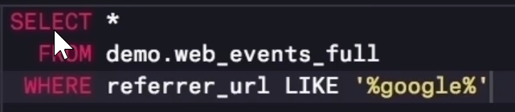

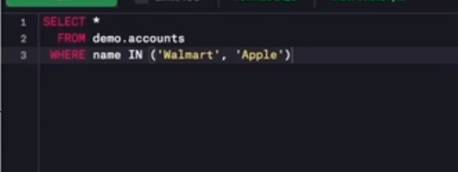

SELECT name, primary_poc, sales_rep_id

FROM accounts

WHERE name IN ('Walmart','Target','Nordstrom');

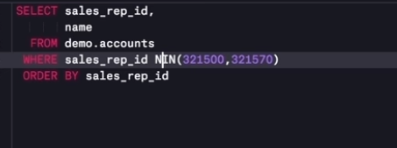

NOT CLAUSE

SELECT name, primary_poc, sales_rep_id

FROM accounts

WHERE name NOT IN ('Walmart','Target','Nordstrom')

ORDER BY name

LIMIT 5 ;

WHERE OPERATOR USING THE AND OPERATOR!

SELECT *

FROM orders

WHERE standard_qty > 1000 AND poster_qty = 0 AND gloss_qty = 0;

SELECT *

FROM accounts

WHERE name NOT LIKE 'C%' AND name LIKE '%s';

You will notice that using **BETWEEN** is tricky for dates! While **BETWEEN** is generally inclusive of endpoints, it assumes the time is at 00:00:00 (i.e. midnight) for dates. This is the reason why we set the right-side endpoint of the period at '2017-01-01'.

SELECT *

FROM web_events

WHERE channel IN ('organic', 'adwords') AND occurred_at BETWEEN '2016-01-01' AND '2017-01-01'

ORDER BY occurred_at DESC;

# Using the OR operator

SELECT id

FROM ORDERS

WHERE gloss_qty > 4000 OR poster_qty > 4000;

SELECT *

FROM orders

WHERE standard_qty = 0 AND (gloss_qty >1000 OR poster_qty > 1000);

LOOKING AHEAD AT SQL STATEMENTS in posgres!

| **Statement** | **How to Use It** | **Other Details** |
| --- | --- | --- |
| SELECT | SELECT **Col1**, **Col2**, ... | Provide the columns you want |
| FROM | FROM **Table** | Provide the table where the columns exist |
| LIMIT | LIMIT **10** | Limits based number of rows returned |
| ORDER BY | ORDER BY **Col** | Orders table based on the column. Used with **DESC**. |
| WHERE | WHERE **Col > 5** | A conditional statement to filter your results |
| LIKE | WHERE **Col LIKE '%me%'** | Only pulls rows where column has 'me' within the text |
| IN | WHERE **Col IN ('Y', 'N')** | A filter for only rows with column of 'Y' or 'N' |
| NOT | WHERE **Col NOT IN ('Y', 'N')** | **NOT** is frequently used with **LIKE** and **IN** |
| AND | WHERE **Col1 > 5 AND Col2 < 3** | Filter rows where two or more conditions must be true |
| OR | WHERE **Col1 > 5 OR Col2 < 3** | Filter rows where at least one condition must be true |
| BETWEEN | WHERE **Col BETWEEN 3 AND 5** | Often easier syntax than using an **AND** |

# Database Normalization

When creating a database, it is really important to think about how data will be stored. This is known as **normalization**, and it is a huge part of most SQL classes. If you are in charge of setting up a new database, it is important to have a thorough understanding of database **normalization**.

There are essentially three ideas that are aimed at database normalization:

1. Are the tables storing logical groupings of the data?
2. Can I make changes in a single location, rather than in many tables for the same information?
3. Can I access and manipulate data quickly and efficiently?

4 Goals for Normalization

When you [normalize a database](https://www.itprotoday.com/article/data-modeling/are-you-really-saving-anything-by-normalizing--96847), you have four goals: arranging data into logical groupings such that each group describes a small part of the whole; minimizing the amount of duplicate data stored in a database; organizing the data such that, when you modify it, you make the change in only one place; and building a database in which you can access and manipulate the data quickly and efficiently without compromising the integrity of the data in storage.

For More Refer: https://www.itprotoday.com/sql-server/sql-design-why-you-need-database-normalization

## JOIN EXAMPLES

SELECT orders.*

FROM orders

JOIN accounts

ON orders.account_id = accounts.id;

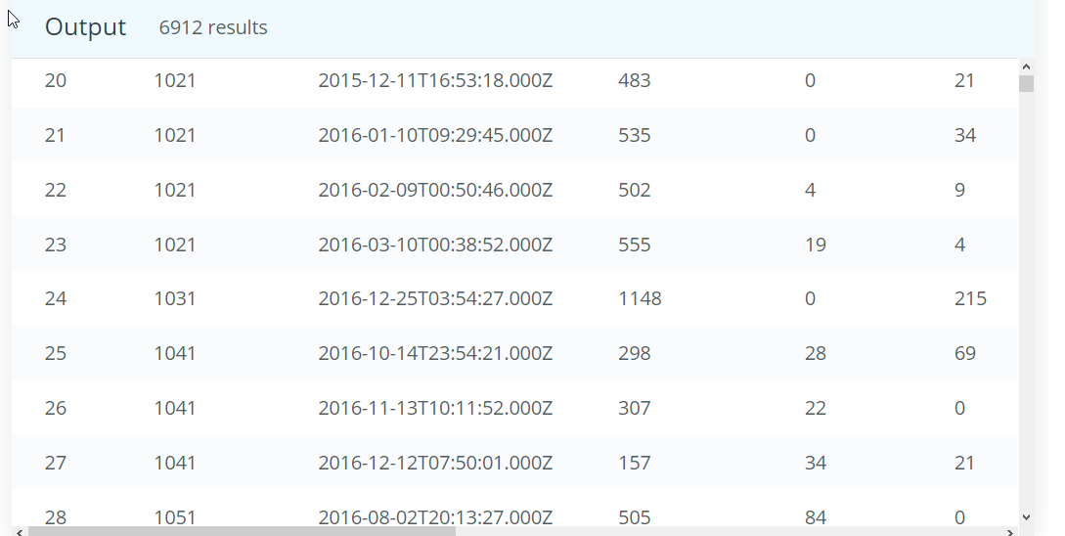

# SQL JOINS

SELECT accounts.name, orders.occurred_at

FROM orders

JOIN accounts

ON orders.account_id = accounts.id;

SELECT *

FROM orders

JOIN accounts

ON orders.account_id = accounts.id;

SELECT orders.*

FROM orders

JOIN accounts

ON orders.account_id = accounts.id;

## QUIZ SELECT *

FROM accounts

JOIN orders

ON orders.account_id = accounts.id;

SELECT orders.standard_qty, orders.gloss_qty,

orders.poster_qty, accounts.website, accounts.primary_poc

FROM accounts

JOIN orders

ON orders.account_id = accounts.id;

# Entity Relationship Diagrams

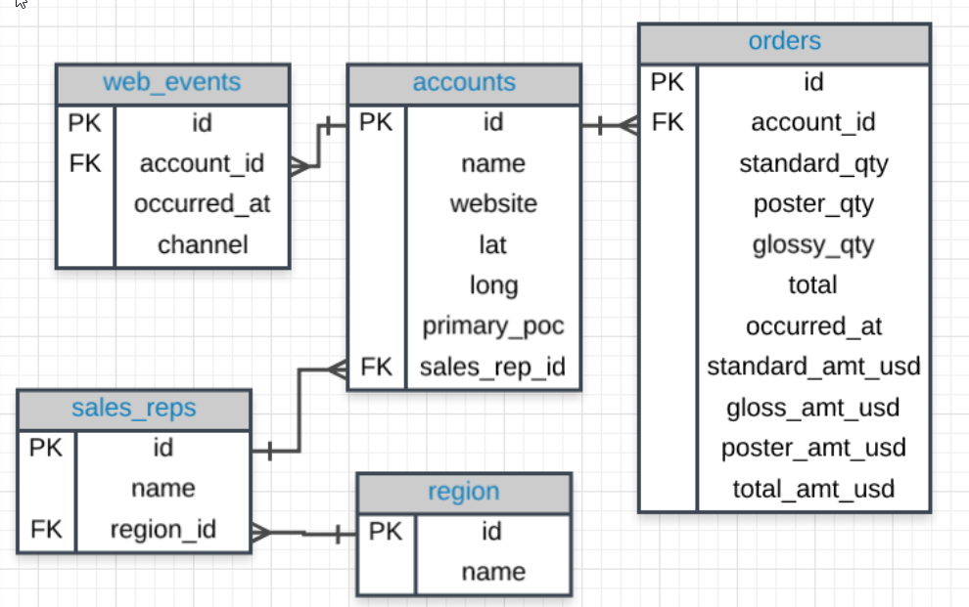

## Tables & Columns

In the Parch & Posey database there are 5 tables:

1. **web_events**
2. **accounts**
3. **orders**
4. **sales_reps**
5. **region**

SELECT *

FROM accounts

JOIN web_events

ON web_events.account_id = accounts.id

LIMIT 5;

# Keys

### Primary Key (PK)

A **primary key** is a unique column in a particular table. This is the first column in each of our tables. Here, those columns are all called **id**, but that doesn't necessarily have to be the name. **It is common that the primary key is the first column in our tables in most databases.**

### Foreign Key (FK)

A **foreign key** is a column in one table that is a primary key in a different table.

# JOIN Revisited

Let's look back at the first JOIN you wrote.

SELECT orders.*

FROM orders

JOIN accounts

ON orders.account_id = accounts.id;

Joining MORE THAN 2 TABLES at the SAME TIME!

SELECT *

FROM web_events

JOIN accounts

ON web_events.account_id = accounts.id

JOIN orders

ON accounts.id = orders.account_id

# Video: Alias

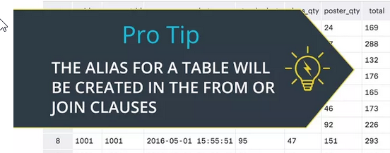

FROM tablename AS t1

JOIN tablename2 AS t2

FROM tablename t1

JOIN tablename2 t2

When we **JOIN** tables together, it is nice to give each table an **alias**. Frequently an alias is just the first letter of the table name. You actually saw something similar for column names in the **Arithmetic Operators** concept.

Example:

FROM tablename AS t1

JOIN tablename2 AS t2

Before, you saw something like:

SELECT col1 + col2 AS total, col3

# Aliases for Columns in Resulting Table

While aliasing tables is the most common use case. It can also be used to alias the columns selected to have the resulting table reflect a more readable name.

Example:

Select t1.column1 aliasname, t2.column2 aliasname2

FROM tablename AS t1

JOIN tablename2 AS t2

QUIZ:

1) Provide a table for all **web_events** associated with account **name** of Walmart. There should be three columns. Be sure to include the primary_poc, time of the event, and the channel for each event. Additionally, you might choose to add a fourth column to assure only Walmart events were chosen.

SELECT ac.primary_poc, we.occurred_at as time_of_event, we.channel, ac.name

FROM web_events AS we

JOIN accounts AS ac

ON we.account_id = ac.id;

2. Provide a table that provides the **region** for each **sales_rep** along with their associated **accounts**. Your final table should include three columns: the region **name**, the sales rep **name**, and the account **name**. Sort the accounts alphabetically (A-Z) according to account name.

# Solutions: JOIN Questions Part I

Provide a table for all the for all **web_events** associated with account **name** of Walmart. There should be three columns. Be sure to include the primary_poc, time of the event, and the channel for each event. Additionally, you might choose to add a fourth column to assure only Walmart events were chosen.

SELECT

acc.primary_poc, we.occurred_at AS time_of_the_event,

we.channel, acc.name

FROM accounts AS acc

JOIN web_events AS we

ON we.account_id = acc.id

WHERE acc.name = 'Walmart';

Provide a table that provides the **region** for each **sales_rep** along with their associated **accounts**. Your final table should include three columns: the region **name**, the sales rep **name**, and the account **name**. Sort the accounts alphabetically (A-Z) according to account name.

SELECT reg.name AS region, salesrep.name, acc.name AS ACCOUNT

FROM sales_reps AS salesrep

JOIN accounts as acc

ON acc.sales_rep_id = salesrep.id

JOIN region AS reg

ON reg.id = salesrep.region_id;

# LEFT AND RIGHT JOINS

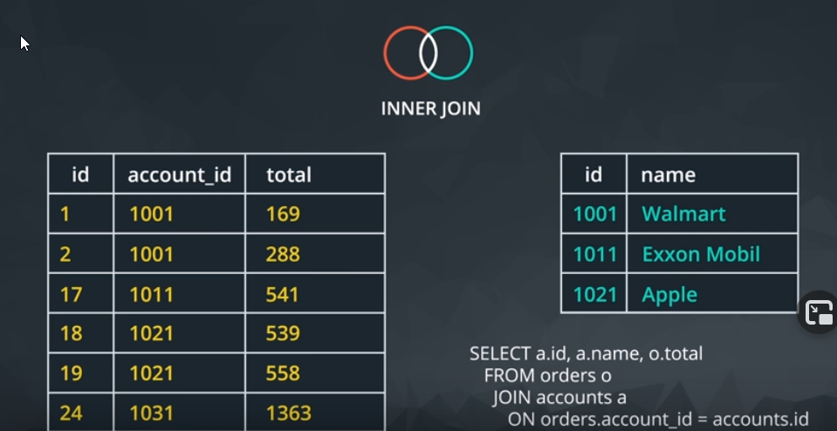

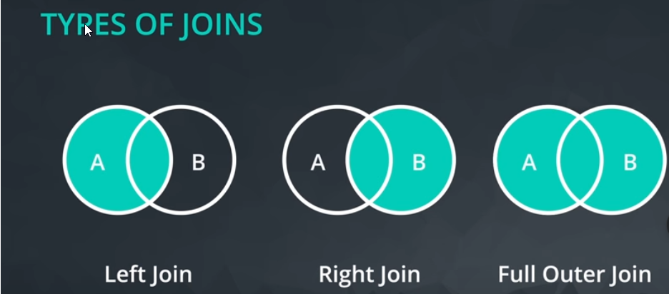

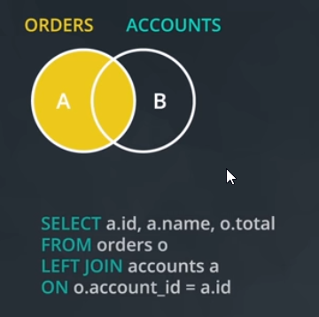

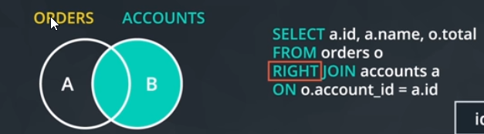

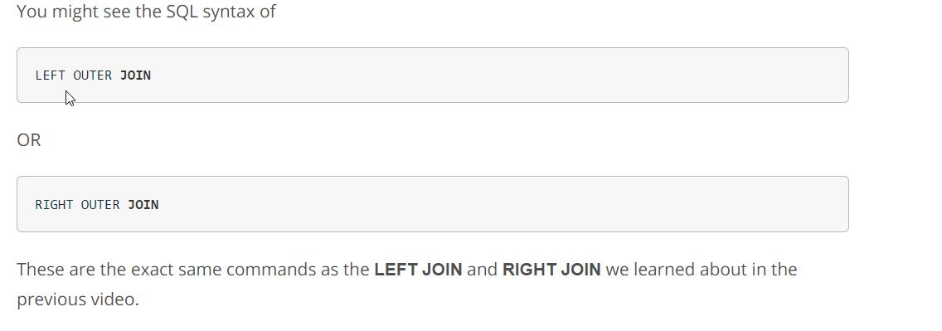

AND CLAUSE PRE-FILER ON AN “ON” CLAUSE

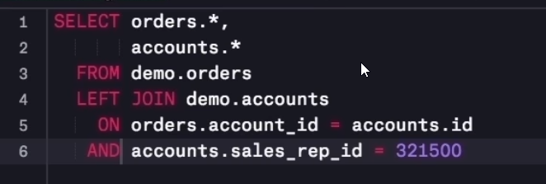

# Questions

1. Provide a table that provides the **region** for each **sales_rep** along with their associated **accounts**. This time only for the Midwest region. Your final table should include three columns: the region **name**, the sales rep **name**, and the account **name**. Sort the accounts alphabetically (A-Z) according to account name.
   * SELECT region.name AS Region, salesrep.name AS Name, acc.name AS Account

FROM accounts AS acc

JOIN sales_reps AS salesrep

ON salesrep.id = acc.sales_rep_id

JOIN region

ON salesrep.region_id = region.id

AND region.name = 'Midwest'

ORDER BY acc.Name;

1. Provide a table that provides the **region** for each **sales_rep** along with their associated **accounts**. This time only for accounts where the sales rep has a first name starting with S and in the Midwest region. Your final table should include three columns: the region **name**, the sales rep **name**, and the account **name**. Sort the accounts alphabetically (A-Z) according to account name.
   * SELECT region.name AS Region, salesrep.name AS Name, acc.name AS Account
   * FROM accounts AS acc
   * JOIN sales_reps AS salesrep
   * ON salesrep.id = acc.sales_rep_id
   * JOIN region
   * ON salesrep.region_id = region.id
   * AND region.name = 'Midwest'
   * AND salesrep.name LIKE 'S%'
   * ORDER BY acc.Name;
2. Provide a table that provides the **region** for each **sales_rep** along with their associated **accounts**. This time only for accounts where the sales rep has a **last** name starting with K and in the Midwest region. Your final table should include three columns: the region **name**, the sales rep **name**, and the account **name**. Sort the accounts alphabetically (A-Z) according to account name.
   * SELECT region.name AS Region, salesrep.name AS Name, acc.name AS Account
   * FROM accounts AS acc
   * JOIN sales_reps AS salesrep
   * ON salesrep.id = acc.sales_rep_id
   * JOIN region
   * ON salesrep.region_id = region.id
   * AND region.name = 'Midwest'
   * AND salesrep.name LIKE '%K%'
   * ORDER BY acc.Name;
3. Provide the **name** for each region for every **order**, as well as the account **name** and the **unit price** they paid (total_amt_usd/total) for the order. However, you should only provide the results if the **standard order quantity** exceeds 100. Your final table should have 3 columns: **region name**, **account name**, and **unit price**. In order to avoid a division by zero error, adding .01 to the denominator here is helpful total_amt_usd/(total+0.01).
   * SELECT region.name AS Region, acc.name AS Account,

(orders.total_amt_usd/(orders.total+0.001)) AS UnitPrice

FROM accounts AS acc

JOIN sales_reps AS salesrep

ON salesrep.id = acc.sales_rep_id

JOIN region

ON salesrep.region_id = region.id

JOIN orders

ON acc.id = orders.account_id

AND orders.standard_qty > 100;

1. Provide the **name** for each region for every **order**, as well as the account **name** and the **unit price** they paid (total_amt_usd/total) for the order. However, you should only provide the results if the **standard order quantity** exceeds 100 and the **poster order quantity** exceeds 50. Your final table should have 3 columns: **region name**, **account name**, and **unit price**. Sort for the smallest **unit price** first. In order to avoid a division by zero error, adding .01 to the denominator here is helpful (total_amt_usd/(total+0.01).
   * SELECT region.name AS Region, acc.name AS Account,

(orders.total_amt_usd/(orders.total+0.001)) AS UnitPrice

FROM accounts AS acc

JOIN sales_reps AS salesrep

ON salesrep.id = acc.sales_rep_id

JOIN region

ON salesrep.region_id = region.id

JOIN orders

ON acc.id = orders.account_id

AND orders.standard_qty > 100

AND orders.poster_qty > 50;

1. What are the different **channel**s used by **account id** 1001? Your final table should have only 2 columns: **account name** and the different **channel**s. You can try **SELECT DISTINCT** to narrow down the results to only the unique values.
   * SELECT DISTINCT acc.name AS Account, webe.channel AS Channels

FROM accounts AS acc

JOIN web_events AS webe

ON acc.id = webe.account_id;

1. Find all the orders that occurred in 2015. Your final table should have 4 columns: **occurred_at**, **account name**, **order total**, and **order total_amt_usd**.

# Recap

### Primary and Foreign Keys

You learned a key element for **JOIN**ing tables in a database has to do with primary and foreign keys:

* **primary keys** - are unique for every row in a table. These are generally the first column in our database (like you saw with the **id** column for every table in the Parch & Posey database).
* **foreign keys** - are the **primary key** appearing in another table, which allows the rows to be non-unique.

Choosing the set up of data in our database is very important, but not usually the job of a data analyst. This process is known as **Database Normalization**.

### JOINs

In this lesson, you learned how to combine data from multiple tables using **JOIN**s. The three **JOIN** statements you are most likely to use are:

1. **JOIN** - an **INNER JOIN** that only pulls data that exists in both tables.
2. **LEFT JOIN** - pulls all the data that exists in both tables, as well as all of the rows from the table in the **FROM** even if they do not exist in the **JOIN** statement.
3. **RIGHT JOIN** - pulls all the data that exists in both tables, as well as all of the rows from the table in the **JOIN** even if they do not exist in the **FROM** statement.

There are a few more advanced **JOIN**s that we did not cover here, and they are used in very specific use cases. [UNION and UNION ALL](https://www.w3schools.com/sql/sql_union.asp), [CROSS JOIN](http://www.w3resource.com/sql/joins/cross-join.php), and the tricky [SELF JOIN](https://www.w3schools.com/sql/sql_join_self.asp). These are more advanced than this course will cover, but it is useful to be aware that they exist, as they are useful in special cases.

### Alias

You learned that you can alias tables and columns using **AS** or not using it. This allows you to be more efficient in the number of characters you need to write, while at the same time you can assure that your column headings are informative of the data in your table.

# Looking Ahead

The next lesson is aimed at **aggregating** data. You have already learned a ton, but **SQL** might still feel a bit disconnected from **statistics** and using **Excel** like platforms. Aggregations will allow you to write **SQL** code that will allow for more complex queries, which assist in answering questions like:

* Which **channel** generated more revenue?
* Which **account** had an order with the most items?
* Which **sales_rep** had the most orders? or least orders? How many orders did they have?

# COUNT AND NULLS AND SUM!

Notice that **COUNT** does not consider rows that have **NULL** values. Therefore, this can be useful for quickly identifying which rows have missing data. You will learn **GROUP BY** in an upcoming concept, and then each of these aggregators will become much more useful.

SELECT SUM(orders.poster_qty)

FROM orders;

SELECT SUM(orders.standard_qty)

FROM orders;

# MIN, MAX, AVG

SELECT MIN(orders.occurred_at)

FROM orders;

SELECT MAX(web_events.occurred_at)

FROM web_events

Same result as above but without using the aggregate function

SELECT occurred_at

FROM web_events

ORDER BY occurred_at DESC

LIMIT 1;

Via the video, you might be interested in how to calculate the MEDIAN. Though this is more advanced than what we have covered so far try finding - what is the MEDIAN **total_usd** spent on all **orders**? Note, this is more advanced than the topics we have covered thus far to build a general solution, but we can hard code a solution in the following way.

SELECT *

FROM (SELECT total_amt_usd

FROM orders

ORDER BY total_amt_usd

LIMIT 3457) AS Table1

ORDER BY total_amt_usd DESC

LIMIT 2;

# Video: GROUP BY

The key takeaways here:

* **GROUP BY** can be used to aggregate data within subsets of the data. For example, grouping for different accounts, different regions, or different sales representatives.
* Any column in the **SELECT** statement that is not within an aggregator must be in the **GROUP BY** clause.
* The **GROUP BY** always goes between **WHERE** and **ORDER BY**.
* **ORDER BY** works like **SORT** in spreadsheet software.

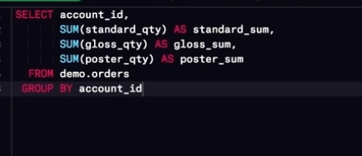

## Questions: GROUP BY

1. Which **account** (by name) placed the earliest order? Your solution should have the **account name** and the **date** of the order.

SELECT acc.name, orders.occurred_at AS date

FROM accounts AS acc

JOIN orders

ON acc.id = orders.account_id

ORDER BY date

LIMIT 1;✔

1. Find the total sales in **usd** for each account. You should include two columns - the total sales for each company's orders in **usd** and the company **name**.

SELECT SUM(orders.total_amt_usd) as usd, acc.name as Name

FROM accounts as acc

JOIN orders

ON orders.account_id = acc.id

GROUP BY Name; ✔

1. Via what **channel** did the most recent (latest) **web_event** occur, which **account** was associated with this **web_event**? Your query should return only three values - the **date**, **channel**, and **account name**.

SELECT orders.occurred_at AS date, web.channel as channel, acc.name AS account_name

FROM accounts AS acc

JOIN web_events AS web

ON acc.id = web.account_id

JOIN orders

ON orders.account_id = acc.id

ORDER BY date DESC

LIMIT 1✔

1. Find the total number of times each type of **channel** from the **web_events** was used. Your final table should have two columns - the **channel** and the number of times the channel was used.

SELECT web.channel, COUNT(web.channel) AS count

FROM web_events AS web

GROUP BY web.channel ✔

ORDER BY count;

1. Who was the **primary contact** associated with the earliest **web_event**?

SELECT acc.primary_poc as Primary_Contact

FROM accounts AS acc

JOIN web_events AS web

ON web.account_id = acc.id

ORDER BY web.occurred_at

LIMIT 1; ✔

1. What was the smallest order placed by each **account** in terms of **total usd**. Provide only two columns - the account **name** and the **total usd**. Order from smallest dollar amounts to largest.

SELECT acc.name AS Name, SUM(orders.total_amt_usd) AS total_usd

FROM accounts as acc

JOIN orders

ON orders.id = acc.id

GROUP BY Name

ORDER BY total_usd

LIMIT 1; ✔

1. Find the number of **sales reps** in each region. Your final table should have two columns - the **region** and the number of **sales_reps**. Order from fewest reps to most reps.

SELECT region.name as REGION, COUNT(salesrep.name) NumOfSalesReps

FROM sales_reps AS salesrep

JOIN region

ON salesrep.region_id = region.id

GROUP BY region.name

ORDER BY NumOfSalesRep;

# Questions: GROUP BY Part II

1. For each account, determine the average amount of each type of paper they purchased across their orders. Your result should have four columns - one for the account **name** and one for the average quantity purchased for each of the paper types for each account.

SELECT acc.name, AVG(orders.standard_qty) as std,

AVG(orders.gloss_qty) as gloassy,

AVG(orders.poster_qty) as poster,

AVG(orders.total) as gloss

FROM orders

JOIN accounts AS acc

ON acc.id = orders.account_id

GROUP BY acc.name;✔

1. For each account, determine the average amount spent per order on each paper type. Your result should have four columns - one for the account **name** and one for the average amount spent on each paper type.

SELECT acc.name as Name,SUM(orders.standard_amt_usd)/ SUM(orders.standard_qty + 0.0001) as Averge_StdSpent,

SUM(orders.gloss_amt_usd)/ SUM(orders.gloss_qty + 0.0001) as Avearge_GlossySpent,

SUM(orders.poster_amt_usd)/ SUM(orders.poster_qty + 0.0001) as AvergePosterSpent

FROM orders

JOIN accounts AS acc

ON acc.id = orders.account_id

GROUP BY Name;

You could also use AVG DIRECTLY!

1. Determine the number of times a particular **channel** was used in the **web_events** table for each **sales rep**. Your final table should have three columns - the **name of the sales rep**, the **channel**, and the number of occurrences. Order your table with the highest number of occurrences first.

SELECT salesrep.name AS Name, web.channel AS Channel, COUNT(web.channel)AS Num_Occrurences

FROM accounts AS acc

JOIN web_events AS web

ON web.account_id = acc.id

JOIN sales_reps AS salesrep

ON salesrep.id = acc.sales_rep_id

GROUP BY salesrep.name, Channel

ORDER BY Num_Occrurences DESC;

1. Determine the number of times a particular **channel** was used in the **web_events** table for each **region**. Your final table should have three columns - the **region name**, the **channel**, and the number of occurrences. Order your table with the highest number of occurrences first.

SELECT region.name as RegionName, web.channel AS Channel, COUNT(web.channel)AS Num_Occrurences

FROM accounts AS acc

JOIN web_events AS web

ON web.account_id = acc.id

JOIN sales_reps AS salesrep

ON salesrep.id = acc.sales_rep_id

JOIN region

ON region.id = salesrep.region_id

GROUP BY region.name, Channel

ORDER BY Num_Occrurences DESC;

# **DISTINCT** is always used in **SELECT** statements, and it provides the unique rows for all columns written in the **SELECT** statement. Therefore, you only use **DISTINCT** once in any particular **SELECT** statement.

SELECT DISTINCT column1, column2, column3

FROM table1;

### Questions: DISTINCT

Use the **SQL** environment below to assist with answering the following questions. Whether you get stuck or you just want to double check your solutions, my answers can be found at the top of the next concept.

1. Use **DISTINCT** to test if there are any accounts associated with more than one region.
2. Have any **sales reps** worked on more than one account?

# HAVING - Expert Tip

**HAVING** is the “clean” way to filter a query that has been aggregated, but this is also commonly done using a [subquery](https://community.modeanalytics.com/sql/tutorial/sql-subqueries/). Essentially, any time you want to perform a **WHERE** on an element of your query that was created by an aggregate, you need to use **HAVING** instead.

WHERE , will not work with aggregates

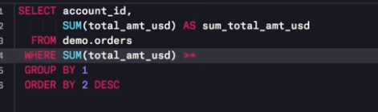

HAVING, will work with aggregrates

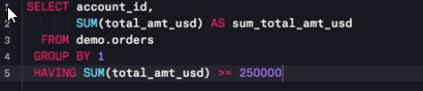

SELECT salesrep.name , COUNT(accounts.*)

FROM sales_reps AS salesrep

JOIN accounts

ON accounts.sales_rep_id = salesrep.id

GROUP by salesrep.name

HAVING COUNT(accounts.name) > 5;

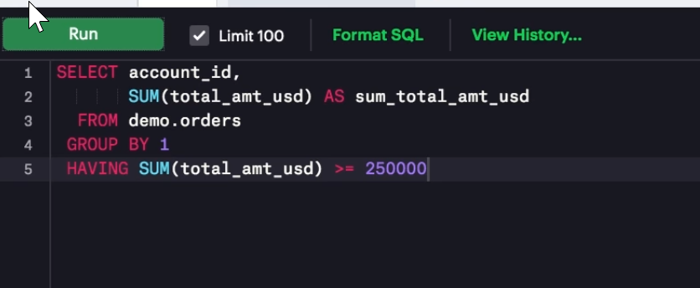

# DATE TYPE IN SQL

YYYY/MM/DD

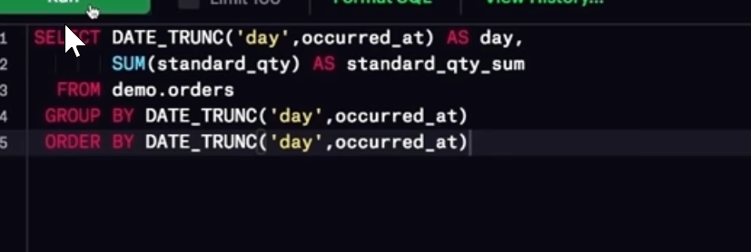

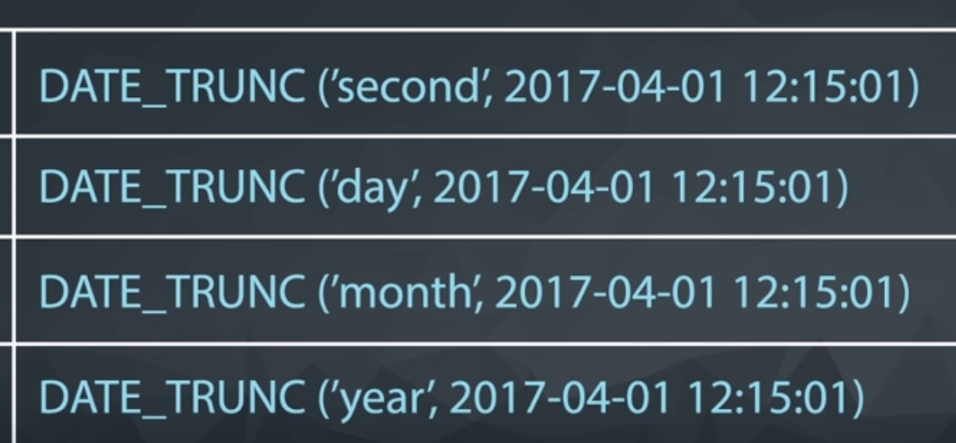

DATE_TRUNC(‘year’,….)

DATE_TRUNC(‘month’,…)

DATE_TRUNC(‘day’,…)

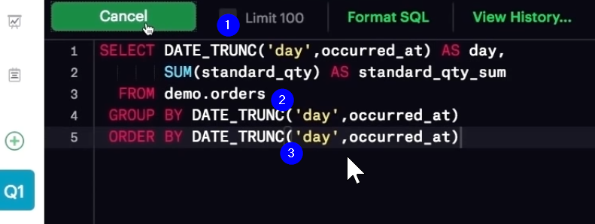

## DATE_PART()

DOW – STANDS FOR A DAY OF WEEK. DOW STANDS FOR DAY OF WEEK, DOW stands FOR DAY OF WEEK, DOW – STANDS FOR DAY OF WEEK. DOW STANDS FOR DAY OF WEEK,

# SQL FUNCTIONS

**DATE_TRUNC** allows you to truncate your date to a particular part of your date-time column. Common trunctions are day, month, and year. [Here](https://blog.modeanalytics.com/date-trunc-sql-timestamp-function-count-on/) is a great blog post by Mode Analytics on the power of this function.

**DATE_PART** can be useful for pulling a specific portion of a date, but notice pulling month or day of the week (dow) means that you are no longer keeping the years in order. Rather you are grouping for certain components regardless of which year they belonged in.

For additional functions you can use with dates, check out the documentation [here](https://www.postgresql.org/docs/9.1/static/functions-datetime.html), but the **DATE_TRUNC** and **DATE_PART** functions definitely give you a great start!

You can reference the columns in your select statement in **GROUP BY** and **ORDER BY** clauses with numbers that follow the order they appear in the select statement. For example

## QUIZ TIME!

Find the sales in terms of total dollars for all orders in each year, ordered from greatest to least. Do you notice any trends in the yearly sales totals?

SELECT DATE_TRUNC('YEAR',occurred_at) AS YearOfSale, SUM(total_amt_usd) as Sales

FROM orders

GROUP BY YearOfSale

ORDER BY Sales DESC;

Which **month** did Parch & Posey have the greatest sales in terms of total dollars? Are all months evenly represented by the dataset?

SELECT DATE_PART('MONTH',occurred_at) AS Month, SUM(total_amt_usd) as Sales

FROM orders

GROUP BY Month

ORDER BY Sales DESC;

Which **year** did Parch & Posey have the greatest sales in terms of total number of orders? Are all years evenly represented by the dataset?

SELECT DATE_PART('YEAR',occurred_at) AS Year, SUM(total) as Orders

FROM orders

GROUP BY Year

ORDER BY Orders DESC;

• Which **month** did Parch & Posey have the greatest sales in terms of total number of orders? Are all months evenly represented by the dataset?

SELECT DATE_PART('MONTH',occurred_at) AS Month, SUM(total) as Orders

FROM orders

GROUP BY Month

ORDER BY Orders DESC;

In which **month** of which **year** did Walmart spend the most on gloss paper in terms of dollars?

SELECT DATE_PART('MONTH',occurred_at) AS Month,

accounts.name,

SUM(gloss_amt_usd) as glossyorders

FROM orders

JOIN accounts

ON accounts.id = orders.account_id

WHERE accounts.name = 'Walmart'

GROUP BY Month, accounts.name

ORDER BY glossyorders DESC

LIMIT 1;

## CASE STATEMENT IN SQL

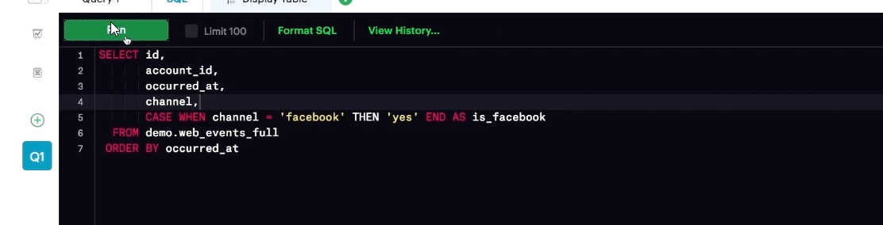

To get even more granular with your case statement, here is an example!

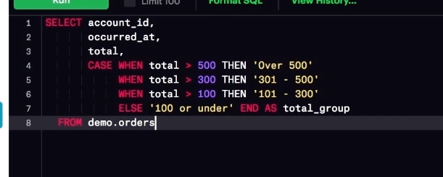

Using case statement along with agregration!

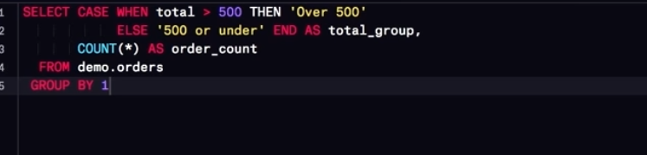

## Questions: CASE

Use the **SQL** environment below to assist with answering the following questions. Whether you get stuck or you just want to double check your solutions, my answers can be found at the top of the next concept.

1. Write a query to display for each order, the account ID, total amount of the order, and the level of the order - ‘Large’ or ’Small’ - depending on if the order is $3000 or more, or smaller than $3000.

SELECT account_id, total_amt_usd AS totalamt,

CASE WHEN total_amt_usd > 3000 THEN 'Large'

ELSE 'Small'END AS levelOfOrder

FROM orders; ✔

1. Write a query to display the number of orders in each of three categories, based on the total number of items in each order. The three categories are: 'At Least 200 0', 'Between 1000 and 2000' and 'Less than 1000'.

SELECT CASE WHEN total > 2000 THEN 'Atleast_2000'

WHEN total > 1000 THEN '1000_2000'

ELSE'Less_1000' END AS QtCategory,

COUNT(* ) AS order_count

FROM orders

GROUP BY 1

ORDER BY 1 DESC;✔

1. We would like to understand 3 different levels of customers based on the amount associated with their purchases. The top level includes anyone with a Lifetime Value (total sales of all orders) greater than 200,000 usd. The second level is between 200,000 and 100,000 usd. The lowest level is anyone under 100,000 usd. Provide a table that includes the **level** associated with each **account**. You should provide the **account name**, the **total sales of all orders** for the customer, and the **level**. Order with the top spending customers listed first.

SELECT

accounts.name as CustomerName,

CASE WHEN total_amt_usd > 200000 THEN 'LifeTime'

WHEN total_amt_usd > 100000 THEN 'SecondLev'

ELSE 'LowLev' END AS CustomerLevel,

orders.total_amt_usd

FROM accounts

JOIN orders

ON orders.account_id = accounts.id

ORDER BY CustomerLevel DESC ✔

1. We would now like to perform a similar calculation to the first, but we want to obtain the total amount spent by customers only in 2016 and 2017. Keep the same **level**s as in the previous question. Order with the top spending customers listed first.

SELECT account_id, total_amt_usd AS totalamt,

CASE WHEN total_amt_usd > 3000 THEN 'Large'

ELSE 'Small'END AS levelOfOrder,

DATE_PART('year',occurred_at)

FROM orders

WHERE DATE_PART('year',occurred_at) BETWEEN 2016 AND 2017

ORDER BY totalamt DESC;

1. We would like to identify top performing **sales reps**, which are sales reps associated with more than 200 orders. Create a table with the **sales rep name**, the total number of orders, and a column with top or not depending on if they have more than 200 orders. Place the top sales people first in your final table.

SELECT s.name, COUNT(*) num_ords,

CASE WHEN COUNT(*) > 200 THEN 'top'

ELSE 'not' END AS sales_rep_level

FROM orders o

JOIN accounts a

ON o.account_id = a.id

JOIN sales_reps s

ON s.id = a.sales_rep_id

GROUP BY s.name

ORDER BY 2 DESC;

1. The previous didn't account for the middle, nor the dollar amount associated with the sales. Management decides they want to see these characteristics represented as well. We would like to identify top performing **sales reps**, which are sales reps associated with more than 200 orders or more than 750000 in total sales. The middle group has any **rep** with more than 150 orders or 500000 in sales. Create a table with the **sales rep name**, the total number of orders, total sales across all orders, and a column with top, middle, or low depending on this criteria. Place the top sales people based on dollar amount of sales first in your final table. You might see a few upset sales people by this criteria!

# SUBQUERIES, SUBQUERIES, SUBQUERIES, SUBQUERIES

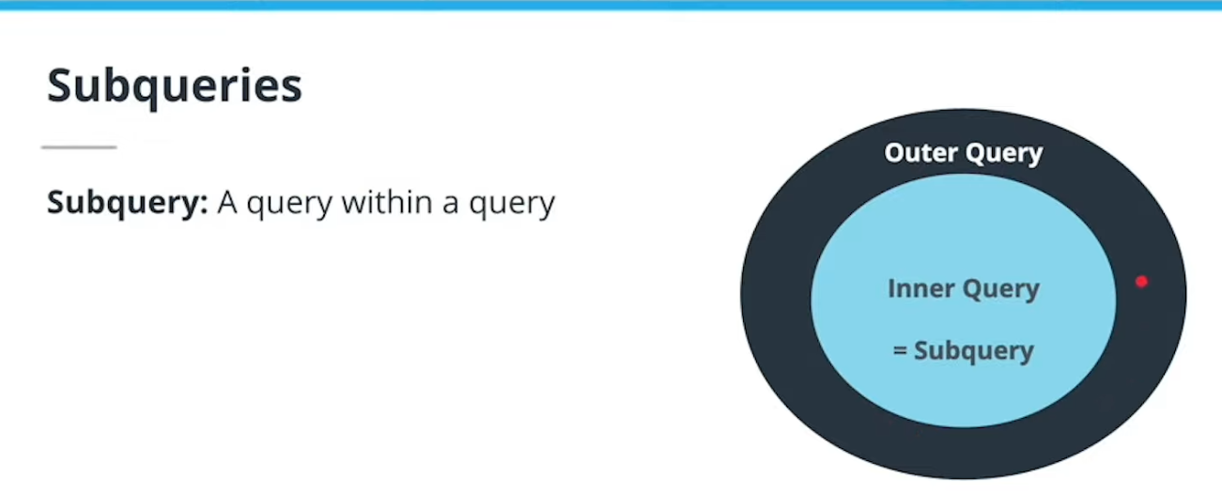

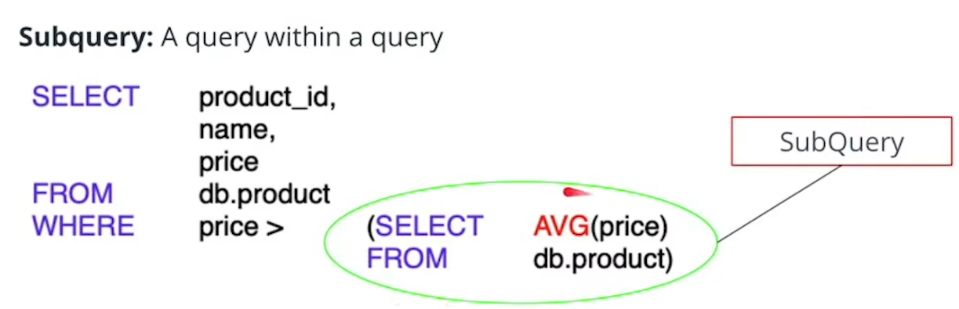

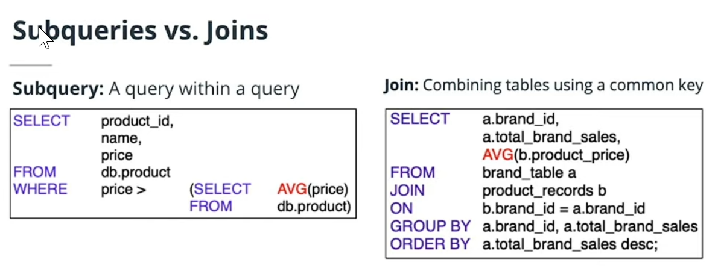

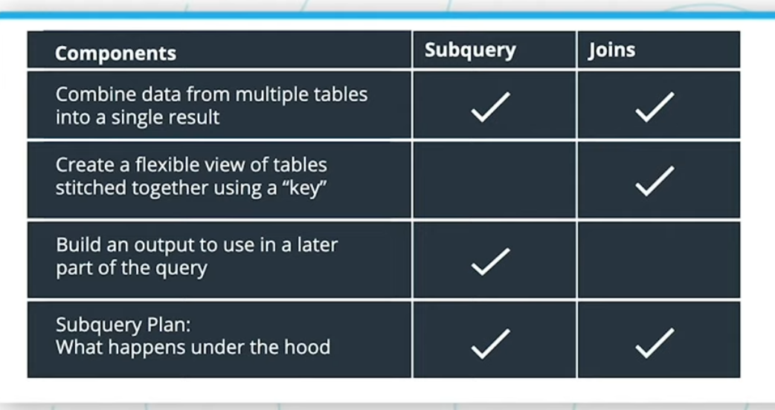

## **Fundamentals to Know about Subqueries:**

1. Subqueries must be fully placed inside parentheses.
2. Subqueries must be fully independent and can be executed on its own
3. Subqueries have two components to consider:
4. Where it’s placed
5. Dependencies with the outer/larger query

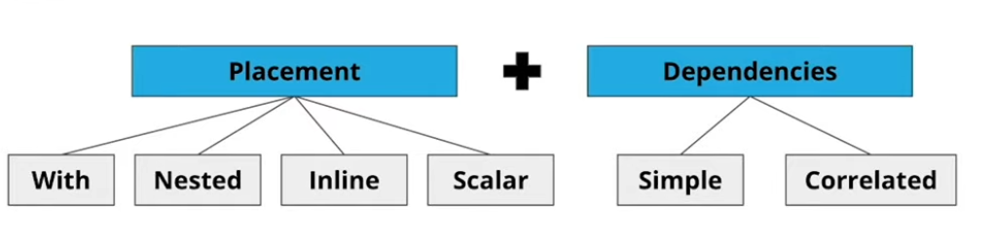

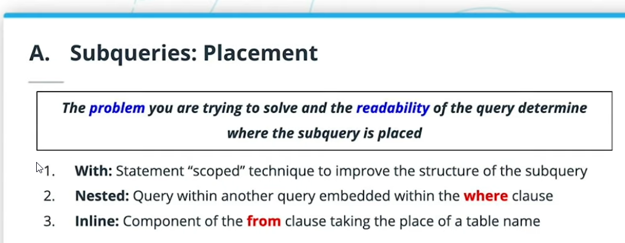



## WITH SUBQUERY

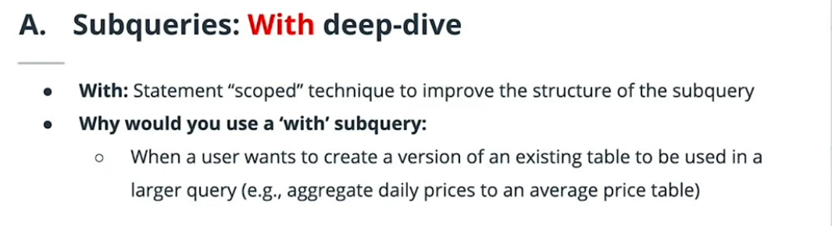

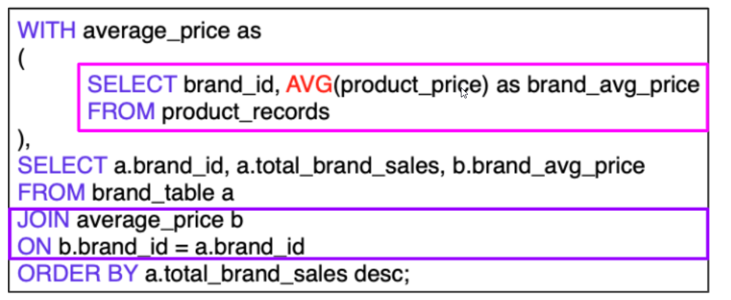

## e Case for a Nested Subquery

* When a user wants to **filter an output using a condition met from another table.**
* This type of placement also has advantages for making the code easy to read.

## Sample Nested Subquery

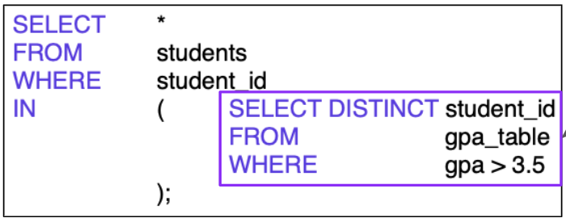

## Use Case for Inline Subquery

* It is very similar use case to ‘With’ subqueries. It **creates a “pseudo table”** that aggregates or **manipulates an existing table** to be **used in a larger query**.
* The disadvantage of the inline subquery is that it is not easy to read.

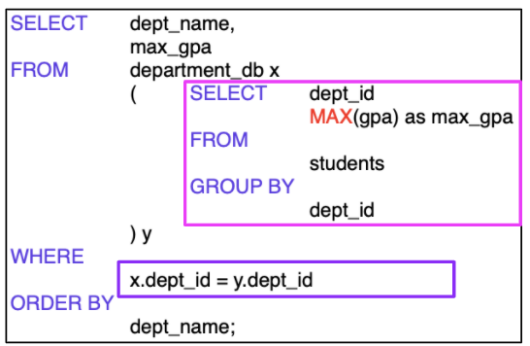

## SUBQUERY EXAMPLES

SELECT DATE_TRUNC('day', occurred_at) as day, channel, COUNT(*) as OccuranceCount

FROM web_events

GROUP BY 1,2

ORDER BY 3 DESC;

SELECT *

FROM (SELECT DATE_TRUNC('day',occurred_at) AS day,

channel, COUNT(*) as events

FROM web_events

GROUP BY 1,2

ORDER BY 3 DESC) sub;

# More Subquery Examples

SELECT channel, ROUND(AVG(OccuranceCount) ,1) as averageEvents FROM

(SELECT DATE_TRUNC('day', occurred_at) as day, channel, COUNT(*) as OccuranceCount

FROM web_events

GROUP BY 1,2) subqu

GROUP BY 1

ORDER BY 2 DESC;

SELECT DATE_TRUNC('month', occurred_at) as monthsale, AVG(standard_qty)as stdqty

from orders

GROUP BY 1

ORDER BY monthsale

limit 1;

SELECT DATE_TRUNC('month', occurred_at) as monthsale, AVG(gloss_qty)as glossqty

from orders

GROUP BY 1

ORDER BY monthsale

limit 1;

SELECT DATE_TRUNC('month', occurred_at) as monthsale, AVG(poster_qty)as Posterqty

from orders

GROUP BY 1

ORDER BY monthsale

limit 1;

# Subquery Example: Challenge

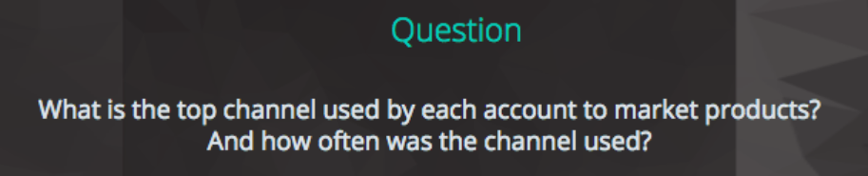

# Subquery Example: Challenge

create view v1

as

SELECT topchan.name, topchan.channel as event, MAX(topchan.toto) as usages

FROM

(SELECT accounts.name, web_events.channel, Count(*) AS toto

FROM accounts

JOIN web_events ON accounts.id = Web_events.account_id

GROUP BY 1, 2

ORDER BY 1,3

) AS topchan

GROUP BY 1,2

order by 1,3 desc;

create view v2

as

SELECT maxevent.name, MAX(maxevent.toto) as usages

FROM

(SELECT accounts.name, web_events.channel, Count(*) AS toto

FROM accounts

JOIN web_events ON accounts.id = Web_events.account_id

GROUP BY 1, 2

ORDER BY 1

) AS maxevent

GROUP BY 1

order by 1 asc;

select * from v1

join v2

on v1.usages = v2.usages and v1.name = v2.name

## without using view

## 

# Views in SQL

create view v1

as

select S.id, S.name as Rep_Name, R.name as Region_Name

from sales_reps S

join region R

on S.region_id = R.id

and R.name = 'Northeast';

### Understanding Views

Tables in SQL reside in the database persistently. In contrast, views are the virtual tables that are derived from one or more base tables.

The term virtual means that the views do not exist physically in a database, instead, they reside in the memory (not database), just like the result of any query is stored in the memory.

CREATE VIEW <VIEW_NAME>

AS

SELECT …

FROM …

WHERE …

### Points to Remember

**Can we update the base tables by updating a view?**  
Since views do not exist physically in the database, it is may or may not be possible to execute UPDATE operations on views. It depends on the SELECT query used in the view definition. Generally, if the SELECT statement contains either an AGGREGATE function, GROUPING, or JOIN, then the view may not update the underlying base tables.

**Can we insert or delete a tuple in the base table by inserting or deleting a tuple in a view?**  
Again, it depends on the view-definition. If a view is created from a single base table, then yes, you can insert/delete tuples by doing so in the view.

**Can we alter the view definition?**  
Most of the databases allow you to alter a view. For example, Oracle and IBM DB2 allows us to alter views and provides CREATE OR REPLACE VIEW option to redefine a view.

## ASIDE PRACTICE ON APRIL 10TH 2021 – GROUP BY , logic and syntax

SELECT DATE_TRUNC('year', occurred_at) as Year,

COUNT(*) AS webevents_ByYear

FROM web_events

GROUP BY year

order by webevents_ByYear DESC;

# Aggregate Functions – Fundamentals -

1. Refer: <https://www.sqlshack.com/learn-sql-aggregate-functions/>
2. Some notes on Aggregate functions:
   1. They are always part of the SELECT statement!
   2. All benefits of SELECT statement available – joining tables to get info, filtering only rows, and columns we need, combine with power of these functions.
   3. SIMPLEST EXAMPLE of AN AGGREGATE FUNCTION IS AS FOLLOWS!
      1. SELECT COUNT(*) AS number_of_countries FROM country;
      2. SELECT COUNT(*) as number_of_webevents FROM web_events;
      3. SELECT COUNT(*) AS number_salesreps FROM sales_reps;
      4. SELECT COUNT(*) AS accounts_total_number FROM accounts;
      5. SELECT COUNT(*) AS total_orders FROM orders;
      6. SELECT COUNT(*) AS regions_total FROM region;
      7. SELECT COUNT(*) AS total_web_acc
         1. FROM web_events
         2. LEFT JOIN accounts ON web_events.account_id = accounts.id;
3. **COUNT** – counts the number of elements in the group defined
4. **SUM** – calculates the sum of the given attribute/expression in the group defined
5. **AVG** – calculates the average value of the given attribute/expression in the group defined
6. **MIN** – finds the minimum in the group defined
7. **MAX** – finds the maximum in the group defined
8. **Others you can use less often**
9. **APPROX_COUNT_DISTINCT**
10. **CHECKSUM_AGG**
11. **COUNT_BIG**
12. **GROUPING**
13. **GROUPING_ID**
14. **STDEV**
15. **STDEVP**
16. **STRING_AGG**
17. **VAR**
18. **VARPB**

## While all aggregate functions could be used without the **GROUP BY** clause, the whole point is to use the **GROUP BY** clause.

## Two ways to use aggregate functions.

1. First way is to do it on the whole table!
2. Second way is to group by a certain field

First BASIC example

SELECT

COUNT(*) AS totalorders,

SUM(total_amt_usd) AS grandsum,

MIN(total_amt_usd) AS lowestOrders,

MAX(total_amt_usd) AS largestOrder

FROM orders;

Second GROUP BY example:

# Practicing a WITH Subquery

WITH events AS (

SELECT DATE_TRUNC('day',occurred_at) AS day,

channel, COUNT(*) as events

FROM web_events

GROUP BY 1,2)

SELECT channel, AVG(events) AS average_events

FROM events

GROUP BY channel

ORDER BY 2 DESC;

WITH table1 AS (

SELECT *

FROM web_events),

table2 AS (

SELECT *

FROM accounts)

SELECT *

FROM table1

JOIN table2

ON table1.account_id = table2.id;

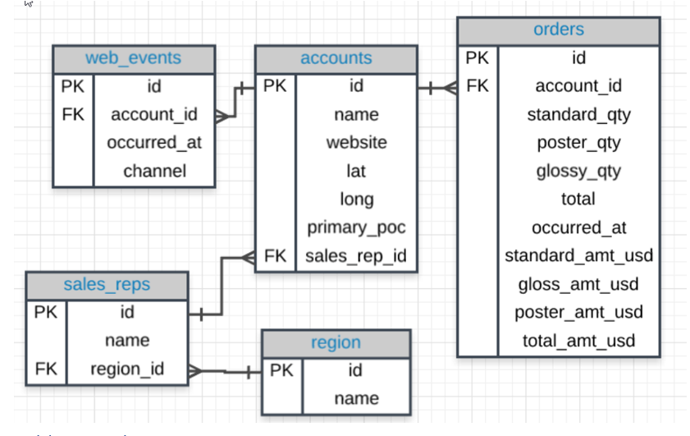

## Quiz: WITH:

1. Provide the name of the sales_rep in each region with the largest amount of total_amt_usd sales.

WITH repregion AS

(SELECT sales_reps.name AS salesguy, region.name

FROM sales_reps

LEFT JOIN region ON sales_reps.region_id = region.id),

repaccorder AS

(SELECT sales_reps.name AS salesguya, SUM(orders.total_amt_usd) as regiontotal

FROM sales_reps

LEFT JOIN accounts ON sales_reps.id = accounts.sales_rep_id

LEFT JOIN orders ON accounts.id = orders.account_id GROUP BY sales_reps.name),

maxregion AS

(SELECT repregion.name,

MAX(repaccorder.regiontotal)

from repregion

JOIN repaccorder ON repregion.salesguy = repaccorder.salesguya

GROUP BY 1

ORDER BY 1 DESC

)

SELECT maxregion.name, repaccorder.salesguya, maxregion.max FROM maxregion

JOIN repaccorder ON maxregion.max = repaccorder.regiontotal;

1. For the region with the largest sales total_amt_usd, how many total orders were placed?

WITH repregion AS

(SELECT sales_reps.name AS salesguy, region.name

FROM sales_reps

LEFT JOIN region ON sales_reps.region_id = region.id),

repaccorder AS

(SELECT sales_reps.name AS salesguya, SUM(orders.total_amt_usd) as regiontotal,

SUM(orders.total) as regionqtytotal

FROM sales_reps

LEFT JOIN accounts ON sales_reps.id = accounts.sales_rep_id

LEFT JOIN orders ON accounts.id = orders.account_id GROUP BY sales_reps.name),

maxregion AS

(SELECT repregion.name,

MAX(repaccorder.regiontotal)

from repregion

JOIN repaccorder ON repregion.salesguy = repaccorder.salesguya

GROUP BY 1

ORDER BY 1 DESC

)

SELECT maxregion.name, repaccorder.salesguya, maxregion.max, repaccorder. regionqtytotal FROM maxregion

JOIN repaccorder ON maxregion.max = repaccorder.regiontotal;

WITH t1 AS (

SELECT r.name region_name, SUM(o.total_amt_usd) total_amt

FROM sales_reps s

JOIN accounts a

ON a.sales_rep_id = s.id

JOIN orders o

ON o.account_id = a.id

JOIN region r

ON r.id = s.region_id

GROUP BY r.name),

t2 AS (

SELECT MAX(total_amt)

FROM t1)

SELECT r.name, COUNT(o.total) total_orders

FROM sales_reps s

JOIN accounts a

ON a.sales_rep_id = s.id

JOIN orders o

ON o.account_id = a.id

JOIN region r

ON r.id = s.region_id

GROUP BY r.name

HAVING SUM(o.total_amt_usd) = (SELECT * FROM t2);

1. How many accounts had more total purchases than the account name which has bought the most standard_qty paper throughout their lifetime as a customer?
2. For the customer that spent the most (in total over their lifetime as a customer) total_amt_usd, how many web_events did they have for each channel?
3. What is the lifetime average amount spent in terms of total_amt_usd for the top 10 total spending accounts?
4. What is the lifetime average amount spent in terms of total_amt_usd, including only the companies that spent more per order, on average, than the average of all orders.

WITH repregion AS

(SELECT sales_reps.name AS salesguy, region.name

FROM sales_reps

LEFT JOIN region ON sales_reps.region_id = region.id),

repaccorder AS

(SELECT sales_reps.name AS salesguya, SUM(orders.total_amt_usd) as regiontotal

FROM sales_reps

LEFT JOIN accounts ON sales_reps.id = accounts.sales_rep_id

LEFT JOIN orders ON accounts.id = orders.account_id GROUP BY sales_reps.name),

maxregion AS

(SELECT repregion.name,

MAX(repaccorder.regiontotal)

from repregion

JOIN repaccorder ON repregion.salesguy = repaccorder.salesguya

GROUP BY 1

ORDER BY 1 DESC

)

SELECT maxregion.name, repaccorder.salesguya, maxregion.max FROM maxregion

JOIN repaccorder ON maxregion.max = repaccorder.regiontotal;

Vs

WITH t1 AS (

SELECT s.name rep_name, r.name region_name, SUM(o.total_amt_usd) total_amt

FROM sales_reps s

JOIN accounts a

ON a.sales_rep_id = s.id

JOIN orders o

ON o.account_id = a.id

JOIN region r

ON r.id = s.region_id

GROUP BY 1,2

ORDER BY 3 DESC),

t2 AS (

SELECT region_name, MAX(total_amt) total_amt

FROM t1

GROUP BY 1)

SELECT t1.rep_name, t1.region_name, t1.total_amt

FROM t1

JOIN t2

ON t1.region_name = t2.region_name AND t1.total_amt = t2.total_amt;

# Introduction to SQL Data Cleaning

In this lesson, you will learn a number of fundamental data cleaning SQL techniques that help prep raw data to make it usable for analyses.

At the end of this lesson, you will be able to:

1. Clean and re-structure messy data.
2. Convert columns to different data types.
3. Tricks for manipulating **NULL**s.

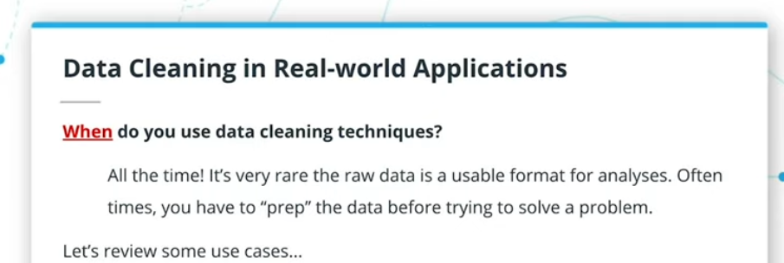

## Data Cleaning Strategy

## Methods to Cover

* **Left:** Extracts a number of characters from a string starting from the left
* **Right:** Extracts a number of characters from a string starting from the right
* **Substr:** Extracts a substring from a string (starting at any position)
* **Position:** Returns the position of the first occurrence of a substring in a string
* **Strpos:** Returns the position of a substring within a string
* **Concat:** Adds two or more expressions together
* **Cast:** Converts a value of any type into a specific, different data type
* **Coalesce:** Returns the first non-null value in a list A handful of these functions, as you’ll quickly realize, are more commonly used than others.

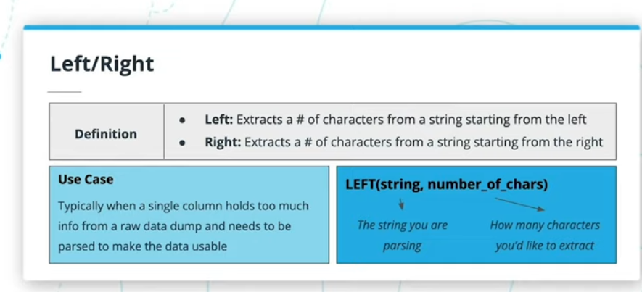

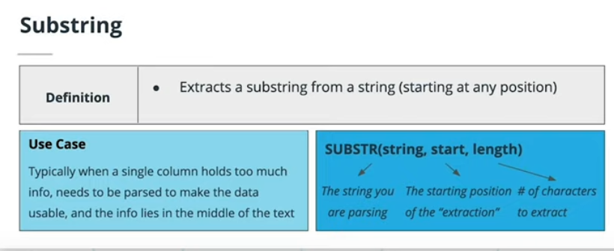

In the **accounts** table, there is a column holding the **website** for each company. The last three digits specify what type of web address they are using. A list of extensions (and pricing) is provided [here](https://iwantmyname.com/domains/domain-name-registration-list-of-extensions). Pull these extensions and provide how many of each website type exist in the **accounts** table.

Example of data cleaning to get information from raw data

select RIGHT(website,3) as extensa, COUNT(*) from

accounts

GROUP BY extensa;

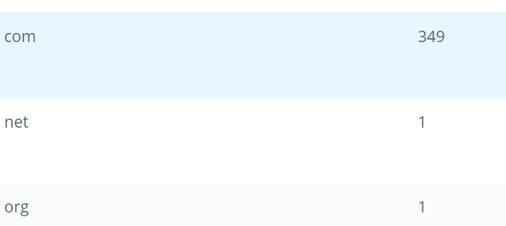

There is much debate about how much the name [(or even the first letter of a company name)](https://www.quora.com/Does-a-companys-name-matter) matters. Use the **accounts** table to pull the first letter of each company name to see the distribution of company names that begin with each letter (or number).

select LEFT(name,1) as firstlet, COUNT(*)

FROM accounts

GROUP BY firstlet

ORDER BY 2 DESC;

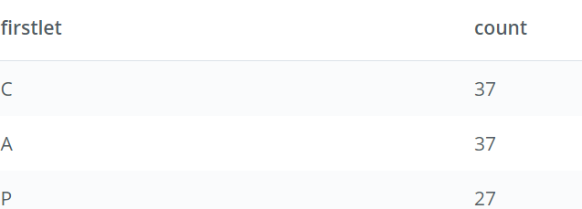

Use the **accounts** table and a **CASE** statement to create two groups: one group of company names that start with a number and a second group of those company names that start with a letter. What proportion of company names start with a letter?

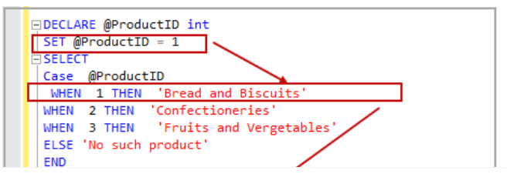

Select EmployeeName,

CASE

WHEN Salary >=80000 AND Salary <=100000 THEN 'Director'

WHEN Salary >=50000 AND Salary <80000 THEN 'Senior Consultant'

Else 'Director'

END AS Designation

from Employee

SELECT

CASE LEFT(name,1)

WHEN ‘1’ THEN ‘n’

ELSE ‘c’

FROM accounts;

Use the **accounts** table and a **CASE** statement to create two groups: one group of company names that start with a number and a second group of those company names that start with a letter. What proportion of company names start with a letter?

SELECT SUM(num) nums, SUM(letter) letters

FROM (SELECT name, CASE WHEN LEFT(UPPER(name), 1) IN ('0','1','2','3','4','5','6','7','8','9')

THEN 1 ELSE 0 END AS num,

CASE WHEN LEFT(UPPER(name), 1) IN ('0','1','2','3','4','5','6','7','8','9')

THEN 0 ELSE 1 END AS letter

FROM accounts) t1;

• Consider vowels as a, e, i, o, and u. What proportion of company names start with a vowel, and what percent start with anything else?

SELECT name, CASE WHEN LEFT(LOWER(name),1) in (‘a’, ‘e’, ‘i’, ‘o’, ‘u’) THEN 1 ELSE 0 END AS vowels,

CASE WHEN LEFT(LOWER(name),1) in (‘a’, ‘e’, ‘i’, ‘o’, ‘u’) THEN 0 ELSE 1 END AS others

FROM accounts;

SELECT SUM(vowels) AS vowelscount, SUM(others) othercount

FROM

(SELECT name, CASE WHEN LEFT(LOWER(name),1) in ('a', 'e', 'i', 'o', 'u') THEN 1 ELSE 0 END AS vowels,

CASE WHEN LEFT(LOWER(name),1) in ('a', 'e', 'i', 'o', 'u') THEN 0 ELSE 1 END AS others

FROM accounts) firstalph;

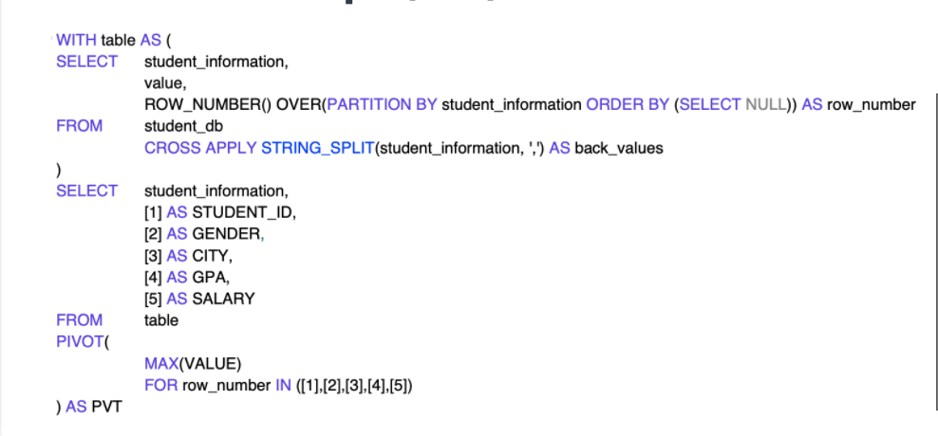

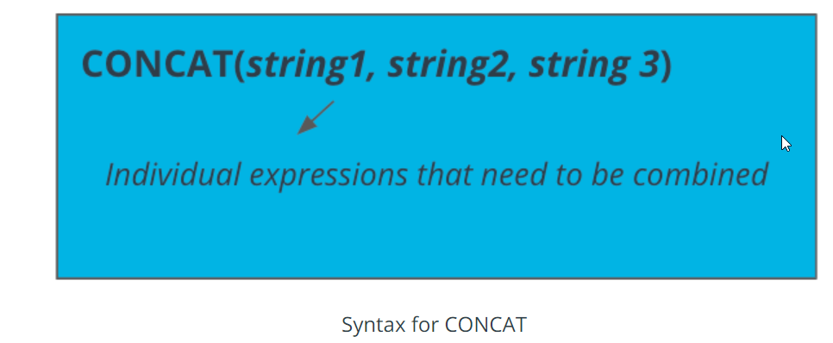

## Quiz: CONCAT, LEFT, RIGHT, and SUBSTR

Suppose the company wants to assess the performance of all the sales representatives. Each sales representative is assigned to work in a particular region. To make it easier to understand for the HR team, display the concatenated sales_reps.id, ‘_’ (underscore), and region.name as EMP_ID_REGION for each sales representative.

SELECT CONCAT(id,'_',name) AS EMP_ID_REGION

FROM sales_reps;

From the accounts table, display the name of the client, the coordinate as concatenated (latitude, longitude), email id of the primary point of contact as

<first letter of the primary_poc><last letter of the primary_poc>@<extracted name and domain from the website>

SELECT name, CONCAT(lat, long) AS coordinate, CONCAT(LEFT(primary_poc,1),RIGHT(primary_poc,1),'@', SUBSTR(website,3,LENGTH(website))) as email_id FROM accounts;

From the web_events table, display the concatenated value of account_id, '_' , channel, '_', count of web events of the particular channel.

SELECT CONCAT(account_id, '_', channel, '_', COUNT(*)) FROM web_events GROUP BY account_id, channel;

# CAST

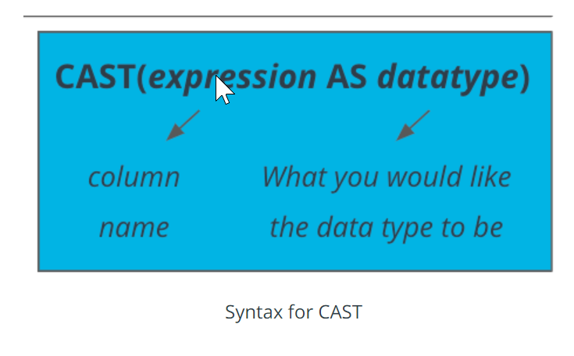

### CAST Quiz

**Tasks to complete:**

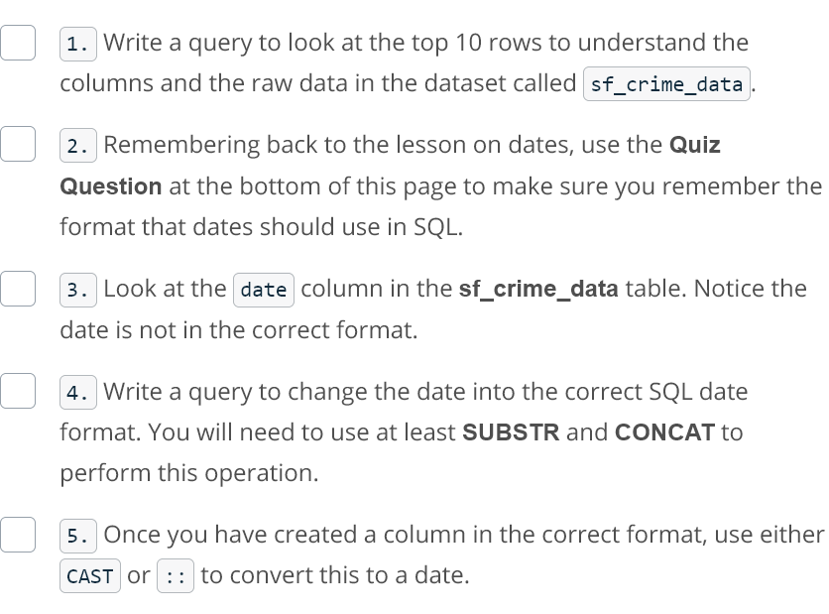

select * from sf_crime_data

limit 10;

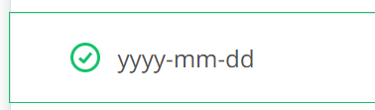

select CONCAT(SUBSTR(date,7,4), '-',SUBSTR(date,1,2),'-',SUBSTR(date,4,2)) as correctedDate

FROM sf_crime_data limit 5;

select CAST(CONCAT(SUBSTR(date,7,4), '-',SUBSTR(date,1,2),'-',SUBSTR(date,4,2)) AS DATE) as correctedDate

FROM sf_crime_data limit 5;

# Advanced Cleaning Functions

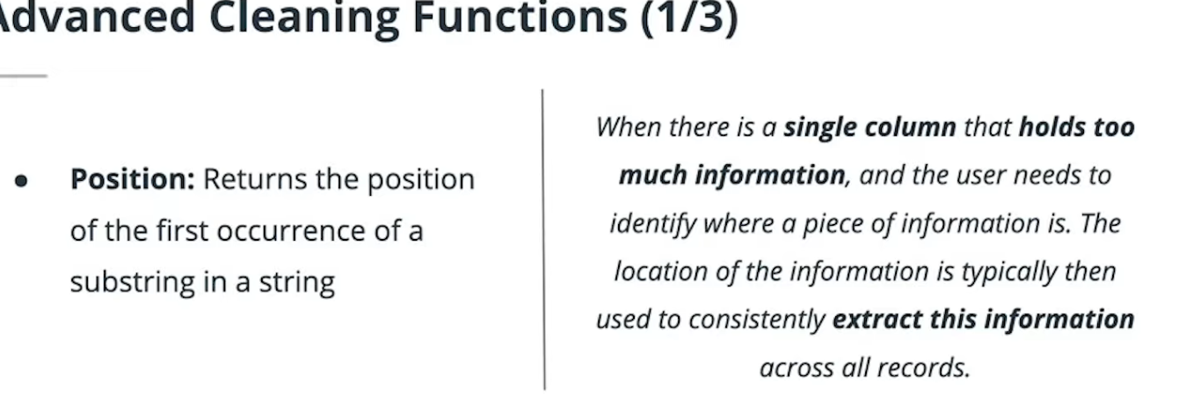

## Syntax

* **POSITION:** Returns the position of the first occurrence of a substring in a string

### Use Case

When there is a single column that holds so much information, and the user needs to identify where a piece of information is. The location of the information is typically then used to consistently extract this information across all records.

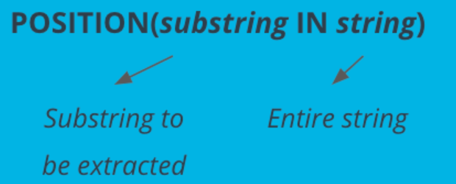

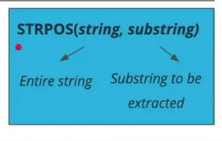

Use the accounts table to create **first** and **last** name columns that hold the first and last names for the primary_poc.

SELECT LEFT(primary_poc,POSITION(' ' IN primary_poc) ) AS first,

SUBSTR(primary_poc, POSITION(' ' IN primary_poc)+1, LENGTH(primary_poc)) AS last

from accounts LIMIT 5;

Now see if you can do the same thing for every rep name in the sales_reps table. Again provide **first** and **last** name columns.

SELECT LEFT(name,POSITION(' ' IN name) ) AS first,

SUBSTR(name, POSITION(' ' IN name)+1, LENGTH(name)) AS last

from sales_reps LIMIT 5;

### Quizzes CONCAT

1. Each company in the accounts table wants to create an email address for each primary_poc. The email address should be the first name of the **primary_poc** . last name **primary_poc** @ company name .com.

SELECT CONCAT( LEFT(primary_poc, POSITION(' ' IN primary_poc)),'.',SUBSTR(primary_poc,POSITION(' ' IN primary_poc)+1,LENGTH(primary_poc)), '@',name,'.com' ) FROM accounts LIMIT 5;

1. You may have noticed that in the previous solution some of the company names include spaces, which will certainly not work in an email address. See if you can create an email address that will work by removing all of the spaces in the account name, but otherwise your solution should be just as in question 1. Some helpful documentation is [here](https://www.postgresql.org/docs/8.1/static/functions-string.html).

SELECT CONCAT( LEFT(primary_poc, POSITION(' ' IN primary_poc)),'.',SUBSTR(primary_poc,POSITION(' ' IN primary_poc)+1,LENGTH(primary_poc)), '@', REPLACE(name, ' ', ''),'.com' ) AS EMAILADD FROM accounts LIMIT 5;

1. We would also like to create an initial password, which they will change after their first log in. The first password will be the first letter of the primary_poc's first name (lowercase), then the last letter of their first name (lowercase), the first letter of their last name (lowercase), the last letter of their last name (lowercase), the number of letters in their first name, the number of letters in their last name, and then the name of the company they are working with, all capitalized with no spaces.

SELECT CONCAT( LEFT(primary_poc, POSITION(' ' IN primary_poc)),'.',SUBSTR(primary_poc,POSITION(' ' IN primary_poc)+1,LENGTH(primary_poc)), '@', REPLACE(name, ' ', ''),'.com' ) AS EMAILADD,

CONCAT(lower(LEFT(primary_poc,1)),

SUBSTR(primary_poc,POSITION(' ' IN primary_poc)-1,1) ,

lower(SUBSTR(primary_poc,POSITION(' ' IN primary_poc)+1,1)),

LOWER(RIGHT(primary_poc,1)) ,

LENGTH(LEFT(primary_poc, POSITION(' ' IN primary_poc)))-1 ,

LENGTH(SUBSTR(primary_poc,POSITION(' ' IN primary_poc)+1,LENGTH(primary_poc))),

UPPER(REPLACE(name, ' ', '')) ) AS password

FROM accounts LIMIT 5;

# COALESCE

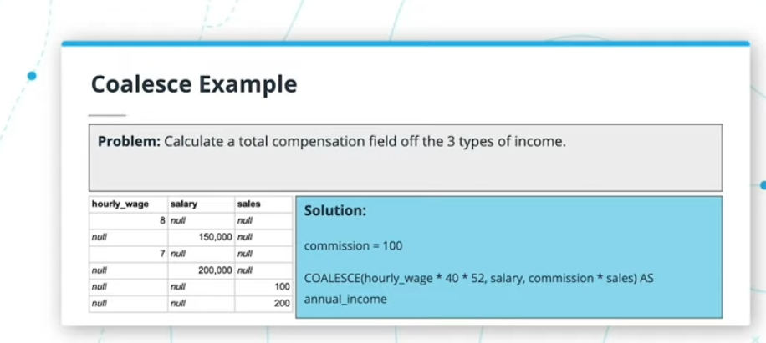

Aside:

# 9.4. String Functions and Operators

<https://www.postgresql.org/docs/8.1/functions-string.html>

# Introduction to Window Functions

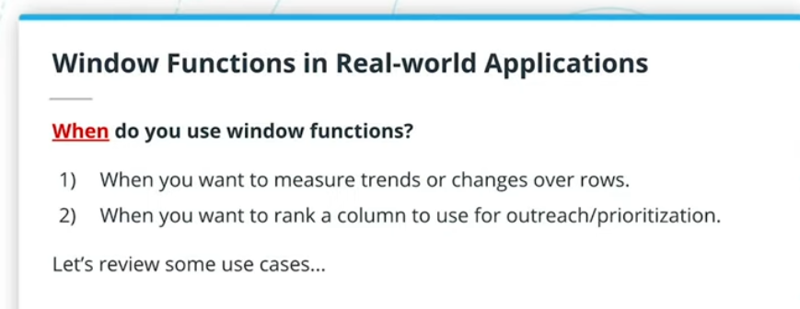

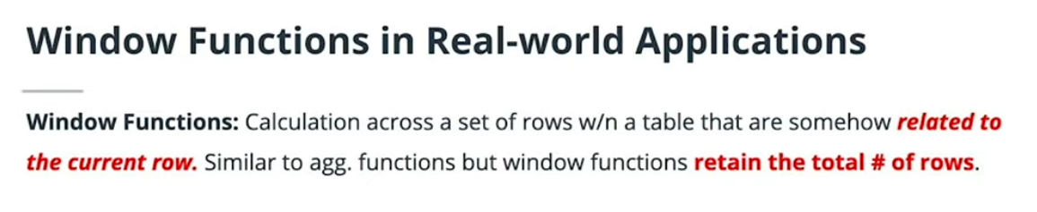

EXAMPLE OF A WINDOW FUNCTION!

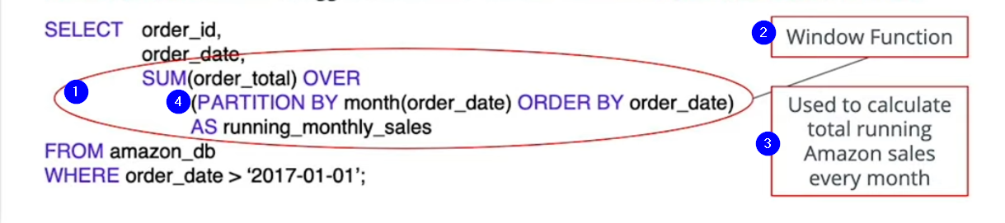

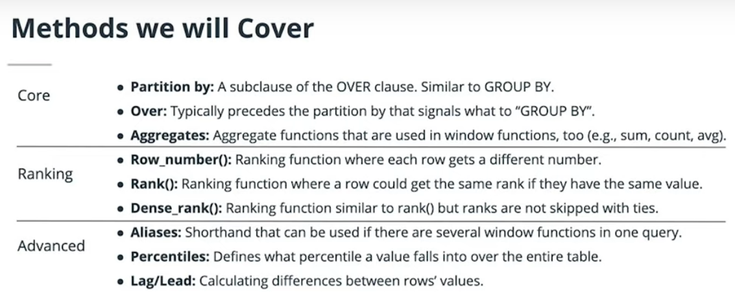

. Most users call all of the functions below “window functions.”

* **Partition by:** A subclause of the OVER clause. Similar to GROUP BY.
* **Over:** Typically precedes the partition by that signals what to “GROUP BY”.
* **Aggregates:** Aggregate functions that are used in window functions, too (e.g., sum, count, avg).
* **Row_number():** Ranking function where each row gets a different number.
* **Rank():** Ranking function where a row could get the same rank if they have the same value.
* **Dense_rank():** Ranking function similar to rank() but ranks are not skipped with ties.
* **Aliases:** Shorthand that can be used if there are several window functions in one query.
* **Percentiles:** Defines what percentile a value falls into over the entire table.
* **Lag/Lead:** Calculating differences between rows’ values.

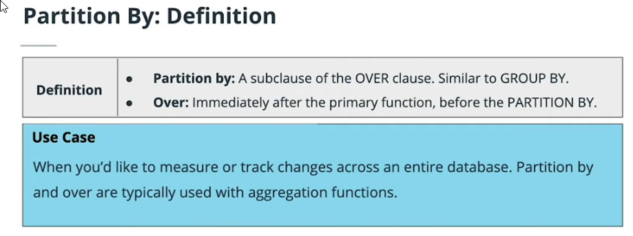

### Syntax

AGGREGATE_FUNCTION (column_1) OVER

(PARTITION BY column_2 ORDER BY column_3)

AS new_column_name;

**Sequence of Code for Window Functions**

Typically, when you are writing a window function that tracks changes or a metric over time, you are likely to structure your syntax with the following components:

1. An aggregation function (e.g., sum, count, or average) + the column you’d like to track
2. OVER
3. PARTITION BY + the column you’d like to “group by”
4. ORDER BY (optional and is often a date column)
5. AS + the new column name

Example:

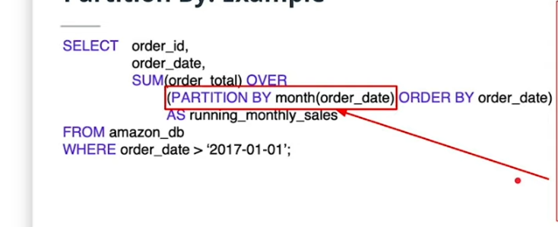

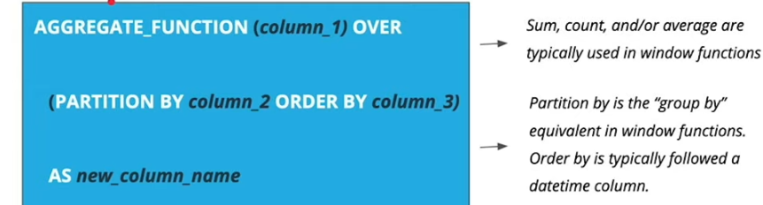

3 variations of the window function!

Here we just sum cumulatively!

SELECT occurred_at as DATE, standard_amt_usd, SUM(standard_amt_usd) OVER(ORDER BY occurred_at)

AS runningtotal

FROM orders;

Here we sum cumulatively for an entire year!

SELECT DATE_TRUNC('year',occurred_at) as year, standard_amt_usd, SUM(standard_amt_usd) OVER(PARTITION BY DATE_TRUNC('year',occurred_at) ORDER BY DATE_TRUNC('year',occurred_at))

AS runningtotalbyyear

FROM orders;

Here we sum cumulatively by date, but reset for every year!

SELECT DATE_TRUNC('year',occurred_at) as year, standard_amt_usd, SUM(standard_amt_usd) OVER(PARTITION BY DATE_TRUNC('year',occurred_at) ORDER BY occurred_at)

AS runningtotalbyyear

FROM orders;

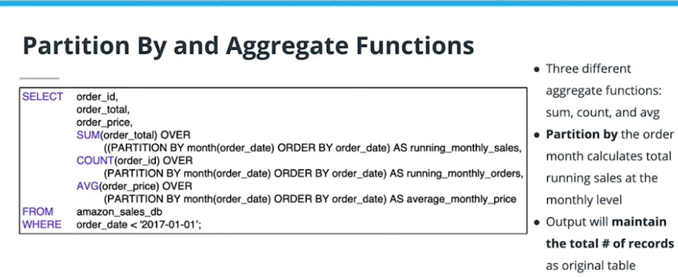

# Ranking Window Functions

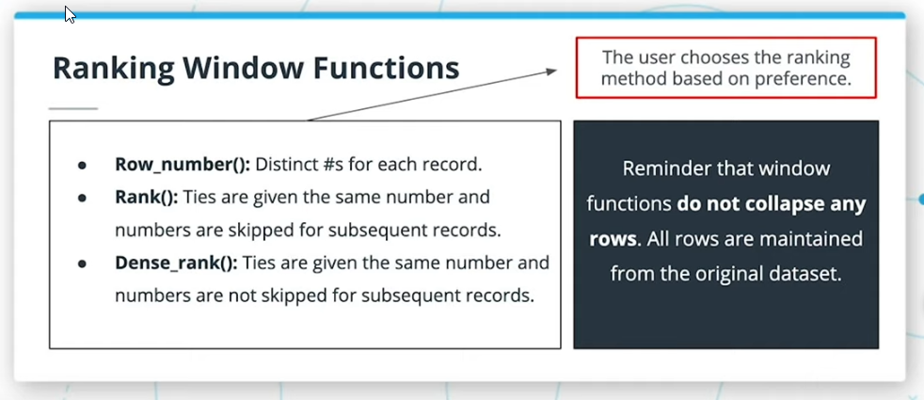

## Examples of Each Ranking Type of Window Function:

## 

## ROW_NUMBER() OVER (..)

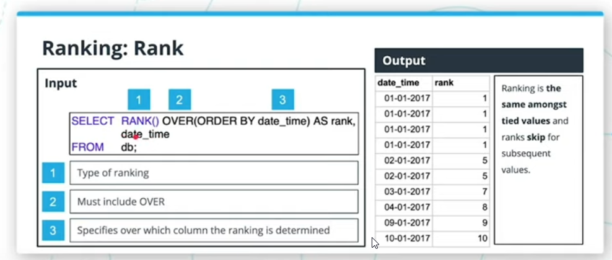

## RANK() OVER(..) ..

## 

## DENSE_RANK OVER(..) …

## Ranking Total Paper Ordered by Account

Select the id, account_id, and total variable from the orders table, then create a column called total_rank that ranks this total amount of paper ordered (from highest to lowest) for each account using a partition. Your final table should have these four columns.

SELECT id, account_id, total, RANK() OVER(ORDER BY total ) AS total_rank FROM orders ORDER BY total;

# Advanced Functions: Aliases for Multiple Window Functions

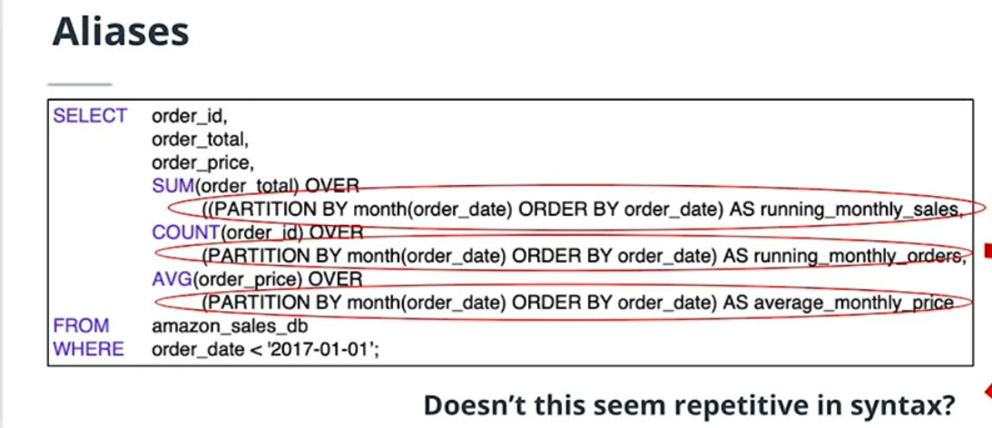

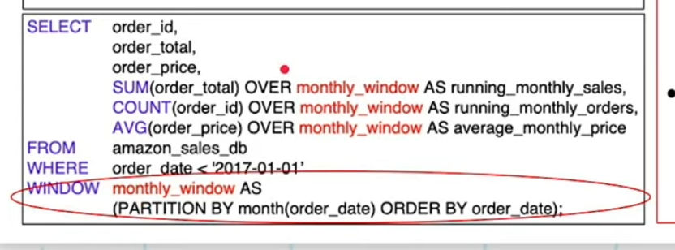

Example:

SELECT id,

account_id,

DATE_TRUNC('year',occurred_at) AS year,

DENSE_RANK() OVER (PARTITION BY account_id ORDER BY DATE_TRUNC('year',occurred_at)) AS dense_rank,

total_amt_usd,

SUM(total_amt_usd) OVER account_year_window AS sum_total_amt_usd,

COUNT(total_amt_usd) OVER (PARTITION BY account_id ORDER BY DATE_TRUNC('year',occurred_at)) AS count_total_amt_usd,

AVG(total_amt_usd) OVER account_year_window AS avg_total_amt_usd,

MIN(total_amt_usd) OVER account_year_window AS min_total_amt_usd,

MAX(total_amt_usd) OVER account_year_window AS max_total_amt_usd

FROM orders

WINDOW account_year_window

AS (PARTITION BY account_id ORDER BY DATE_TRUNC('year',occurred_at))

# Comparing a Row to Previous Row LAG AND LEAD FUNCTIONS!!

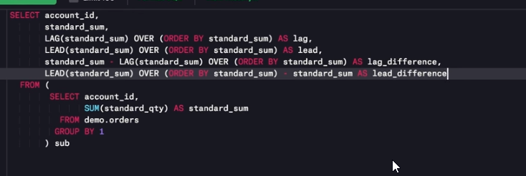

**Now let’s look at the LEAD function.**

### LEAD function

**Purpose**:  
Return the value from the row following the current row in the table.

## Comparing a Row to Previous Row

In the previous video, Derek outlines how to compare a row to a previous or subsequent row. This technique can be useful when analyzing time-based events. Imagine you're an analyst at Parch & Posey and you want to determine how the current order's total revenue ("total" meaning from sales of all types of paper) compares to the next order's total revenue.

Modify Derek's query from the previous video in the SQL Explorer below to perform this analysis. You'll need to use occurred_at and total_amt_usd in the orders table along with LEAD to do so. In your query results, there should be four columns: occurred_at, total_amt_usd, lead, and lead_difference

SELECT account_id,

standard_sum,

LAG(standard_sum) OVER (ORDER BY standard_sum) AS lag,

LEAD(standard_sum) OVER (ORDER BY standard_sum) AS lead,

standard_sum - LAG(standard_sum) OVER (ORDER BY standard_sum) AS lag_difference,

LEAD(standard_sum) OVER (ORDER BY standard_sum) - standard_sum AS lead_difference

FROM (

SELECT account_id,

SUM(standard_qty) AS standard_sum

FROM orders

GROUP BY 1

) sub

# Percentiles

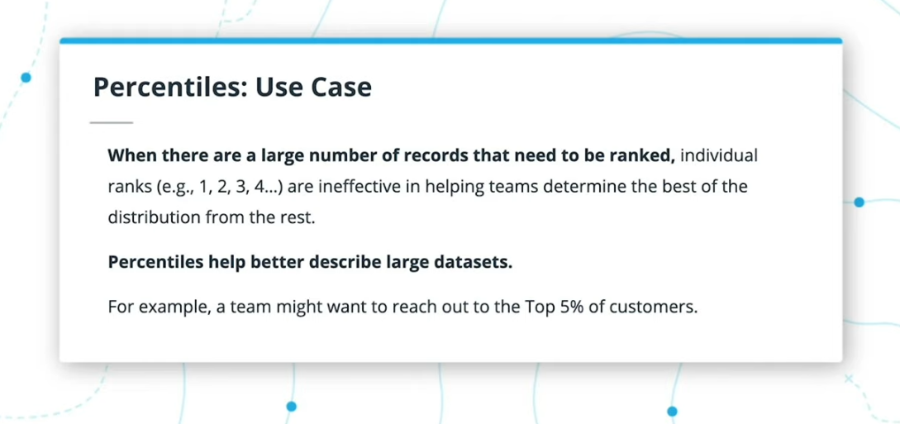

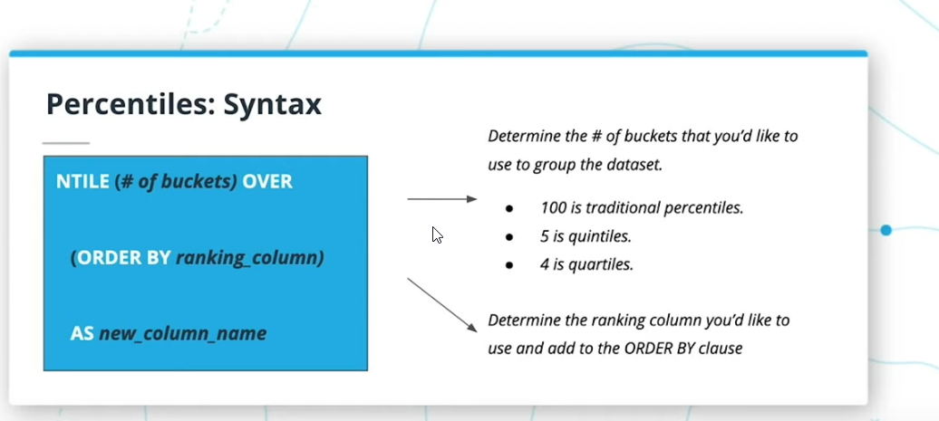

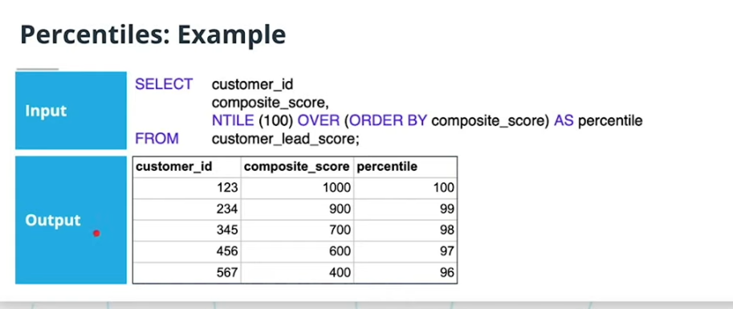

Use the NTILE functionality to divide the accounts into 4 levels in terms of the amount of standard_qty for their orders. Your resulting table should have the account_id, the occurred_at time for each order, the total amount of standard_qty paper purchased, and one of four levels in a standard_quartile column.s

SELECT account_id, occurred_at, standard_qty, NTILE(4) OVER (ORDER BY standard_qty) AS percentile

FROM orders ;

SELECT

account_id,

occurred_at,

standard_qty,

NTILE(4) OVER (PARTITION BY account_id ORDER BY standard_qty) AS standard_quartile

FROM orders

ORDER BY account_id DESC

SELECT account_id, occurred_at, standard_qty, NTILE(4) OVER (PARTITION BY account_id ORDER BY standard_qty) AS quartile

FROM orders ORDER BY account_id ;

Use the NTILE functionality to divide the accounts into two levels in terms of the amount of gloss_qty for their orders. Your resulting table should have the account_id, the occurred_at time for each order, the total amount of gloss_qty paper purchased, and one of two levels in a gloss_half column.

SELECT account_id, occurred_at, gloss_qty, NTILE(2) OVER (PARTITION BY account_id ORDER BY gloss_qty) AS gloss_half

FROM orders ORDER BY account_id ;

Use the NTILE functionality to divide the orders for each account into 100 levels in terms of the amount of total_amt_usd for their orders. Your resulting table should have the account_id, the occurred_at time for each order, the total amount of total_amt_usd paper purchased, and one of 100 levels in a total_percentile column.

SELECT account_id, occurred_at, total_amt_usd, NTILE(100) OVER (PARTITION BY account_id ORDER BY total_amt_usd) AS gloss_half

FROM orders ORDER BY account_id ;

# SUPER DUPER LESSONS ON JOINS ALONG WITH SOME SET THEORY!

*Venn diagrams, which are helpful for visualizing table joins, are provided below along with sample queries. Consider the circle on the left Table A and the circle on the right Table B.*



INNER JOIN Venn Diagram

SELECT column_name(s)

FROM Table_A

INNER JOIN Table_B ON Table_A.column_name = Table_B.column_name;

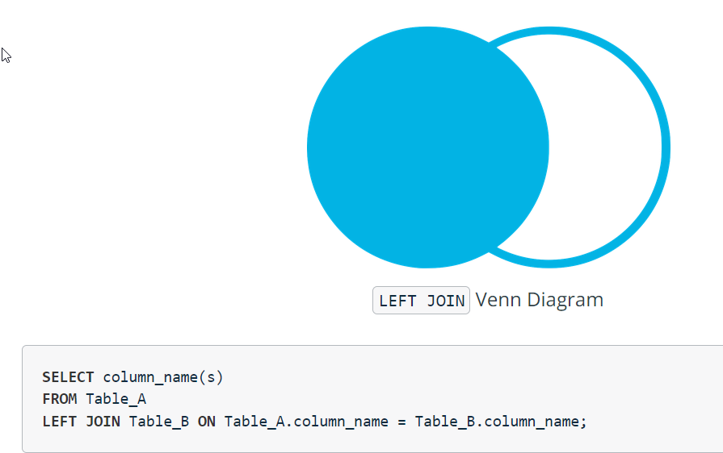

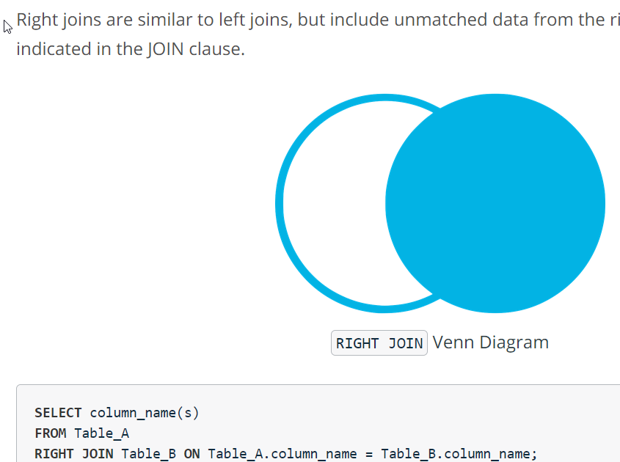

In some cases, you might want to include unmatched rows from *both* tables being joined. You can do this with a full outer join.

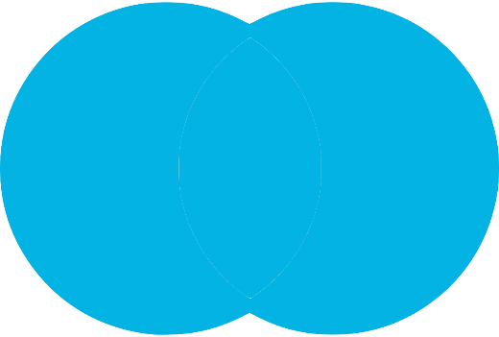

FULL OUTER JOIN Venn Diagram

SELECT column_name(s)

FROM Table_A

FULL OUTER JOIN Table_B ON Table_A.column_name = Table_B.column_name;

If you wanted to return unmatched rows only, which is useful for some cases of data assessment, you can isolate them by adding the following line to the end of the query:

WHERE Table_A.column_name IS NULL OR Table_B.column_name IS NULL



FULL OUTER JOIN with WHERE A.Key IS NULL OR B.Key IS NULL Venn Diagram

WHERE accounts.sales_rep_id IS NULL OR sales_reps.id IS NULL

## Inequality JOINs

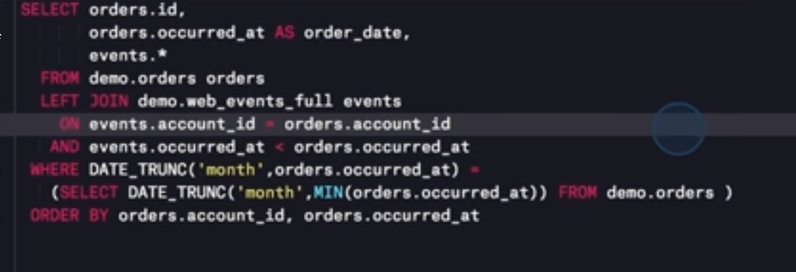

# JOINs with Comparison Operators

## Inequality JOINs

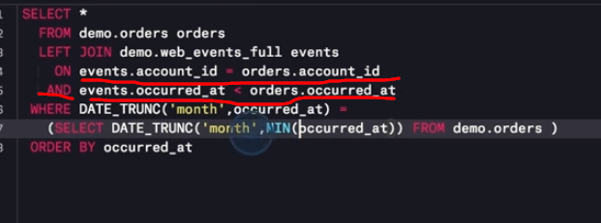

Even with an inequality join, you have 1 match that has equality!

you recall from earlier lessons on joins, the join clause is evaluated before the where clause -- filtering in the join clause will eliminate rows before they are joined, while filtering in the WHERE clause will leave those rows in and produce some nulls.

## Expert Tip

If you recall from earlier lessons on joins, the join clause is evaluated BEFORE the where clause .-- filtering in the join clause will eliminate rows before they are joined,

while filtering in the WHERE clause will leave those rows in and produce some nulls.

## Inequality JOINs

In the following SQL Explorer, write a query that left joins the accounts table and the sales_reps tables on each sale rep's ID number and joins it using the < comparison operator on accounts.primary_poc and sales_reps.name, like so:

# Video: Self JOINs

WHEN DO YOU DO A SELF JOIN? That is to say joining a table onto itself!

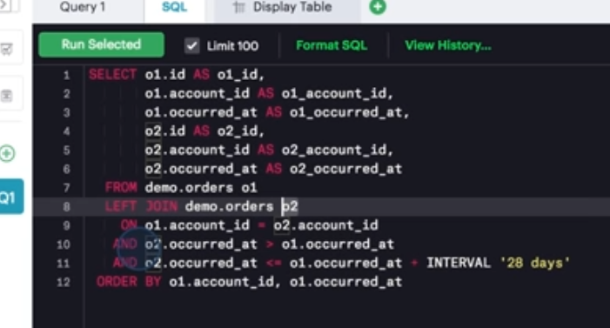s

# Video: UNION

## Appending Data via UNION

### UNION Use Case

• The UNION operator is used to combine the result sets of 2 or more SELECT statements. It removes duplicate rows between the various SELECT statements.

• Each SELECT statement within the UNION must have the same number of fields in the result sets with similar data types.

• Typically, the use case for leveraging the UNION command in SQL is when a user wants to pull together distinct values of specified columns that are spread across multiple tables. For example, a chef wants to pull together the ingredients and respective aisle across three separate meals that are maintained in different tables.

**Details of UNION**

* There must be the same number of expressions in both SELECT statements.
* The corresponding expressions must have the same data type in the SELECT statements. For example: expression1 must be the same data type in both the first and second SELECT statement.

**Expert Tip**

* UNION removes duplicate rows.
* UNION ALL does not remove duplicate rows.

SELECT supplier_id

FROM suppliers

UNION

SELECT supplier_id

FROM orders

ORDER BY supplier_id;

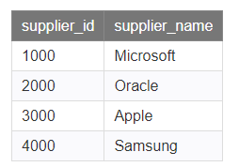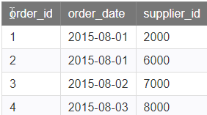’

Result is: 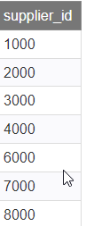

## Example - Different Field Names

It is not necessary that the corresponding columns in each SELECT statement have the same name, but they do need to be the same corresponding data types.

SELECT supplier_id, supplier_name

FROM suppliers

WHERE supplier_id > 2000

UNION

SELECT company_id, company_name

FROM companies

WHERE company_id > 1000

ORDER BY 1;

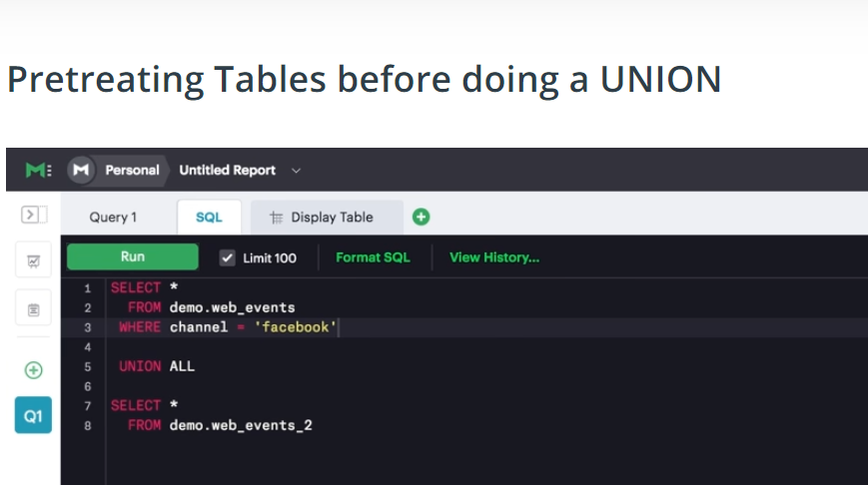

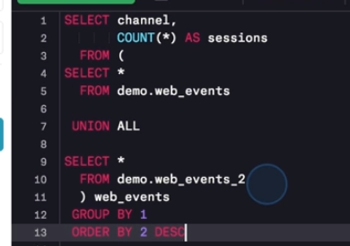

## Appending Data via UNION

Write a query that uses UNION ALL on two instances (and selecting all columns) of the accounts table. Then inspect the results and answer the subsequent quiz.



SELECT * FROM accounts acc1

UNION ALL

SELECT * FROM accounts acc2;

## Pretreating Tables before doing a UNION

Add a WHERE clause to each of the tables that you unioned in the query above, filtering the first table where name equals Walmart and filtering the second table where name equals Disney. Inspect the results then answer the subsequent quiz.

SELECT * FROM accounts acc1

WHERE acc1.name = 'Walmart'

UNION ALL

SELECT * FROM accounts acc2

WHERE acc2.name = 'Disney';

# Video: Performance Tuning Motivation

## How You Can and Can't Control Performance

One way to make a query run faster is to reduce the number of calculations that need to be performed. Some of the high-level things that will affect the number of calculations a given query will make include:

* Table size
* Joins
* Aggregations

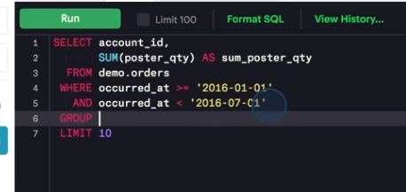

Speed up!

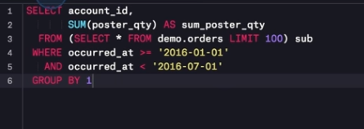

Only can really be used to test query logic, but cannot fully get your accurate data!

# Video: Performance Tuning 2

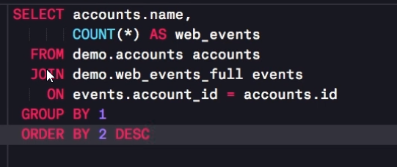

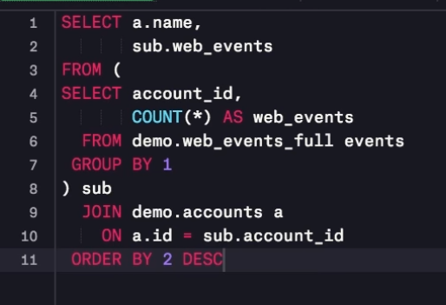

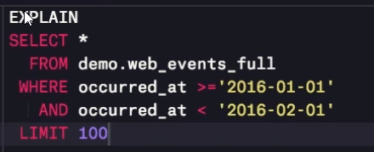

# Final work BEFORE FIRST PROJECT: WEAK SPOTS TO BE REPEATED AGAIN. BEFORE DOING PROJECT

1. 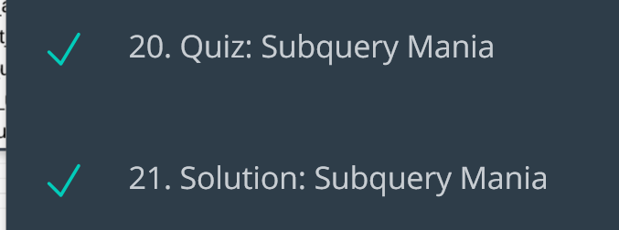
2. Repeat these 2 items again!

# Project Introduction

1. You’re a data analyst for **ForestQuery**, a non-profit organization. on a mission to reduce deforestation around the world and which raises awareness about this important environmental topic.
2. Your executive director and her leadership team members are looking to understand:
   1. which countries and regions around the world seem to have forests that have been shrinking in size,
   2. which countries and regions have the most significant forest area, both in terms of amount and percent of total area.
3. The hope is that these findings can help inform initiatives, communications, and personnel allocation to achieve the largest impact with the precious few resources that the organization has at its disposal.
4. You’ve been able to find tables of data online dealing with forestation as well as total land area and region groupings, and you’ve brought these tables together into a database that you’d like to query to answer some of the most important questions in preparation for a meeting with the ForestQuery executive team coming up in a few days.
5. Ahead of the meeting, you’d like to prepare and disseminate a report for the leadership team that uses complete sentences to help them understand the global deforestation overview between 1990 and 2016.

## Steps to Complete

1. Create a **View** called **“forestation”** by joining all three tables - **forest_area, land_area** and **regions** in the workspace.
2. The **forest_area** and **land_area** tables join on both **country_code** AND **year**.
3. The **regions** table joins these based on only **country_code**.
4. In the ‘forestation’ View, include the following:
   * **All of the columns of the origin tables**
   * A **new column** that provides the **percent of the land area that is designated as forest**.
5. Keep in mind that the column **forest_area_sqkm** in the forest_area table and the **land_area_sqmi** in the land_area table are in **different units (square kilometers and square miles, respectively)**, so an adjustment will need to be made in the calculation you write (1 sq mi = 2.59 sq km).

## Instructions

You will be creating a report for the executive team in which you explain your results using complete sentences.

### Report Sections

The report has five sections that you will need to complete:

1. Global Situation
2. Regional Outlook
3. Country-Level Detail
4. Recommendations
5. Appendix: SQL queries used

You'll find further details on what you should complete for these sections on the next few pages.

### Project Starter Template

We've provided a template for you that you can use for your report. You can get the template in either of the following formats:

* [Click here to download the template as a Microsoft Word (docx) file](https://video.udacity-data.com/topher/2020/April/5e952379_project-starter-template-deforestation-exploration-solution-template/project-starter-template-deforestation-exploration-solution-template.docx).
* [Click here to get a Google doc version](https://docs.google.com/document/d/1XERnuppRwuy3FuzGMBQMXu8aExcB6e9_4EFm4H7DC_g/copy). Click the **Make a copy** button to get your own copy that you can edit.

Once you have completed the report, you can export it as a **PDF** file to submit for review.

### Project Rubric

When you submit your project, we'll give it a thorough review and provide you with feedback on what you did well and anything that needs to be improved. To see the exact criteria that your reviewer will use to check your work, you can look over the [project rubric](https://review.udacity.com/#!/rubrics/2771/view).

## 1. GLOBAL SITUATION

Instructions:

* Answering these questions will help you add information into the template.
* Use these questions as guides to write SQL queries.
* Use the output from the query to answer these questions.

a. What was the total forest area (in sq km) of the world in 1990? Please keep in mind that you can use the country record denoted as “World" in the region table.

SELECT forest_area_sqkm FROM

forest_area

WHERE (forest_area.year = 1990)

AND (forest_area.country_name = 'World');

41282694.9

b. What was the total forest area (in sq km) of the world in 2016? Please keep in mind that you can use the country record in the table is denoted as “World.”

SELECT forest_area_sqkm FROM

forest_area

WHERE (forest_area.year = 2016)

AND (forest_area.country_name = 'World');

39958245.9

c. What was the change (in sq km) in the forest area of the world from 1990 to 2016?

CREATE VIEW FOREST2016

AS

SELECT SUB2016.forest_area_sqkm AS ForestAREA2016

FROM

(SELECT forest_area_sqkm FROM

forest_area

WHERE (forest_area.year = 2016)

AND (forest_area.country_name = 'World')) SUB2016;

CREATE VIEW FOREST1990

AS

SELECT SUB1990.forest_area_sqkm AS ForestAREA1990

FROM

(SELECT forest_area_sqkm FROM

forest_area

WHERE (forest_area.year = 1990)

AND (forest_area.country_name = 'World')) SUB1990;

SELECT ( FOREST2016.ForestAREA2016 - FOREST1990.ForestAREA1990) CHANGE_iN_ForestArea_1990To2016

FROM FOREST1990, FOREST2016;

-1324449

d. What was the percent change in forest area of the world between 1990 and 2016?

SELECT

FOREST1990.ForestAREA1990 AS ForestAREA1990,

FOREST2016.ForestAREA2016 AS ForestAREA2016,

( FOREST2016.ForestAREA2016 - FOREST1990.ForestAREA1990) AS CHANGE_iN_ForestArea, (100* (FOREST2016.ForestAREA2016 - FOREST1990.ForestAREA1990)/FOREST1990.ForestAREA1990) AS PERCENTAGECHANGE

FROM FOREST1990, FOREST2016;

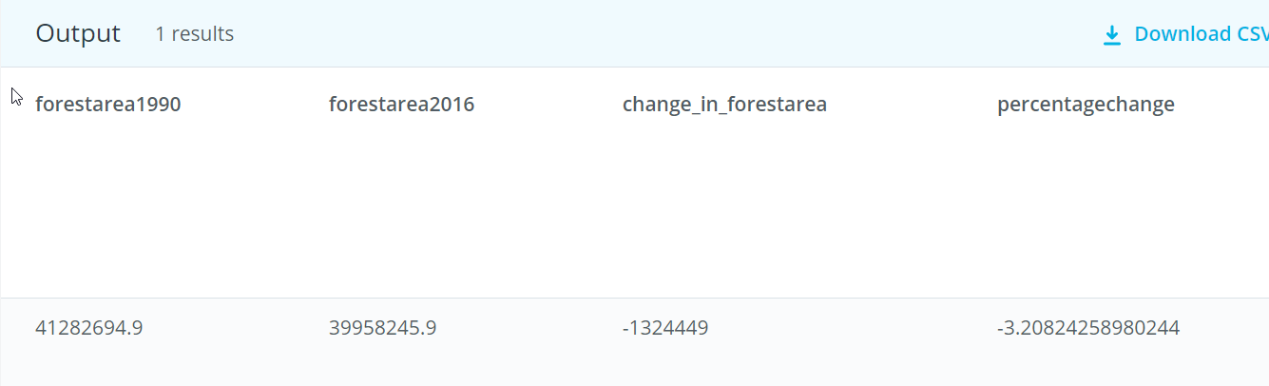

e. If you compare the amount of forest area lost between 1990 and 2016, to which country's total area in 2016 is it closest to?

SELECT

ABS( FOREST2016.ForestAREA2016 - FOREST1990.ForestAREA1990) AS CHANGE_iN_ForestArea , sub2016.country_name, sub2016.total_area_sq_mi*2.58999 as total_area_sqkm,

ABS(ABS( FOREST2016.ForestAREA2016 - FOREST1990.ForestAREA1990)- sub2016.total_area_sq_mi*2.58999) AS MINDIFF

FROM FOREST1990, FOREST2016,

(SELECT * FROM land_area

WHERE year = 2016 AND NOT(country_name = 'World') AND NOT(total_area_sq_mi = 0)

) sub2016

ORDER BY MINDIFF

LIMIT 9

;

| **change_in_forestarea** | **country_name** | **total_area_sqkm** | **mindiff** |
| --- | --- | --- | --- |
| 1324449 | Peru | 1279995.0470151 | 44453.9529849002 |

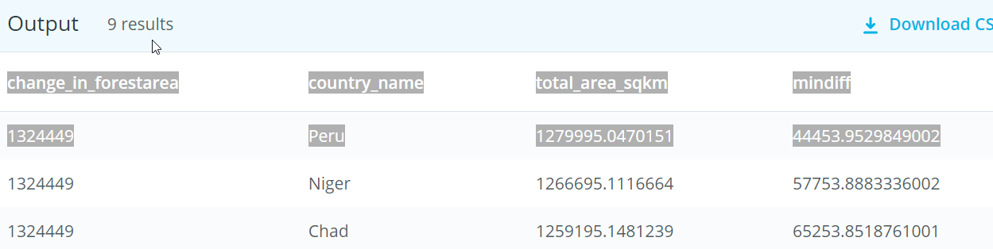

## 2. REGIONAL OUTLOOK

Instructions:

1. Answering these questions will help you add information into the template.
2. Use these questions as guides to write SQL queries.
3. Use the output from the query to answer these questions.
4. Create a table that shows the Regions and their percent forest area (sum of forest area divided by sum of land area) in 1990 and 2016. (Note that 1 sq mi = 2.59 sq km).  
   Based on the table you created, ....
   1. 2016
      1. What was the percent forest of the entire world in 2016?

SELECT Percent_ForestArea, country_name from

(select regions.region, forest_area.country_name, forest_area.year as fyear,forest_area.forest_area_sqkm AS forestArea, (land_area.total_Area_sq_mi*2.59) as totalArea,

(100*forest_area.forest_area_sqkm)/(land_area.total_Area_sq_mi*2.59) as Percent_ForestArea

from forest_area

INNER JOIN land_area on

(forest_area.country_code = land_area.country_code) and

(forest_area.year = land_area.year)

INNER JOIN regions ON

land_area.country_code = regions.country_code

WHERE forest_area.year = 2016

ORDER BY regions.region, forest_area.country_name,forest_area.year

) AS subq1990To2016

WHERE fyear = 2016 AND country_name = 'World';

|  |  |
| --- | --- |
| 31.38 World   1. Which region had the HIGHEST percent forest in 2016, and which had the LOWEST, to 2 decimal places?   SELECT region,  (100*sum(subq2O16.forestArea)/ SUM(subq2O16.landArea*2.59)) AS thepercentage  FROM  (select regions.region, forest_area.country_name, forest_area.year as fyear,  forest_area.forest_area_sqkm AS forestArea, land_area.total_Area_sq_mi AS landArea  from forest_area  INNER JOIN land_area on  (forest_area.country_code = land_area.country_code) and  (forest_area.year = land_area.year)  INNER JOIN regions ON  land_area.country_code = regions.country_code  ) AS subq2O16  WHERE fyear = 2016 AND (NOT country_name ='World')  GROUP BY region ORDER BY 2; |  |
| |  |  |  |  |  |  |  |  |  |  |  |  | | --- | --- | --- | --- | --- | --- | --- | --- | --- | --- | --- | --- | | | **region** | **thepercentage** | | --- | --- | | Middle East & North Africa | 2.06826486871501 | | … |  | |  |  | | Latin America & Caribbean | 46.1620721996047 | |  | | |  |  | | --- | --- | | Latin America & Caribbean | 46.1620721996047 | | Europe & Central Asia | 38.0414216032517 | | North America | 36.0393609681438 | | Sub-Saharan Africa | 28.7881883550464 | | East Asia & Pacific | 26.3586765000485 | | South Asia | 17.5058634081534 | | Middle East & North Africa | 2.06826486871501 | |  | |  |
|  |  |

* 1. 1990
     1. What was the percent forest of the entire world in 1990?

SELECT Percent_ForestArea, country_name from

(select regions.region, forest_area.country_name, forest_area.year as fyear,forest_area.forest_area_sqkm AS forestArea, (land_area.total_Area_sq_mi*2.59) as totalArea,

(100*forest_area.forest_area_sqkm)/(land_area.total_Area_sq_mi*2.59) as Percent_ForestArea

from forest_area

INNER JOIN land_area on

(forest_area.country_code = land_area.country_code) and

(forest_area.year = land_area.year)

INNER JOIN regions ON

land_area.country_code = regions.country_code

ORDER BY regions.region, forest_area.country_name,forest_area.year

) AS subq1990

WHERE fyear = 1990 AND country_name = 'World';

|  |  |
| --- | --- |
| 32.4222035575689 | World |

* + 1. Which region had the HIGHEST percent forest in 1990, and which had the LOWEST, to 2 decimal places?

SELECT region,

(100*sum(subq1990.forestArea)/ SUM(subq1990.landArea*2.59)) AS thepercentage

FROM

(select regions.region, forest_area.country_name, forest_area.year as fyear,

forest_area.forest_area_sqkm AS forestArea, land_area.total_Area_sq_mi AS landArea

from forest_area

INNER JOIN land_area on

(forest_area.country_code = land_area.country_code) and

(forest_area.year = land_area.year)

INNER JOIN regions ON

land_area.country_code = regions.country_code

) AS subq1990

WHERE fyear = 1990 AND (NOT country_name ='World')

GROUP BY region ORDER BY 2 DESC;

Latin America & Caribbean 51.0299798667514

Europe & Central Asia 37.2839398564019

North America 35.655

Sub-Saharan Africa 30.6741454610006

East Asia & Pacific 25.7760953973174

South Asia 16.510767001421

Middle East & North Africa 1.77524062469353

c. Based on the table you created, which regions of the world DECREASED in forest area from 1990 to 2016?

## 

## COUNTRY-LEVEL DETAIL

Instructions:

* Answering these questions will help you add information into the template.
* Use these questions as guides to write SQL queries.
* Use the output from the query to answer these questions.

a. Which 5 countries saw the largest amount decrease in forest area from 1990 to 2016? What was the difference in forest area for each?

b. Which 5 countries saw the largest percent decrease in forest area from 1990 to 2016? What was the percent change to 2 decimal places for each?

c. If countries were grouped by percent forestation in quartiles, which group had the most countries in it in 2016?

d. List all of the countries that were in the 4th quartile (percent forest > 75%) in 2016.

e. How many countries had a percent forestation higher than the United States in 2016?

CREATE VIEW Country1990 AS

select forest_area.country_name, forest_area.forest_area_sqkm AS forestArea

from forest_area

WHERE forest_area.year = 1990 AND NOT(forest_area.country_name = 'World')

ORDER BY forest_area.country_name,forest_area.year;

land_area.total_area_sq_mi

CREATE VIEW Country2016 AS

select forest_area.country_name, forest_area.forest_area_sqkm AS forestArea,

regions.region

from forest_area

INNER JOIN regions

ON forest_area.country_code = regions.country_code

INNER JOIN land_area

ON regions.country_code = land_area.country_code

WHERE forest_area.year = 2016 AND NOT(forest_area.country_name = 'World')

ORDER BY forest_area.country_name,forest_area.year;

CREATE VIEW CountryForestLand2016 AS

select forest_area.country_name, forest_area.forest_area_sqkm AS forestArea, land_area.total_area_sq_mi*2.59 as landArea,

regions.region

from forest_area

INNER JOIN regions

ON forest_area.country_code = regions.country_code

INNER JOIN land_area

ON forest_area.country_code = land_area.country_code

WHERE forest_area.year = 2016 and land_area.year = 2016 AND NOT(forest_area.country_name = 'World')

ORDER BY forest_area.country_name;

SELECT Country2016.country_name, Country2016.region, (Country1990.forestArea - Country2016.forestArea) AS DecreaseFrom2016tO1990

FROM Country2016 JOIN

Country1990 ON

Country2016.country_name = Country1990.country_name

WHERE (Country1990.forestArea - Country2016.forestArea) > 0

ORDER BY DecreaseFrom2016tO1990 DESC LIMIT 5 ;

|  |  |  |  |  |  |  |  |  |  |  |  |  |  |  |  |  |  |  |  |
| --- | --- | --- | --- | --- | --- | --- | --- | --- | --- | --- | --- | --- | --- | --- | --- | --- | --- | --- | --- |
| | **country_name** | **region** | **decreasefrom2016to1990** | | --- | --- | --- | | Brazil | Latin America & Caribbean | 541510 | | Indonesia | East Asia & Pacific | 282193.98 | | Myanmar | East Asia & Pacific | 107234.00 | | Nigeria | Sub-Saharan Africa | 106506.00 | | Tanzania | Sub-Saharan Africa | 102320 | |  |
|  |  |
| SELECT Country2016.country_name, Country2016.region, (Country1990.forestArea -Country2016.forestArea) AS DecreaseFrom1990To2016,  (100*(Country1990.forestArea- Country2016.forestArea))/(Country1990.forestArea) AS PercentageDecrease  FROM Country2016 JOIN  Country1990 ON  Country2016.country_name = Country1990.country_name  WHERE ( Country1990.forestArea - Country2016.forestArea ) > 0  ORDER BY 4 desc LIMIT 5 ;   | **country_name** | **region** | **decreasefrom1990to2016** | **percentagedecrease** | | --- | --- | --- | --- | | Togo | Sub-Saharan Africa | 5168.000031 | 75.4452559270073 | | Nigeria | Sub-Saharan Africa | 106506.00098 | 61.7999309388418 | | Uganda | Sub-Saharan Africa | 28091.99951 | 59.1286034729531 | | Mauritania | Sub-Saharan Africa | 1940 | 46.7469879518072 | | Honduras | Latin America & Caribbean | 36640 | 45.0344149459194 | |  |

SELECT Country2016.country_name, (Country2016.forestArea - Country1990.forestArea) AS IncreaseFrom1990To2016

FROM Country2016 JOIN

Country1990 ON

Country2016.country_name = Country1990.country_name

WHERE ( Country2016.forestArea - Country1990.forestArea ) > 0

ORDER BY IncreaseFrom1990To2016 DESC LIMIT 5 ;

| **country_name** | **increasefrom1990to2016** |
| --- | --- |
| China | 527229.062 |
| United States | 79200 |
| India | 69213.9844 |
| Russian Federation | 59395 |
| Vietnam | 55390 |

SELECT Country2016.country_name, (Country2016.forestArea - Country1990.forestArea) AS IncreaseFrom1990To2016,

100*(Country2016.forestArea - Country1990.forestArea)/(Country1990.forestArea) AS PercentageIncrease

FROM Country2016 JOIN

Country1990 ON

Country2016.country_name = Country1990.country_name

WHERE ( Country2016.forestArea - Country1990.forestArea ) > 0

ORDER BY PercentageIncrease DESC LIMIT 3 ;

| **country_name** | **increasefrom1990to2016** | **percentageincrease** |
| --- | --- | --- |
| Iceland | 343.9999962 | 213.664588870028 |
| French Polynesia | 1000 | 181.818181818182 |
| Bahrain | 3.900000155 | 177.272735285124 |

CREATE VIEW CountryForestLand2016 AS

select forest_area.country_name,

regions.region,

100*forest_area.forest_area_sqkm/(land_area.total_area_sq_mi*2.59) as ForestTolandPercent

from forest_area

INNER JOIN regions

ON forest_area.country_code = regions.country_code

INNER JOIN land_area

ON forest_area.country_code = land_area.country_code

WHERE forest_area.year = 2016 and land_area.year = 2016 AND NOT(forest_area.country_name = 'World') AND (forest_area.forest_area_sqkm > 0) AND (land_area.total_area_sq_mi > 0)

ORDER BY forest_area.country_name;

select country_name, region,ForestTolandPercent,

CASE

WHEN ForestTolandPercent > 75 THEN 4

WHEN ForestTolandPercent > 50 THEN 3

WHEN ForestTolandPercent > 25 THEN 2

WHEN ForestTolandPercent > 0 THEN 1

END as QuartileOfForestPerc

from CountryForestLand2016

ORDER BY foresttolandpercent;

c. If countries were grouped by percent forestation in quartiles, which group had the most countries in it in 2016?

SELECT SUBPERC.quartileofforestperc, count(*) AS COUNTRYCOUNT

from

(select country_name, region,ForestTolandPercent,

CASE

WHEN ForestTolandPercent > 75 THEN 4

WHEN ForestTolandPercent > 50 THEN 3

WHEN ForestTolandPercent > 25 THEN 2

WHEN ForestTolandPercent > 0 THEN 1

END as QuartileOfForestPerc

from CountryForestLand2016

ORDER BY foresttolandpercent) SUBPERC

GROUP BY SUBPERC.quartileofforestperc

ORDER BY SUBPERC.quartileofforestperc;

| **quartileofforestperc** | **countrycount** |
| --- | --- |
| 1 | 85 |
| 2 | 72 |
| 3 | 38 |
| 4 | 9 |

d. List all of the countries that were in the 4th quartile (percent forest > 75%) in 2016.

SELECT SUBPERC.country_name, SUBPERC.region ,SUBPERC.foresttolandpercent, SUBPERC.QuartileOfForestPerc

FROM

(select country_name, region,ForestTolandPercent,

CASE

WHEN ForestTolandPercent > 75 THEN 4

WHEN ForestTolandPercent > 50 THEN 3

WHEN ForestTolandPercent > 25 THEN 2

WHEN ForestTolandPercent > 0 THEN 1

END as QuartileOfForestPerc

from CountryForestLand2016

ORDER BY foresttolandpercent) SUBPERC

where SUBPERC.foresttolandpercent > 75

ORDER BY SUBPERC.foresttolandpercent ;

|  |  |  |
| --- | --- | --- |
| Solomon Islands | East Asia & Pacific | 77.8635177945066 |
| Lao PDR | East Asia & Pacific | 82.1082317640861 |
| Guyana | Latin America & Caribbean | 83.9014489110682 |
| American Samoa | East Asia & Pacific | 87.5000875000875 |
| Palau | East Asia & Pacific | 87.6068085491203 |
| Seychelles | Sub-Saharan Africa | 88.4111367385789 |
| Gabon | Sub-Saharan Africa | 90.0376418700565 |
| Micronesia, Fed. Sts. | East Asia & Pacific | 91.8572390715248 |
| Suriname | Latin America & Caribbean | 98.2576939676578 |

e. How many countries had a percent forestation higher than the United States in 2016?

United States

CREATE VIEW USAPercView AS

SELECT

SUBPERC.foresttolandpercent

AS USAForestPercent

FROM

(select country_name, region,ForestTolandPercent,

CASE

WHEN ForestTolandPercent > 75 THEN 4

WHEN ForestTolandPercent > 50 THEN 3

WHEN ForestTolandPercent > 25 THEN 2

WHEN ForestTolandPercent > 0 THEN 1

END as QuartileOfForestPerc

from CountryForestLand2016

ORDER BY foresttolandpercent) SUBPERC

WHERE SUBPERC.country_name = 'United States'

;

SELECT * FROM USAPercView;

| **usaforestpercent** |
| --- |
| 33.9297857030622 |
|  |

SELECT SUBPERC.country_name, SUBPERC.region ,SUBPERC.foresttolandpercent

FROM

(select country_name, region,ForestTolandPercent,

CASE

WHEN ForestTolandPercent > 75 THEN 4

WHEN ForestTolandPercent > 50 THEN 3

WHEN ForestTolandPercent > 25 THEN 2

WHEN ForestTolandPercent > 0 THEN 1

END as QuartileOfForestPerc

from CountryForestLand2016

ORDER BY foresttolandpercent) SUBPERC

JOIN USAPercView

ON NOT SUBPERC.ForestTolandPercent = USAPercView.usaforestpercent

WHERE SUBPERC.ForestTolandPercent > USAPercView.usaforestpercent

ORDER BY 3 ;

SELECT count(*) AS NumberOfCountries_WithPercntForestation_GreaterThanUSA

FROM

(select country_name, region,ForestTolandPercent,

CASE

WHEN ForestTolandPercent > 75 THEN 4

WHEN ForestTolandPercent > 50 THEN 3

WHEN ForestTolandPercent > 25 THEN 2

WHEN ForestTolandPercent > 0 THEN 1

END as QuartileOfForestPerc

from CountryForestLand2016

ORDER BY foresttolandpercent) SUBPERC

JOIN USAPercView

ON NOT SUBPERC.ForestTolandPercent = USAPercView.usaforestpercent

WHERE SUBPERC.ForestTolandPercent > USAPercView.usaforestpercent

;

| **numberofcountries_withpercntforestation_greaterthanusa** |
| --- |
| 94 |

# 3. Management of Relational & Non-Relational Databases

# Introduction to SQL vs. NoSQL

In this course, we'll use Postgres as our support database for designing relational data schemas. We'll also look at two non-relational databases, MongoDB and Redis. By the end of the course, we'll be able to compare these SQL and NoSQL worlds. We'll see that there's no clear winner in that face-off.

In your career, you'll come to interact with relational databases either as an analyst or as an application developer.

As a data analyst, you often don't get the choice of which database you work with, so being familiar with the tradeoffs and characteristics of many database types will make you better prepared to query them and get insights.

As an application developer, you might be part of the technology decision process, which will involve picking the right kind of database — or even databases — for your use-case. Knowing the behaviours, guarantees, and requirements of different types of databases will be essential in making the right decisions.

## History of these kinds of Systems: History of "SQL vs NoSQL"

The term **NoSQL** was coined around 2009 to refer to these types of databases, because they evolved out of shortcomings in existing relational databases, which for the most part use SQL as their query language.

## Course Outline

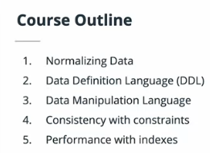

* Create normalized data schemas by following the rules of "normal forms"
* Bring these schemas to life in a relational database using the SQL Data Definition Language
* Add and manipulate data in these schemas using the SQL Data Manipulation Language
* Enable business rules at the level of the database using constraints
* Keep your relational database running quickly and efficiently despite storing and querying large amounts of data
* Use two non-relational databases, MongoDB and Redis, and be able to compare their characteristics to those of relational databases, to make educated decisions about which suits your needs better

## Project: Udiddit, A Social News Aggregator

* After completing the instructional portion of the course, you'll be honing your skills with a final project called Udiddit!
* Udiddit is a social news aggregator which allows registered users to share content, vote, and comment on each other's content
* Since this is a database-only course, you won't be building any UI as part of the project, only the data portion

# Introduction to Data Normalization

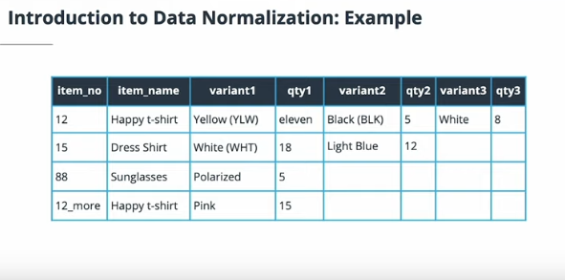

A denormalized table is, succinctly put, a "free-for-all". The only thing consistent about it is that it fits into rows and columns.

Some examples of things that can make data denormalized are:

* Inconsistent data types
* Repeating columns
* Repeating values

Denormalized data exhibits many issues:

* Inconsistent data types across a given column, making it difficult to manage and reason about
* Repeated columns, which disable us from scaling the number of items of related data
* Repeated values in a column, which make querying on those values more challenging
* The inability to uniquely identify rows of data to target them for manipulation
* Irrelevant dependencies, which cause repetitions and anomalies

## First Normal Form

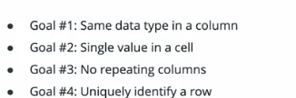

Going from denormalized to First Normal Form — 1NF:

* Make all values in a column consistently of the same data type
* Make sure each cell contains only a single value
* Make sure there are no repeating columns for the same data (e.g. category 1, 2, 3…)
* Enable the rows of data to be uniquely identified through a column or combination of columns

Example of a de-normalized table, disobeying First Normal Form:

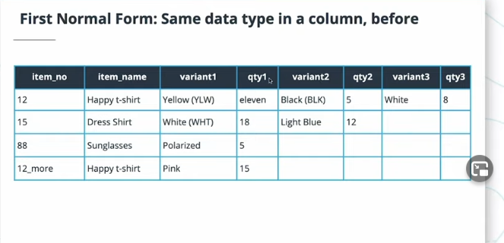

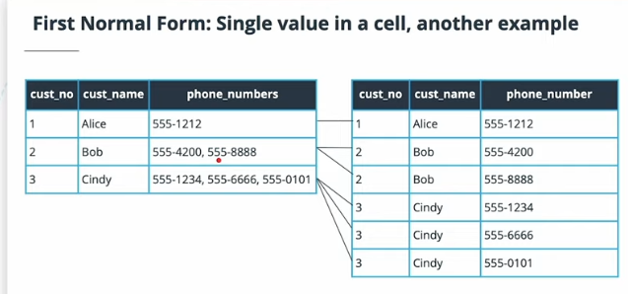

De normalize in the above manner by duplication of certain parts of the rows!

IN further chapters, the author claims we will fix this. Don’t worry about this right now.

To keep a single value in a cell, you might need to do two things:

* If multiple values in a cell are disjoint, e.g. a name and a code, split them into two columns—one for the name and one for the code
* If multiple values in a cell are the same type, e.g. a list of phone numbers, create multiple rows for that single row and put one of the values in each new row

Removing repeating columns is done in a similar fashion to when a single cell contains multiple, comma-separated values: keep a single one of the repeating columns and duplicate rows for each value in those columns.

* **Candidate key**: a set of one or more columns that can uniquely identify a row in a table
* **Primary key**: the key we choose from the candidate keys to uniquely represent a row in a table.

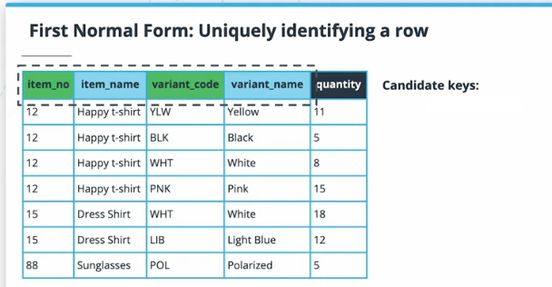

To keep a single value in a cell, you might need to do two things:

* If multiple values in a cell are disjoint, e.g. a name and a code, split them into two columns—one for the name and one for the code
* If multiple values in a cell are the same type, e.g. a list of phone numbers, create multiple
* rows for that single row and put one of the values in each new row

First step towards not having any repeating columns!

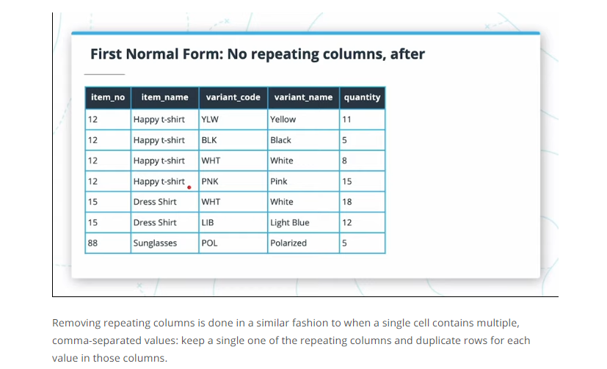

Using two columns to make a primary key!

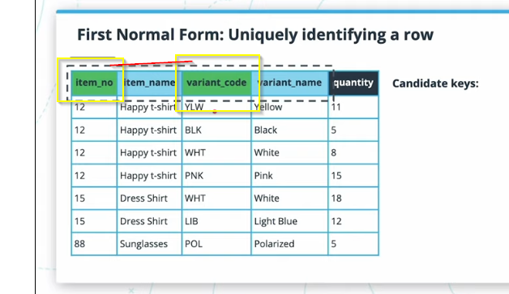

Exercise 5 from Lesson 2 : For Normalizing Data:

### Your reflection

**emp_number emp_name departments**

**1000 Alice HR**

**1000 Alice Sales**

**1005 Bob Sales**

**1420 Cindy Engineering**

post_id title category1

10 Everything wrong with the world Editorial

10 Everything wrong with the world Clickbait

11 You won't believe this! Clickbait

12 Welcome to our blog

## Second Normal Form

Second Normal Form Recipe:

1. Bring table to First Normal Form
2. Remove all partial dependencies

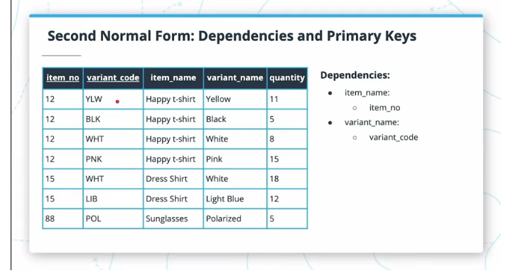

Quantity field depends on the full primary key here!

Remove all partial dependencies by removing them into separate tables and leaving original table with a compound primary key!

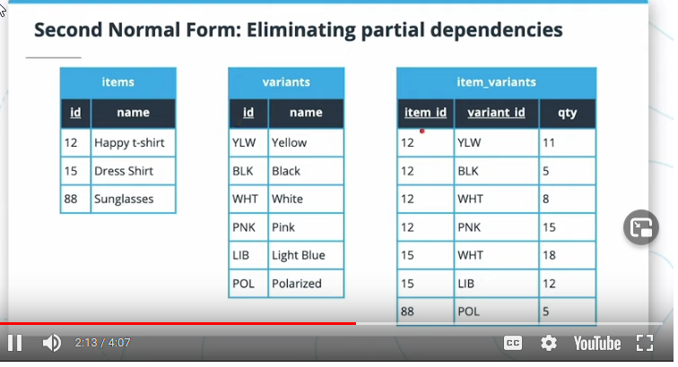

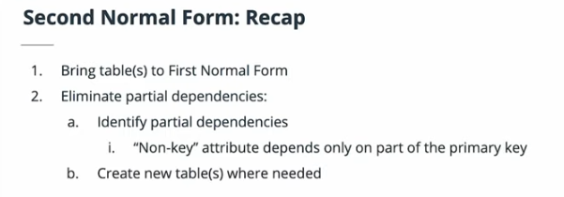

## Second Normal Form Exercise

For this exercise, you’re tasked with bringing the following data to Second Normal Form:

|  | **id** | | **Date** | **employee_id** |  | **categories** | **expense_amount** |
| --- | --- | --- | --- | --- | --- | --- | --- |
|  | 1 | 2015-05-12 | | 5 |  | Food | 25.48 |
|  | 2 | 2015-05-12 | | 5 |  | Travel | 25.48 |
|  |  | 2015-05-15 | | 42 |  | Taxi | 40 |
|  |  | **employee_id** | | **employee_name** |  |  |  |
|  |  | 5 | | Bob |  |  |  |
|  |  | 42 | | Travis |  |  |  |

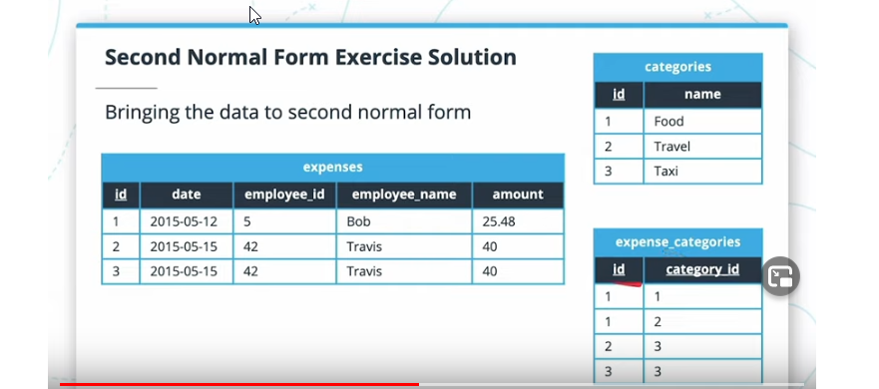

## Third Normal Form

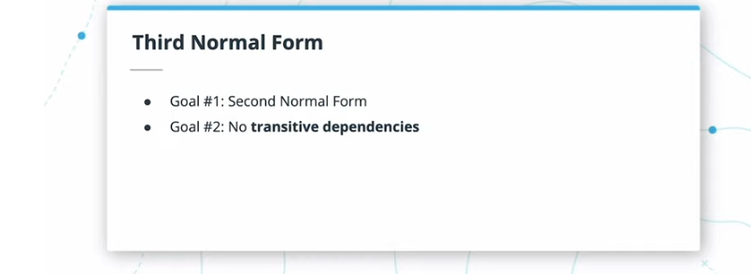

**Transitive dependency**: when a column that isn't part of the primary key depends on the primary key, but through another non-key column. For example, a table of movie reviews would have a surrogate id column as its PK, and a movie_id column to refer to the movie which is being reviewed. If the table also contains a movie_name column, then that movie_name is transitively dependent on the PK, because it depends on it through movie_id.

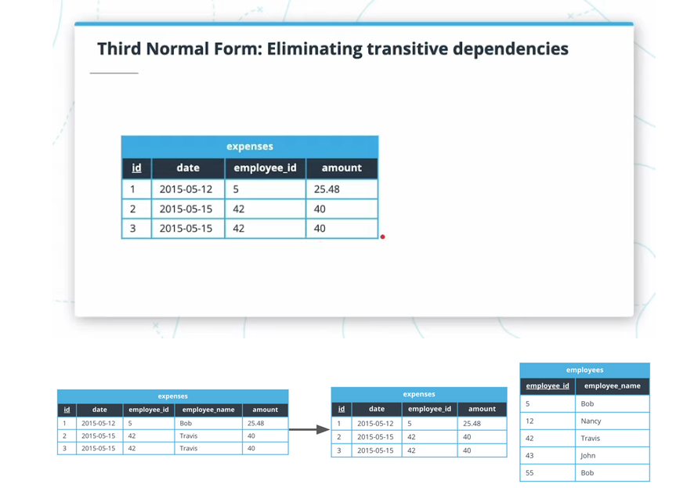

## Third Normal Form Exercise

Bring the following data to Third Normal Form:

|  |  |  | **artist** | **agentId** |
| --- | --- | --- | --- | --- |
|  | 1 |  | Alice | 1 |
|  | 2 |  | Chad | 2 |
|  | 3 |  | Emily | 3 |

| **agentId** | **agent_name** | **agent_phone1** | **agent_phone2** |
| --- | --- | --- | --- |
| 1 | Bob | 555-4200 | 555-8080 |
| 2 | Denise | 555-6660 |  |
| 3 | Frank | 555-7777 |  |

## Lesson Conclusion

* Denormalized data contains repetitions that can cause anomalies
* Rules exist to normalize data
* First Normal Form:
  + Single-valued columns
  + No repeating columns
  + Consistent data across a column
  + Uniquely identify a row
* Second Normal Form: No partial dependencies
* Third Normal Form: No transitive dependencies
* Sometimes, it's OK to violate normal forms; use your best judgement

# Glossary

|  |  |
| --- | --- |
| First Normal Form (1NF) | Shaping data to eliminate inconsistencies, and allowing unique identification of each row |
| Second Normal Form (2NF) | Extends 1NF by removing partial dependencies |
| Third Normal Form (3NF) | Extends 2NF by removing transitive dependencies |
| One-One Relationship | When one entity "has one" of another entity, and that second entity "belongs to" only the first. For example, entity "user" and "home address" have a one-one relationship |
| One-Many Relationship | When one entity "has many" of another entity, and that second entity "belongs to" only the first. For example, entity "user" and "email address" have a one-many relationship, because a user can have many email addresses, but each email address belongs to only one user |
| Many-Many Relationship | When two entities are related in such a way where many links can exist on both sides. For example, entities "books" and "categories" have a many-many relationship, because a book can have multiple categories, and a category can belong to multiple books |
| Candidate Key | A set of one or more columns that can uniquely identify a row in a database table |
| Primary Key | The key from the set of candidate keys that we actually choose in order to uniquely identify a row in that table |
| Composite Key | A key that is composed of more than one column |
| Partial Dependency | When a non-key column depends on only part of the primary key |
| Transitive Dependency | When a non-key column depends on the primary key through another non-key column |

# Introduction to SQL DDL with Postgres

This lesson is going to focus on the Data Definition Language (DDL) part of SQL.

We'll be looking at the ins and ALTER TABLE commands to help us bring the normalized data schemas from the previous lesson to life in Postgres, one of the most advanced open-source relational database systems out there.

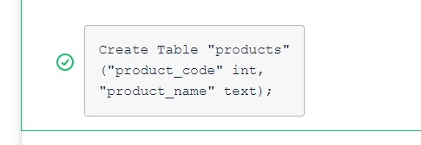

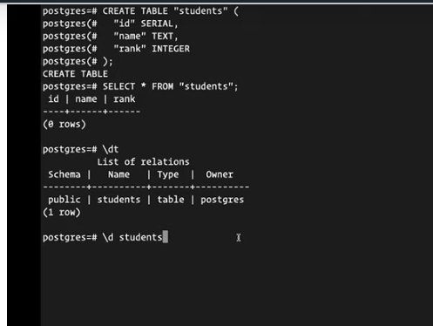

## Creating Tables

Click the below button to make sure the postgres service is started (otherwise done with service postgresql start), and to switch the user from root to postgres (otherwise done with su - postgres).

You can then use the psql command to enter the database.

### Exercise Instructions

Create a normalized set of tables that can support the following data. Don't worry about inserting any data in the tables, only create the structure:

| **emp_id** | **emp_name** | **manager_id** | **manager_name** | **manager_phones** |
| --- | --- | --- | --- | --- |
| 1 | Alice | 6 | Frank | 555-1212 |
| 2 | Bob | 5 | Emily | 555-6042, 555-7213 |
| 3 | Cindy | 6 | Frank | 555-1212 |
| 4 | David |  |  |  |
| 5 | Emily | 4 | David | 555-7654, 555-4242 |
| 6 | Frank | 4 | David | 555-7654, 555-4242 |

After you create the table, you should be able to reload the schema to view the results.

**Note**: In psql, you must add a semi-colon (;) at the end of a given command/query for it to execute. If something seems to not be running, that's the likely culprit.

Remember, the data in postgres will be reset after 15 minutes of inactivity (including the workspace being closed). You may consider using the *scratchpad.sql* file on the tab at the top of the terminal to store your work long-term.

MY SOLUTION:

CREATE TABLE "managers"(

"id" SERIAL,

"manager_id" INTEGER,

"manager_name" TEXT

);

CREATE TABLE "managerphones”

(

"id" SERIAL,

"manager_id" INTEGER,

"phone" TEXT

);

CREATE TABLE "workers"

(

"emp_id" SERIAL,

"emp_name" TEXT,

"manager_id" INTEGER

)

## Udacity Solution is Simpler:

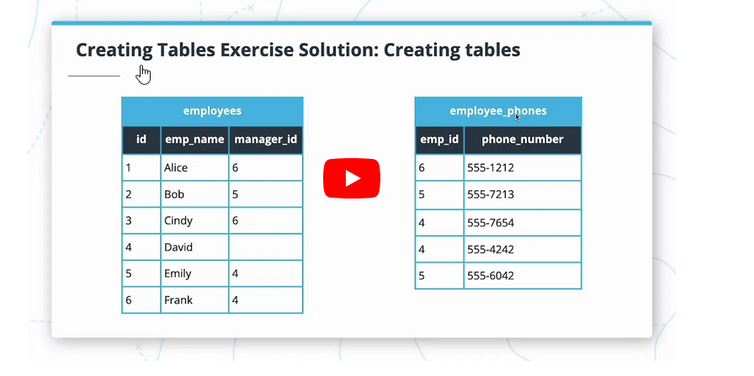

CREATE TABLE "employees" (

"id" SERIAL,

"emp_name" TEXT,

"manager_id" INTEGER

);

CREATE TABLE "employee_phones" (

"emp_id" INTEGER,

"phone_number" TEXT

);

\d “tablename” and \dt commands in postgresql

## Numeric Data Types

The first category of data types we'll be exploring are number types. Postgres offers a large variety of number types, which might seem paralyzing when deciding which to choose. In the next videos, we'll be dissecting these types, and finding out that the decision can be more straightforward than you think.

You may follow this link to find the full documentation on [Postgres Numeric Data Types](https://www.postgresql.org/docs/9.6/datatype-numeric.html).

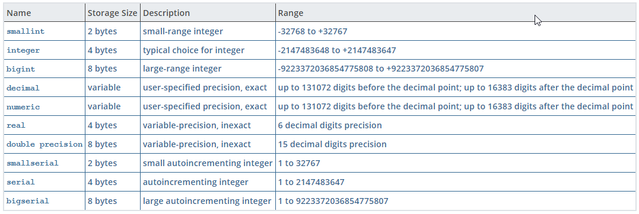

#### Numeric Data Types: Integers

Postgres offers three varieties of integers that vary only by the range of numbers they can represent:

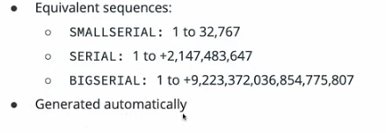

* SMALLINT: -32,768 to +32,767
* INTEGER: -2,147,483,648 to +2,147,483,647
* BIGINT: -9,223,372,036,854,775,808 to +9,223,372,036,854,775,807

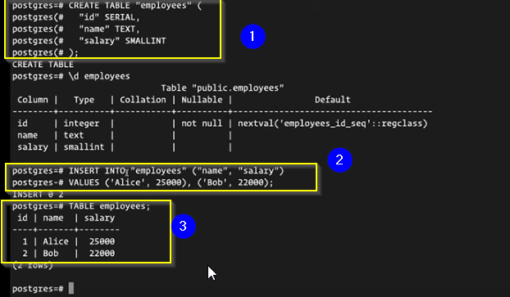

## Numeric Data Types: Decimals

What we call a decimal number in normal English numbering is in fact represented by two categories of data types in postgres: exact decimal numbers, and inexact decimal numbers.

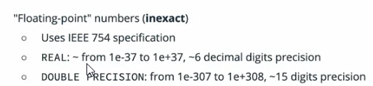

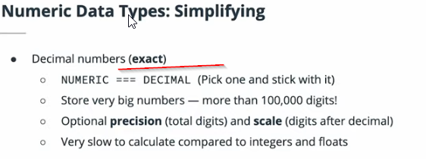

Exploring NUMERIC versus REAL

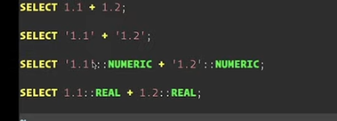

For accuracy use NUMERIC OR DECIMAL TYPE!

However, if we're trying to measure the world record for the 100 meters sprint, then we might want to have an exact decimal number. Another important field where this exactitude is required is in the world of finance: an interest rate of 2.54% versus one of 2.55% can make a significant difference after it compounds over a long period of time! For these cases, postgres offers the NUMERIC or DECIMAL type, where one can choose the scale, i.e. the number of digits required after the decimal. These numbers will be stored as-is, without any loss of precision.

# Text Data Types

1. Postgres offers two kinds of text data types: fixed-length, and variable length.
2. Variable-length data types are:
   1. VARCHAR(n) — where the limit part, (n), is optional — and
   2. TEXT, which offers no limit.
   3. Internally, they are stored in exactly the same way,
   4. So VARCHAR without limit is the same as TEXT.
   5. The VARCHAR type can also be written as CHARACTER VARYING, and it's exactly the same.
3. The fixed-length type is written CHAR(n) or CHARACTER(n). When the (n) limit part is not used, it stores only one character.
4. 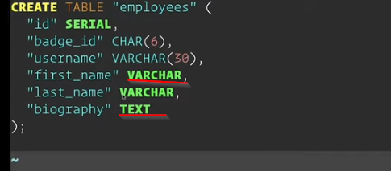
   1. you might use VARCHAR to represent something unbounded, but that would fit on a single line, and TEXT to represent large amounts of text like the contents of a book or someone's biography.

## Date/Time Data Types

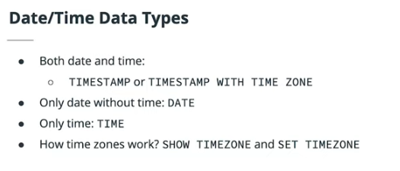

SHOW TIMEZONE; command

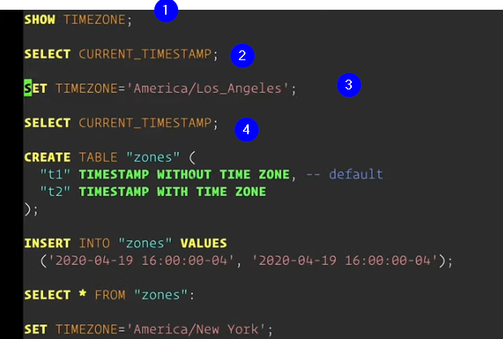

Postgresql command short cut for clearing screen is: Control L

Postgres provides the values CURRENT_DATE and CURRENT_TIMESTAMP in order to retrieve these current values. You can use these when comparing column values for a SELECT, or when inserting/updating data.

# Other Data Types

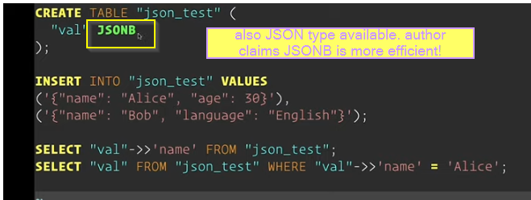

Postgres offers many data types that we won't have the time to explore in this course. Here, we've seen an example of that with the JSONB type, which allows us to store composite values inside a single column. Care should be taken when using this type in order to make sure we don't negate the benefits of normalized data.

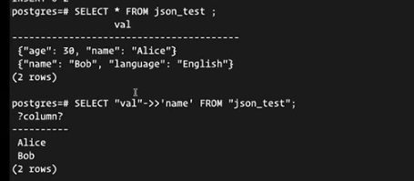

This is the complete SQL solution:

CREATE TABLE "employees" (

"id" SERIAL,

"emp_name" TEXT,

"manager_id" INTEGER

);

CREATE TABLE "employee_phones" (

"emp_id" INTEGER,

"phone_number" TEXT

);

## DML and Data Types

Click the below button to make sure the postgres service is started.

You can then use the psql command to enter the database.

**Exercise Instructions**

Create a schema that can accommodate a hotel reservation system. Your schema should have:

The ability to store customer data: first and last name, an optional phone number, and multiple email addresses.

The ability to store the hotel's rooms: the hotel has twenty floors with twenty rooms on each floor. In addition to the floor and room number, we need to store the room's livable area in square feet.

The ability to store room reservations: we need to know which guest reserved which room, and during what period.

After you create the schema, you should be able to reload the workspace schema to view the results.

Customers

customerId firstname lastname phonenumber

CREATE TABLE “customers”(

“customerId” SERIAL,

“Firstname” TEXT,

“Lastname” TEXT,

“phonenum” TEXT

);

Emails

Id customerid emailaddy

CREATE TABLE “emailAdds”

( “customerId” INTEGER,

“email” TEXT);

HotelRooms

roomId floornumber roomnumber area

CREATE TABLE "HotelRooms"

( "roomId" SERIAL,

"FloorNo" INTEGER,

"RoomNo" INTEGER,

“AreaSqFt” REAL

);

RoomReservations

Id roomid customerid startdate enddate

CREATE TABLE “RoomReservations”

( “id” SERIAL,

“roomId” INTEGER,

“customerId” INTEGER,

“startdate” DATETIME,

“enddate” DATETIME);

## Modifying Table Structure with ALTER TABLE

Once you've created a table, Postgres offers you the ability to modify its structure using ALTER TABLE. This doesn't remove your responsibility to carefully plan out your data schema! Modifying a table structure after millions of rows have been inserted could mean having to take your database or your whole application offline.

In some cases, depending on your situation in terms of volume of data and throughput, another solution might be to create a new table with the structure you need, and migrate the data to it. This solution isn't without its pitfalls either.

CREATE TABLE “usersLosers”

(“id” SERIAL,

“firstname” VARCHAR(20),

“lastname” VARCHAR(20),

“nickname” VARCHAR(10)

);

ALTER TABLE

ALTER TABLE

ALTER TABLE

ALTER TABLE ALTER TABLE ALTER TABLE ALTER TABLE ALTER TABLE

You may use ALTER TABLE with ADD COLUMN in order to bring in a new column to an already existing table.

ALTER TABLE “userslosers” ADD COLUMN “email” TEXT;

ALTER TABLE “userslosers” ADD COLUMN “zipcode” INTEGER;

You may use ALTER TABLE with ALTER COLUMN to change the data type of an existing column in your table.

ALTER TABLE “userslosers” ALTER COLUMN “firstname” SET DATA TYPE VARCHAR;

ALTER TABLE “userslosers” ALTER COLUMN “lastname” SET DATA TYPE VARCHAR;

You may use ALTER TABLE with DROP COLUMN to completely remove a column, as well as all the data that was ever stored in all rows for that column. This operation is destructive, and unless you have a database backup, the lost data is unrecoverable!

ALTER TABLE “userslosers” DROP COLUMN “nickname”;

ALTER TABLE “userslosers” DROP COLUMN “zipcode”;

UDACITY SOLUTIONS:

ALTER TABLE "students" ALTER COLUMN "email_address" SET DATA TYPE VARCHAR;

ALTER TABLE "courses" ALTER COLUMN "rating" SET DATA TYPE REAL;

ALTER TABLE "registrations" ALTER COLUMN "student_id" SET DATA TYPE INTEGER;

ALTER TABLE "registrations" ALTER COLUMN "course_id" SET DATA TYPE INTEGER;

## Other DDL Commands

Postgres offers three other DDL commands: DROP, TRUNCATE, and COMMENT.

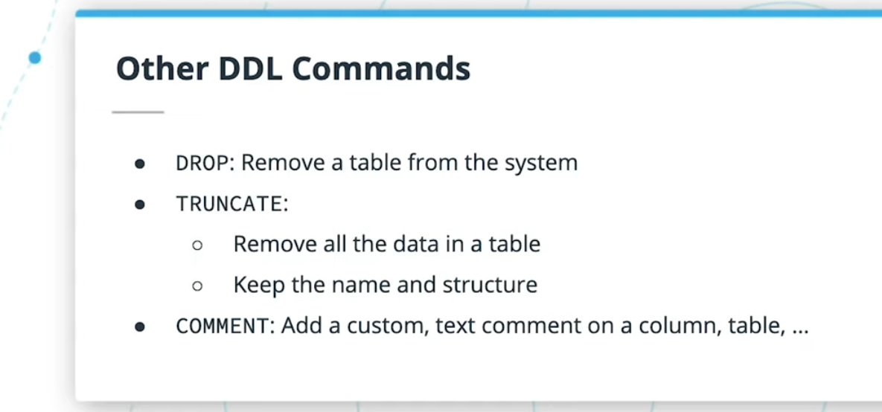

DROP TABLE will completely remove a table's structure and all associated data from the database, and is a destructive operation. Unless you have a backup, there's no way to recover the lost data!

TRUNCATE TABLE keeps the table structure intact, but removes all the data in the table. If you add the optional RESTART IDENTITY to the command, a SERIAL column's sequence will have its next value reset to 1.

Finally, the COMMENT command allows you to add a text comment on a table's column. If describing a table using \d table_name, you won't see the comments. You'd have to use \d+ in order to see the comments that were defined on a table.

## Recap of SQL DDL

• reating tables with CREATE TABLE

• Using Postgres data types to represent real-life data:

* Numbers: INTEGER, SERIAL, REAL, DOUBLE PRECISION, DECIMAL
* Characters: CHARACTER(n), CHARACTER VARYING/VARCHAR, TEXT
* Dates/Times: TIMESTAMP WITH/WITHOUT TIME ZONE, DATE, TIME

• There are many data types that we haven't touched, like Geometry, Arrays, ...

• How to change table structure using ALTER TABLE to:

* Add/remove columns
* Change the data type of a column

• Others DDL commands:

* DROP to remove a table from the database
* TRUNCATE to remove all data in a table
* COMMENT to add a text comment to a table or column

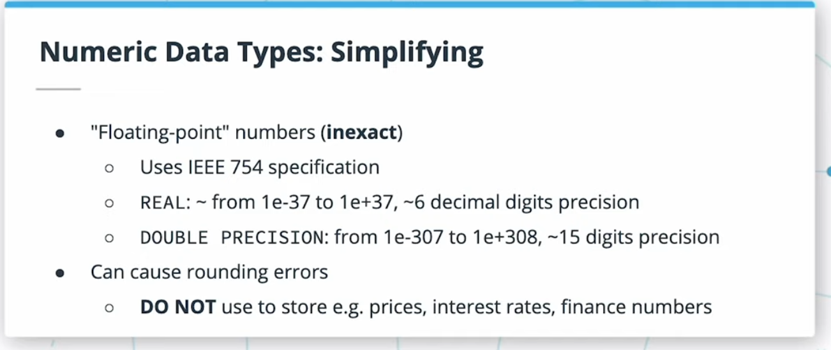

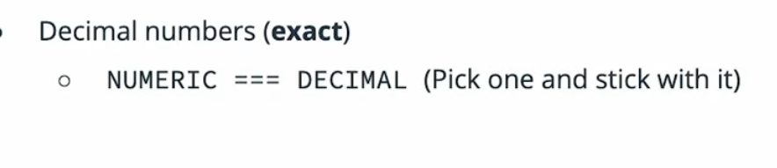

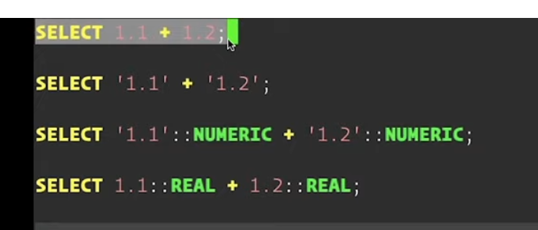

# Glossary

|  |  |
| --- | --- |
| CREATE TABLE | Allows you to create tables in Postgres. |
| INTEGER | A numeric data type that stores numbers without decimals. |
| SERIAL | A numeric data type stored as an INTEGER, but that is incremented by one automatically by Postgres each time a new row is added. |
| REAL | An inexact numeric data type, with precision to six decimal points. |
| DOUBLE PRECISION | An inexact numeric data type, with precision to 15 decimal points. |
| DECIMAL | An exact numeric data type that includes decimal values; also known as NUMERIC. |
| CHARACTER(n) | Stores text data of length (n). Anything shorter is padded. |
| VARCHAR | Stores text of varying data lengths (can be limited by an “n”). |
| TEXT | Stores much longer texts of varying data lengths. |
| TIMESTAMP | Stores data and time data. Use WITH/WITHOUT TIME ZONE to determine whether a time zone is associated with it (which Postgres updates to match the database’s time zone). |
| DATE | Stores date data. |
| TIME | Stores time data. |
| JSONB | Store more complex data in key-value pairs. |
| ALTER TABLE | Change table structure to add/remove columns or change the data type of a column. |
| DROP | Remove a table from the database |
| TRUNCATE | Remove all data in a table |
| COMMENT | Add a text comment to a table or column |

# SQL DML: Data Manipulation Language

this lesson, we'll be learning how to use the SQL DML — Data Manipulation Language — in order to add (INSERT), modify (UPDATE), and remove (DELETE) data from the database tables we now know how to create.

While manipulating data, it's often the case that we need to use functions in order to transform that data. As part of the lesson, we'll be learning about various functions that can act on strings, numbers, and dates.

## Inserting Data: Form One

Postgres commands used: dt \d movies Cntrl + l

The first form of the INSERT command we're looking at is: INSERT INTO table (column list) VALUES (first row of values), ....

Inserting values manually in a SERIAL column is perfectly fine by Postgres, since that column is in fact a simple INTEGER with a default value. Postgres won't prevent a SERIAL column from having duplicate values.

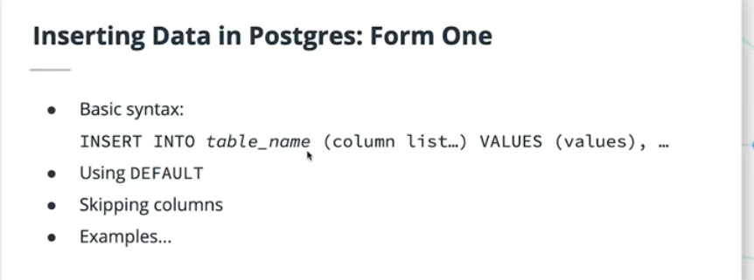

## Inserting Data: Form Two

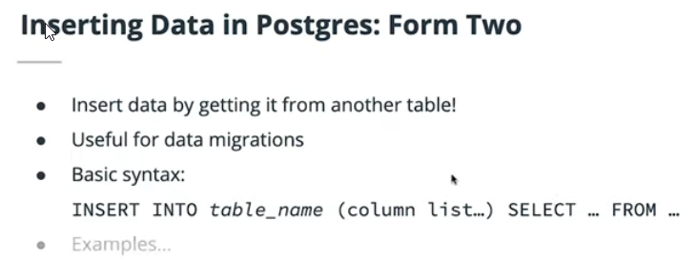

Postgres also allows a second form for inserting data, where we feed the result of a regular SELECT query to the INSERT command. This form is really useful for migrating data from one table to another while transforming it

The general way to achieve this is to first use simple SELECTs until we have the data exactly in the form that we want it, then executing a final: INSERT INTO table_name (column list in the order it's returned by the SELECT) SELECT …

EXAMPLE:

INSERT INTO "categories" ("name") SELECT DISTINCT "category" FROM "books"

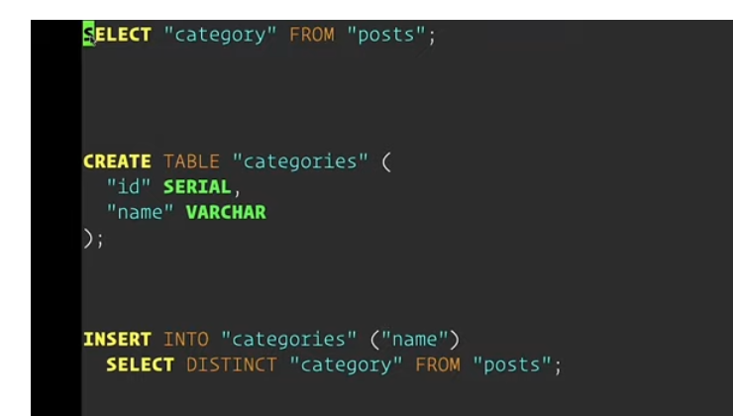

INSERT INTO table_name (column list in the order it's returned by the SELECT) SELECT

Here is a great example of such a usage: imagine a table of books with an id and title, as well as a category column that is currently in text. The same category can appear multiple times in this table, and we'd want to create a separate categories table with id and name. We can do the following:

INSERT INTO "categories" ("name") SELECT DISTINCT "category" FROM "books"

# Exercise: Inserting Data in Postgres

public | denormalized_people

public | people

public | people_emails

1. In this exercise, you'll be asked to migrate a table of denormalized data into two normalized tables.
2. The table called denormalized_people contains a list of people, but there is one problem with it: the emails column can contain multiple emails, violating one of the rules of first normal form.
3. What more, the primary key of the denormalized_people table is the combination of the first_name and last_name columns.
4. Good thing they're unique for that data set!

Task#1

In a first step, you'll have to migrate the list of people without their emails into the normalized people table, which contains an id SERIAL column in addition to first_name and last_names✔

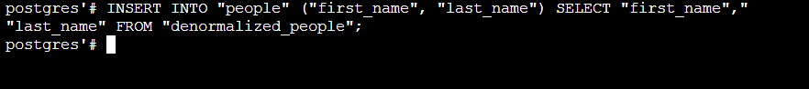

INSERT INTO “people” (“first_name”, “last_name”) SELECT “first_name”, “last_name” FROM “denormalized_people”;

Task#2

Once that is done, you'll have to craft an appropriate query to migrate the email addresses of each person to the normalized people_emails table. Note that this table has columns person_id and email, so you'll have to find a way to get the person_id corresponding to the first_name + last_name combination of the denormalized_people table.

• Hint #1: You'll need to use the Postgres regexp_split_to_table function to split up the emails

|  |  |
| --- | --- |
| 1  2  3 | SELECT number::INTEGER  FROM regexp_split_to_table('1,3,2,4,7,5,9,10', ',') AS number  ORDER BY 1; |
|  |  |

• Hint #2: You'll be using INSERT...SELECT queries to achieve the desired result

• Hint #3: If you're not certain about your INSERT query, use simple SELECTs until you have the correct output. Then, use that same SELECT inside an INSERT...SELECT query to finalize the exercise

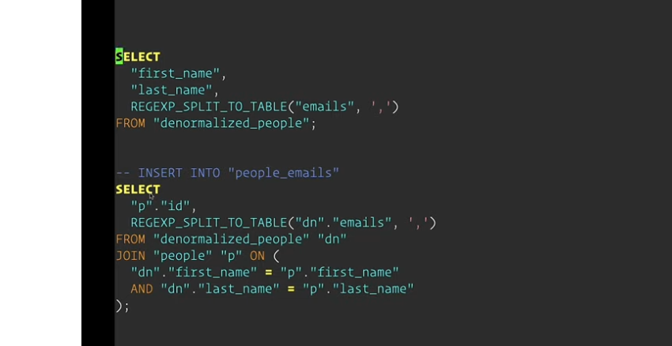

I needed help formulating using the regexp_split_to_table!

SELECT people.id, REGEXP_SPLIT_TO_TABLE(deno.emails, ',') AS email

FROM denormalized_people "deno"

JOIN people

ON ( deno.first_name = people.first_name

AND deno.last_name = people.last_name);

# Updating Data in Postgres

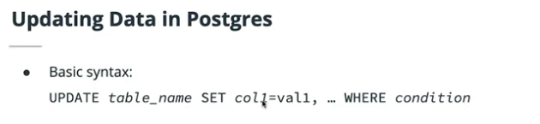

he basic syntax for updating data in a table is: UPDATE table_name SET col1=newval1, … WHERE ….

The WHERE part of the syntax is exactly the same as for a SELECT. Among other things, if you don't include a WHERE clause, you'll be updating *all* the rows in the table, which is not often what you'd want to do!

Example:

UPDATE “users” SET “mood” = ‘Low’ WHERE “happiness_level” < 33;

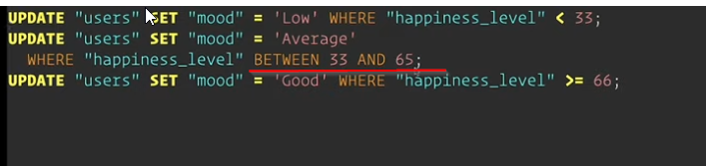

An example of setting multiple fields being updated



An example of using sub-select update?

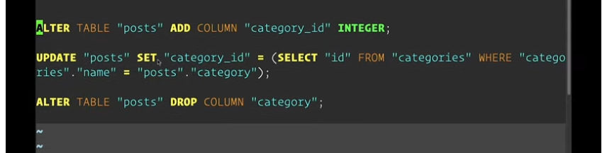

What command would you use to add 1 to the rating of all movies in the movies table?

# Exercise: Updating Data in Postgres

### Exercise Instructions

For this exercise, you're being asked to fix a people table that contains some data annoyances due to the way the data was imported:

1. All values of the last_name column are currently in upper-case. We'd like to change them from e.g. "SMITH" to "Smith". Using an UPDATE query and the right string function(s), make that happen.

postgres=# UPDATE "people" SET last_name = INITCAP(last_name);

UPDATE 100

postgres=# select * from people limit 3;

id | first_name | last_name | born_ago

----+------------+-----------+--------------------------

1 | Minerva | Burks | 57 years 5 months 7 days

2 | Carolyn | Travis | 38 years 1 month 27 days

3 | Ria | Hogan | 55 years 6 months 7 days

1. Instead of dates of birth, the table has a column born_ago, a TEXT field of the form e.g. '34 years 5 months 3 days'. We'd like to convert this to an actual date of birth. In a first step, use the appropriate DDL command to add a date_of_birth column of the appropriate data type. Then, using an UPDATE query, set the date_of_birth column to the correct value based on the value of the born_ago column. Finally, using another DDL command, remove the born_ago column from the table.

postgres=# ALTER TABLE "people" ADD COLUMN "date_of_birth" DATE;

UPDATE "people" SET "date_of_birth" =

(CURRENT_TIMESTAMP - "born_ago"::INTERVAL)::DATE;

postgres=# select * from people limit 3;

id | first_name | last_name | born_ago

----+------------+-----------+--------------------------

1 | Minerva | BURKS | 57 years 5 months 7 days

2 | Carolyn | TRAVIS | 38 years 1 month 27 days

3 | Ria | HOGAN | 55 years 6 months 7 days

## Deleting Data in Postgres

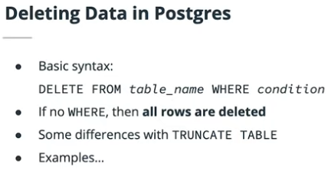

The basic syntax for deleting rows from a table is DELETE FROM table_name WHERE …

The basic syntax for deleting rows from a table is DELETE FROM table_name WHERE …

The basic syntax for deleting rows from a table is DELETE FROM table_name WHERE …

The basic syntax for deleting rows from a table is DELETE FROM table_name WHERE …

The basic syntax for deleting rows from a table is DELETE FROM table_name WHERE …

The basic syntax for deleting rows from a table is DELETE FROM table_name WHERE …

The basic syntax for deleting rows from a table is DELETE FROM table_name WHERE …

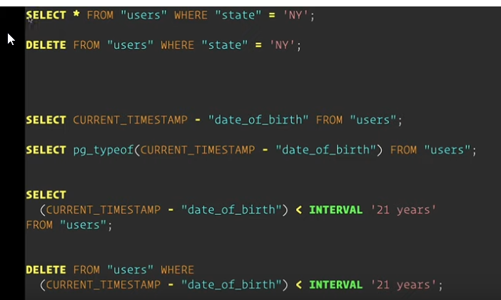

CURRENT_TIMESTAMP, CURRENT_TIMESTAMP, CURRENT_TIMESTAMP, CURRENT_TIMESTAMP

CURRENT_TIMESTAMP, CURRENT_TIMESTAMP, CURRENT_TIMESTAMP, CURRENT_TIMESTAMP

Procedure in PostgreSql that is available to query a type, is: pg_typeof(…).

That is to say: pg_typeof(), pg_typeof(), pg_typeof().

USING INTERVAL TYPECAST as a way to stringify an interval!

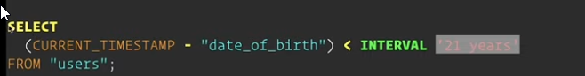

## Data Manipulation: Transactions

ACID GURANTEES

ACID GUARANTEES, ACID GUARANTEES, ACID GUARANTEES, ACID GUARANTEES, ACID GUARANTEES

• **Atomicity**: The database guarantees that a transaction will either register all the commands in a transaction, or none of them.

• **Consistency**: The database guarantees that a successful transaction will leave the data in a consistent state, one that obeys all the rules that you've setup. We've seen simple rules like limiting the number of characters in a VARCHAR column, and we'll see many more in the next lesson

• **Isolation**: The database guarantees that concurrent transactions don't "see each other" until they are committed. Committing a transaction is a command that tells the database to execute all the commands we passed to it since we started that transaction.

* **Durability**: The database guarantees that once it accepts a transaction and returns a success, the changes introduced by the transaction will be permanently stored on disk, even if the database crashes right after the success response

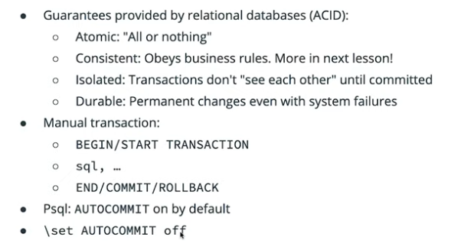

We can observe the isolation property of transactions by running two psql sessions and issuing commands with AUTOCOMMIT set to off. Doing so, we'll see that the commands executed in one session don't affect the data seen in the other session until we run COMMIT.

## Data Manipulation: Final Exercise

**Exercise Instructions**

For this exercise, you'll be given a table called user_data, and asked to make some changes to it. In order to make sure that your changes happen coherently, you're asked to turn off auto-commit, and create your own transaction around all the queries you will run.

Here are the changes you will need to make:

1. Due to some obscure privacy regulations, all users from California and New York must be removed from the data set. ✔
2. For the remaining users, we want to split up the name column into two new columns: first_name and last_name.
   1. ALTER TABLE "user_data" ADD COLUMN "first_name" VARCHAR;
   2. ALTER TABLE "user_data" ADD COLUMN "last_name" VARCHAR;
   3. How to split??
      1. INSERT INTO “people” (“first_name”, “last_name”) SELECT “first_name”, “last_name” FROM “denormalized_people”;
      2. select a[1], a[2], a[3], a[4]
      3. from (
      4. select regexp_split_to_array('a,b,c,d', ',')
      5. ) as dt(a)
3. get an array:

=========================== ANSWERS =======================

ALTER TABLE "user_data" ADD COLUMN "first_name" VARCHAR;

ALTER TABLE "user_data" ADD COLUMN "last_name" VARCHAR;

delete from user_data where state = ‘NYs';

delete from user_data where state = 'CA';

SELECT REGEXP_SPLIT_TO_ARRAY(name,E'\\s+') as splitta FROM (SELECT name FROM user_data) AS subq;

SELECT splitta[1] AS FIRST_NAME ,splitta[2] AS LAST_NAME from ((SELECT REGEXP_SPLIT_TO_ARRAY(name,E'\\s+') as splitta FROM (SELECT name FROM user_data) AS subq)) as bob;

CREATE TABLE "namesdata" (id SERIAL, "first_name" VARCHAR, "last_name" VARCHAR);

INSERT INTO "namesdata" ("first_name","last_name") SELECT splitta[1] ,splitta[2] from ((SELECT REGEXP_SPLIT_TO_ARRAY(name,E'\\s+') as splitta FROM (SELECT name FROM user_data) AS subq)) as bobo ;

UPDATE "user_data" SET "first_name" = ( SELECT namesdata.first_name from namesdata where user_data.id = namesdata.id);

UPDATE "user_data" SET "last_name" = (SELECT namesdata.last_name FROM namesdata WHERE namesdata.id = user_data.id);

INSERT INTO "states" ("state") SELECT DISTINCT user_data.state from user_data;

ALTER TABLE "user_data" ADD COLUMN "stateid" INTEGER;

UPDATE "user_data" SET "stateid" = (SELECT states.stateid from states WHERE states.state = user_data.state);

ALTER TABLE "user_data" DROP COLUMN "state";

1. Finally, we want to simplify the data by changing the state column to a state_id column.
   1. First create a states table with an automatically generated id and state abbreviation.
   2. Then, migrate all the states from the dataset to that table, taking care to not have duplicates.
   3. Once all the states are migrated and have their unique ID, add a state_id column to the user_data table.
   4. Use the appropriate query to make the state_id of the user_data column match the appropriate ID from the new states table.
   5. Remove the now redundant state column from the user_data table.

# Glossary

| **Key Term** | **Definition** |
| --- | --- |
| INSERT ... VALUES | One form of adding data into a table; used when introducing new data in a table. This data would come from an external source like an application. |
| INSERT ... SELECT | One form of adding data into a table; used when taking already existing data from a table and migrating it — most often with some modifications or clean-ups — into an already existing table. |
| UPDATE | Used to update rows of data within a given column with new values. |
| DELETE | Used to delete some portion of data from a table. |
| BEGIN | Starts a transaction. |
| COMMIT | Tells the system to attempt to complete the transaction (make the requested changes). Similar functionality is also achieved with END. |
| ROLLBACK | Tells the system to not commit any changes as part of the current transaction, discarding the changes. |
| ACID | An acronym that describes the transactional guarantees provided by a relational database. |
| Atomicity | The database guarantees that a transaction will either register all the commands in a transaction, or none of them. |
| Consistency | The database guarantees that a successful transaction will leave the data in a consistent state, one that obeys all the rules that you've setup. We've seen simple rules like limiting the number of characters in a VARCHAR column, and we'll see many more in the next lesson. |
| Isolation | The database guarantees that concurrent transactions don't "see each other" until they are committed. Committing a transaction is a command that tells the database to execute all the commands we passed to it since we started that transaction. |
| Durability | The database guarantees that once it accepts a transaction and returns a success, the changes introduced by the transaction will be permanently stored on disk, even if the database crashes right after the success response. |

# Introduction to Consistency

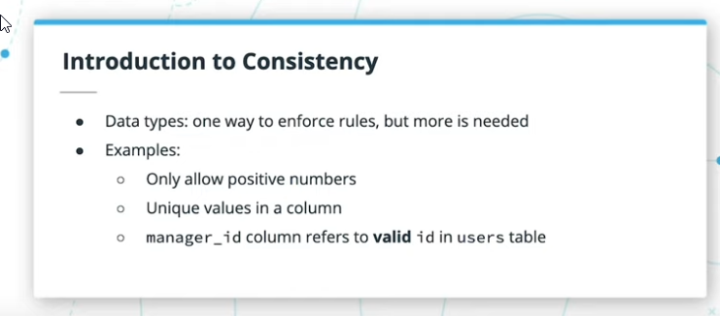

**The Big Picture on Consistency**

# Unique Constraints

ADD UNIQUE ADD UNIQUE ADD UNIQUE ADD UNIQUE

ADD CONSTRAINT ADD CONSTRAINT ADD CONSTRAINT

ADD CONSTRAINT ADD CONSTRAINT ADD CONSTRAINT

ADD CONSTRAINT

When adding a unique constraint to a table, you can choose to give it a name or not. If you don't, Postgres will automatically generate a name for the constraint. Providing your own name for the constraint is a great and simple way to document what business rule this constraint is enforcing.

GIVING NAME TO CONSTRAINT. GIVING NAME TO CONSTRAINT, GIVING NAME TO CONSTRAINT – ADD CONSTRAINT “…” ….

EXAMPLE SYNTAX FOR adding a constraint to a field within a just created table!

ALTER TABLE “Yamaha” ADD CONSTRAINT “uniquid” UNIQUE (“UUID”);

ALTER TABLE “Honda” ADD CONSTRAINT “honiduniq” UNIQUE (“honid”);

ALTER TABLE “boeingplanes” ADD CONSTRAINT “boingIdUnq” UNIQUE (“boingID”);

**ADDING CONSTRAINT THAT INVOLVES multiple fields!**

CREATE …. UNIQUE(“game_id”, “rank”);

OR ALTER …. UNIQUE(“productname”, “prodId”);

# Primary Key Constraints

A primary key constraint is a special type of unique constraint: just like a unique constraint, it enforces unique values across a column or set of columns. In addition to that, it also enforces a NOT NULL, which is another database constraint that can be used by itself to ensure that a column's values cannot be null.

In fact, a unique constraint cannot deduplicate between NULL values, because the special NULL value is not even equal to itself! This means that having a unique constraint on a column will still allow multiple rows of data to have the value NULL for that column. Sometimes, that's exactly what you need.

SERIAL IS NOT UNIQUE! SERIAL IS NOT UNIQUE! SERIAL IS NOT UNIQUE! SERIAL IS NOT UNIQUE!

User can still manipulate the SERIAL field and add “duplicate” values.

(remember TRUNCATE “tablename” – just deletes everything from that TABLES).

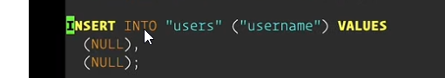

While the combination UNIQUE NOT NULL has the same effect in terms of constraints as **PRIMARY KEY**, we'll want to have a primary key constraint on most of our tables: this will be the special unique key that identifies rows in that table.

Often, a good choice is to have a so-called "surrogate key", that is, a key that is artificially generated,

PREFER TO KEEP PRIMARY KEY unique and independent of the data within the TABLE!

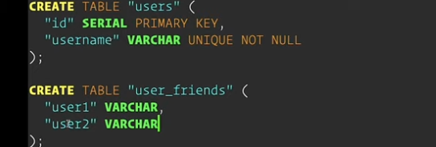

SIMPLEST WAY TO SETUP A PRIMARY KEY WITHIN A TABLE!

CREATE TABLE “bloobla” (“ID” SERIAL PRIMARY KEY, “namath” VARCHAR,…);

Either define the column as PRIMARY KEY as part of the column declaration

OR

“ADD CONSTRAINT WITHIN TABLE CREATION, using PRIMARY KEY (“SOMEiD”), …

# Exercise: Unique & Primary Key Constraints

### Exercise Instructions

For this exercise, you're going to have to explore the data schema in the Postgres workspace in order to determine which pieces of data require Unique and Primary Key constraints. Then, you'll have to execute the appropriate ALTER TABLE statements to add these constraints to the data set.

Hint: There are 6 total constraints to be added.

ALTER TABLE “boeingplanes” ADD CONSTRAINT “boingIdUnq” UNIQUE (“boingID”);

ADDING CONSTRAINT THAT INVOLVES multiple fields!

CREATE …. UNIQUE(“game_id”, “rank”);

OR ALTER …. UNIQUE(“productname”, “prodId”);

\d authors;

Table "public.authors"

Column | Type | Modifiers

---------------+-------------------+------------------------------------------------------

id | integer | not null default nextval('authors_id_seq'::regclass)

name | character varying |

email_address | character varying |

postgres-# \d book_authors;

Table "public.book_authors"

Column | Type | Modifiers

-------------------+----------+-----------

book_id | integer |

author_id | integer |

contribution_rank | smallint |

postgres-# \d books;

Table "public.books"

Column | Type | Modifiers

--------+-------------------+----------------------------------------------------

id | integer | not null default nextval('books_id_seq'::regclass)

title | character varying |

isbn | character varying |

ADDING 6 CONSTRAINTS AS REQURIED:

ALTER TABLE "books" ADD PRIMARY KEY("id"); ✔

ALTER TABLE "books" ADD CONSTRAINT "isbn_uniq" UNIQUE("isbn"); ✔

ALTER TABLE "authors" ADD PRIMARY KEY("id");✔

ALTER TABLE "book_authors" ADD CONSTRAINT "uniquebookauth" UNIQUE("book_id", "author_id");✔

ALTER TABLE "book_authors" ADD CONSTRAINT "uniqrank" UNIQUE("contribution_rank");✔

ALTER TABLE "authors" ADD CONSTRAINT "name_uniq" UNIQUE("name");👇

ALTER TABLE “authors” ADD CONSTRAINT “emailUniq” UNIQUE(“email_address”);⬆

# Foreign Key Constraints

Foreign key constraints will restrict the values in a column to only values that appear in another column.

They're often used to relate IDs in relationships between tables, thereby preserving what we call "referential integrity". In many cases, the foreign key will refer to a primary key in another table, but that is not necessary. Any column can be referenced by a foreign key constraints.

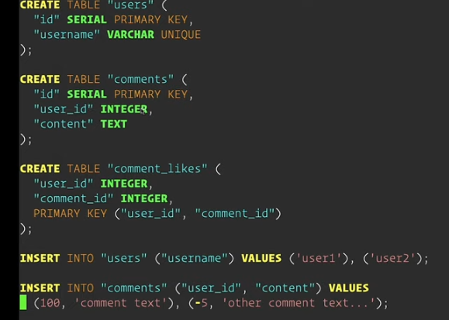

We can add foreign key constraints while creating a table, either by adding a REFERENCES clause with the column definition, or by adding a CONSTRAINT … FOREIGN KEY clause along with all the column definitions.

The basic syntax would be:

FOREIGN KEY "referencing_column"

REFERENCES "referenced_table" ("referenced_column")

TRUNCATE TABLE comments;

TWO WAYS

ALTER TABLE “comments” ADD FOREIGN KEY (“user_id”) REFERENCES “users” (“id”);

OR

ALTER TABLE “comment_likes” ADD FOREIGNT KEY (“user_id”) REFERENCES “users”;

ADDING CONSTRAINTS, USING CREATE TABLE!

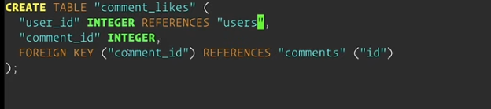

## Foreign Key Constraints: Modifiers

Once we set up a foreign key constraint, the database will enforce it from all angles.

For example, if we have a comments table with a user_id column, and insert a new comment with a valid user ID, we shouldn't be able to delete the referenced user. But what if we wanted to do that?



For example, in the comment example, our business rules might state that "if a user deletes their account, then we want to keep all their comments, but simply dissociate them from the now deleted user". In practice, we could achieve that by setting the user_id column of the comments table to NULL everywhere where the value was the now deleted user account's ID.

Adding ON DELETE CASCADE to a foreign key constraint will have the effect that when the referenced data gets deleted, the referencing rows of data will be automatically deleted as well.

USE CASCADE, USE CASCADE, USE CASCADE!

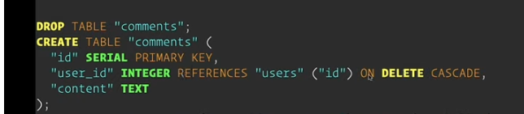

“user_id” INTEGER REFERENCES “users” (“id”) ON DELETE CASCADE

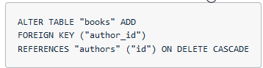

# Exercise: Foreign Key Constraints

**Exercise Instructions:** For this exercise, you're going to add some foreign key constraints to an existing schema, but you'll have to respect some business rules that were put in place:

1. As a first step, please explore the currently provided schema and understand the relationships between all the tables
2. Once that's done, please create all the foreign key constraints that are necessary to keep the referential integrity of the schema, with the following in mind:
   1. When an employee who's a manager gets deleted from the system, we want to keep all the employees that were under him/her. They simply won't have a manager assigned to them.✔
   2. We can't delete an employee as long as they have projects assigned to them✔
   3. When a project gets deleted from the system, we won't need to keep track of the people who were working on it.

Table "public.employee_projects"

employee_id | integer | not null

project_id | integer | not null

Indexes:

"employee_projects_pkey" PRIMARY KEY, btree (employee_id, project_id)

Table "public.employees"

id | integer | not null default nextval('employees_id_seq'::regclass)

name | character varying |

manager_id | integer |

Indexes:

"employees_pkey" PRIMARY KEY, btree (id)

Table "public.projects"

id | integer | not null default nextval('projects_id_seq'::regclass)

name | character varying |

Indexes:

"projects_pkey" PRIMARY KEY, btree (id)

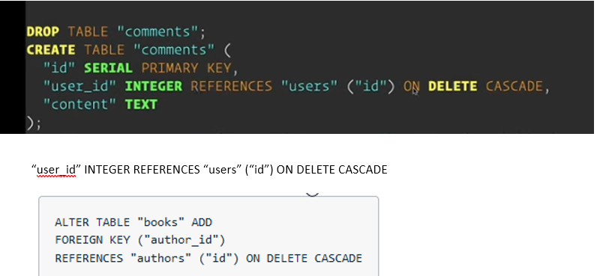

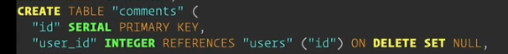

**ON DELETE RESTRICT**

ALTER TABLE "employees" ADD FOREIGN KEY ("manager_id") REFERENCES "employees" ON DELETE SET NULL;✔

ALTER TABLE "employee_projects" ADD FOREIGN KEY ("employee_id") REFERENCES "employees" ON DELETE RESTRICT;✔

ALTER TABLE "employee_projects" ADD CONSTRAINT “valid_emp” FOREIGN KEY ("employee_id") REFERENCES "employees" ON DELETE RESTRICT;

ALTER TABLE "employee_projects" ADD FOREIGN KEY ("project_id") REFERENCES "projects" ON DELETE CASCADE;✔

ALTER TABLE "employee_projects" ADD CONSTRAINT “valid_proj” FOREIGN KEY ("project_id") REFERENCES "projects" ON DELETE CASCADE;

# Check Constraints

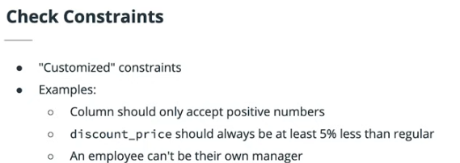

CHECK constraints allow us to implement custom business rules at the level of the database. Examples of such rules would be: "a product can't have a negative quantity" or "the discount price should always be less than the regular price".

Check check check checl check

CHECK(…) CHECK (…) CHECK (…)

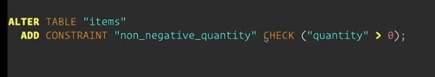

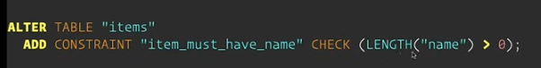

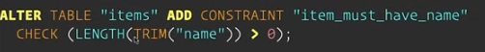

ALTER TABLE “tycos” ADD CONSTRAINT “nonzerochk” CHECK (“dollah > 0);

A CHECK constraint can be added either after a table was created, or during table creation. Like all other constraints, it can be added along with the column definition, or along with all the column definitions.

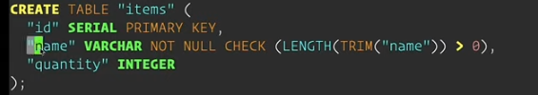

## Check Constraints Hard Quiz

Given a table users with a date_of_birth column of type DATE, write the SQL to add a requirement for users to be at least 18 years old.

ALTER TABLE "users" ADD CONSTRAINT "ATLEAST18" CHECK( CURRENT_DATE - date_of_birth) > = INTERVAL '18 years');

# Exercise: Final Review

**Exercise Instructions**

In this exercise, you're going to manage a database schema that contains no constraints, allowing you to practice all the concepts that you learned in this lesson!

After exploring the schema, this is what you'll have to identify the following for each table, and add the appropriate constraints for them:

1. Identify the primary key for each table
   * ALTER TABLE "books" ADD CONSTRAINT "primekey" PRIMARY KEY (“id”);
   * ALTER TABLE "user_book_preferences" ADD CONSTRAINT "primekey2" PRIMARY KEY ("user_id", "book_id");
   * ALTER TABLE "users" ADD CONSTRAINT "primekey3" PRIMARY KEY ("id");
2. Identify the unique constraints necessary for each table
   * ALTER TABLE "books" ADD CONSTRAINT "uniqISBN" UNIQUE("isbn");
   * ALTER TABLE "user_book_preferences" ADD CONSTRAINT "uniqpair" UNIQUE("user_id", "book_id");
   * ALTER TABLE "users" ADD CONSTRAINT "uniqEMAIL" UNIQUE("email");
3. Identify the foreign key constraints necessary for each table
   * ALTER TABLE "user_book_preferences" ADD CONSTRAINT "foreignuser" FOREIGN KEY ("user_id") REFERENCES "users";
4. In addition to the three types of constraints above, you'll have to implement some custom business rules:
   * + 1. Usernames need to have a minimum of 5 characters
          1. ALTER TABLE "users" ADD CONSTRAINT "namelength5" CHECK(LENGTH(TRIM("username")) >= 5);
       2. A book's name cannot be empty
          1. ALTER TABLE "books" ADD CONSTRAINT "booknamelen" CHECK(LENGTH(TRIM("name")) > 0);
       3. A book's name must start with a capital letter
          1. 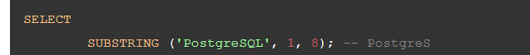
          2. ALTER TABLE "books" ADD CONSTRAINT "booknamCaps" CHECK(ascii(SUBSTRING("name",1,1)) BETWEEN 97 AND 122 );
          3. 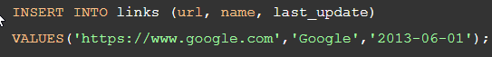
          4. ALTER TABLE "books" ADD CONSTRAINT "booknCaps2" CHECK(SUBSTRING("name",1,1) = UPPER(SUBSTRING("name",1,1)) );
       4. A user's book preferences have to be distinct
          1. ALTER TABLE "user_book_preferences" ADD CONSTRAINT "UNQPREF" UNIQUE("preference");

ALTER TABLE distributors DROP CONSTRAINT zipchk RESTRICT;

## Tables:

books

id | integer | not null default nextval('books_id_seq'::regclass)

isbn | character varying |

name | character varying |

user_books_preferences

user_id | integer |

book_id | integer |

preference | integer |

users

id | integer | not null default nextval('users_id_seq'::regclass)

username | character varying |

email | character varying |

o ALTER TABLE "user_book_preferences" ADD CONSTRAINT "foreignuser" FOREIGN KEY ("user_id") REFERENCES "users";

(a) ALTER TABLE "users" ADD CONSTRAINT "namelength5" CHECK(LENGTH(TRIM("username")) >= 5);

(a) ALTER TABLE "books" ADD CONSTRAINT "booknamelen" CHECK(LENGTH(TRIM("name")) > 0);

(b) ALTER TABLE "books" ADD CONSTRAINT "booknamCaps" CHECK(ascii(SUBSTRING("name",1,1)) BETWEEN 97 AND 122 );

(d) ALTER TABLE "books" ADD CONSTRAINT "booknCaps2" CHECK(SUBSTRING("name",1,1) = UPPER(SUBSTRING("name",1,1)) );

(a) ALTER TABLE "user_book_preferences" ADD CONSTRAINT "UNQPREF" UNIQUE("preference");

**ALTER TABLE "users" ADD CONSTRAINT "ATLEAST18" CHECK( CURRENT_DATE - date_of_birth) > = INTERVAL '18 years');**

**ALTER TABLE "users" ADD CONSTRAINT "ATLEAST18" CHECK( CURRENT_DATE - date_of_birth) > = INTERVAL '18 years');s**

**ALTER TABLE "users" ADD CONSTRAINT "ATLEAST18" CHECK( CURRENT_DATE - date_of_birth) > = INTERVAL '18 years');**

# Glossary FOR LESSON 5: Consistency with Constraints

|  |  |
| --- | --- |
| Constraint | A rule that can be added at the table or column level to restrict insertion and updates of data based on business rules. |
| Unique Constraint | Ensures that a column or set of columns are unique across all the rows of the table. |
| Primary Key Constraint | Like a unique constraint, it enforces unique values across a column or set of columns. In addition to that, it also enforces a NOT NULL, which is another database constraint that can be used by itself to ensure that a column's values cannot be null. Lastly, there can only be one of these for a given table. |
| Surrogate Key | A primary key that is composed of a value not present in the business data, an artificial value created only for the purpose of uniquely identifying the rest of the data. It is not exposed to users of the system. |
| Natural key | When a primary key is composed of a value that is present in the business data and exposed to users of the system. |
| Foreign Key Constraint | Restricts the values in a column to only values that appear in another column. They're often used to relate IDs in relationships between tables, thereby preserving what we call "referential integrity". In many cases, the foreign key will refer to a primary key in another table, but that is not necessary. Any column can be referenced by a foreign key constraint. |
| Referential Integrity | The property of columns referencing other entities to be consistent and valid, only referring to existing data. |
| ON DELETE CASCADE | When the referenced data gets deleted, the referencing rows of data will be automatically deleted as well. |
| ON DELETE SET NULL | When the referenced data gets deleted, the referring column will have its value set to NULL. Since NULL is a special value, it won't break the foreign key constraint because it will be clear that the row of data is now referencing absolutely nothing. |
| Check Constraint | Allows one to implement custom business rules at the level of the database, such as "a product can't have a negative quantity". |

# LESSON 6: PERFORMANCE WITH INDICES

# Introduction to Indexing

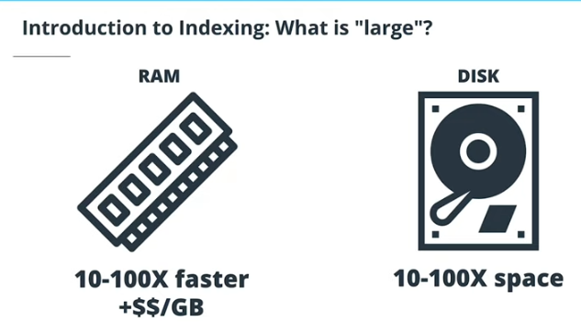

## Creating an Index

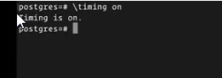

\psql

\dt

\d <table name>

\timing on \timing on \timing on \timing on

For lessons and analysis on timing and performance.

SELECT * ….. WHERE … = …;

EXAMPLE OF CREATING AN INDEX WITHIN A TABLE!

CREATE INDEX ON “table” (“drum_name”);

CREATE INDEX ON “airplanes” (“airline”);

CREATE INDEX ON “plants” (“continent”);

CREATE INDEX ON “cars” (“mfgcompany”);

Using the timing functionality, we saw that adding an index on the last_name column of our phonebook table with one million entries, using the syntax CREATE INDEX ON table_name (column_name) cut down the time it took to run a WHERE last_name= query by a factor of 20x for this particular data set and computer.

INDEXING ON A REGEX

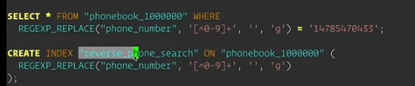

While learning this, we took a look at the Postgres REGEXP_REPLACE function, which is part of the extensive library of [Postgres String function](https://www.postgresql.org/docs/9.6/functions-string.html)

One place where expression indexes are really useful is to allow for case-insensitive searches, while still storing the capitalized version of the data. These searches would be done using a WHERE LOWER(word_column) = 'lowercase input', and speeding them up can be done by creating an expression index with the LOWER function.

TWO SYNTAXs to do INDICES!

CREATE INDEX ON “table” (“knowncolumn”);

CREATE INDEX “indexlable” ON “table” expression;

CANCELLING AN INDEX is done by using

DROP INDEX “index name”;

# Multi-Column Indexes

Indexes can span multiple columns, and the order of those columns will determine which queries can be supported by the composite (multiple-column) index

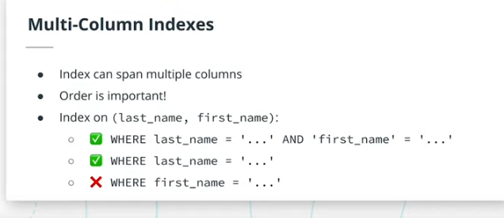

EXAMPLE OF MULT-COLUMN INDEX CREATION!

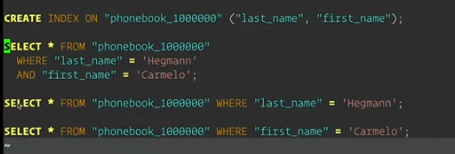

Thinking back to the phonebook example, the way the phonebook is setup allows you to answer the following queries:

1. Find all the Smiths
2. Find all the Smiths whose first name is John

The phonebook won't allow you to easily answer the query "Find all the Johns" though. This is because the phonebook is organized, or indexed, by last name, *then* by first name.

## Unique Indexes

# Exercise: Indexing

The tables books, authors, and book_authors have had their columns setup, but no constraints nor indexes have been added.

Given the business requirements below, add the necessary constraints and indexes to support each use-case:

1. We need to be able to quickly find books and authors by their IDs.
   * \d authors
   * Table "public.authors"
   * Column | Type | Modifiers
   * --------+-------------------+------------------------------------------------------
   * id | integer | not null default nextval('authors_id_seq'::regclass)
   * name | character varying |
   1. CREATE INDEX "indexbyId" ON "authors" ("id");
2. We need to be able to quickly tell which books an author has written
   1. ALTER TABLE "authors" ADD PRIMARY KEY ("id");
   2. ALTER TABLE "books" ADD FOREIGN KEY ("author_id") REFERENCES "authors";
   3. ALTER TABLE "books" ADD PRIMARY KEY ("id");
   4. CREATE INDEX "indexBooksbyauthid" ON "books" ("author_id");
3. We need to be able to quickly find a book by its ISBN #.
   1. CREATE INDEX "booksbyisbn" ON "books" ("isbn");
4. We need to be able to quickly search for books by their titles in a case-insensitive way, even if the title is partial. For example, searching for "the" should return "The Lord of the Rings".
   1. CREATE INDEX "find_books_by_partial_title" ON "books" (
   2. LOWER("title") VARCHAR_PATTERN_OPS
   3. );
5. For a given book, we need to be able to quickly find all the topics associated to it.
6. For a given topic, we need to be able to quickly find all the books tagged with it.
   1. ALTER TABLE "topics" ADD PRIMARY KEY ("id");
   2. ALTER TABLE "book_topics" ADD FOREIGN KEY ("book_id") REFERENCES "books";
   3. ALTER TABLE "book_topics" ADD FOREIGN KEY ("topic_id") REFERENCES "topics";
   4. CREATE INDEX "topiclookup" ON "book_topics" ("topic_id");
   5. SELECT * FROM “books” JOIN “b

## Verifying Index Usage with EXPLAIN: Part I

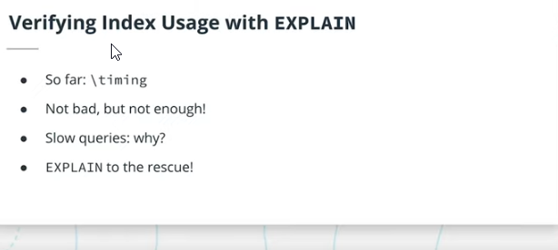

The Postgres command line's timing feature is a poor debugging tool. At best, it can tell you that one of your queries is slow. But why is it slow? Postgres' EXPLAIN command can give you all that information.

Adding EXPLAIN to the beginning of a query -- most often a SELECT query -- will not execute the query. Instead, it will show you the *query plan*, i.e. what Postgres would do if you were to execute that query.

EXPLAIN SELECT * FROM “someTable” WHERE “last_name” = “babaYagga”;

The first thing that EXPLAIN showed us is that when a table has no indexes and we execute a query on it, Postgres executes a sequential scan of the table to return the results: much like searching the phonebook for "John", Postgres goes through every row of data, filters it against any WHERE condition in the query, and adds it to the returned data set.

After adding an index to our table with one million records, we observe a different result of EXPLAIN after running a query with a WHERE clause on last_name: Postgres is executing a bitmap index scan, followed by a bitmap heap scan.

EXPLAIN can also show us a really interesting and important behaviour: simply having an index on a column of a table does NOT mean that Postgres will use that index when executing a query with a WHERE condition on the indexed column.

Indeed, the Postgres query planner will choose the query plan it thinks is the fastest, based not only on the query and available indexes, but also on statistics that Postgres keeps about every table. Postgres keeps track of the approximate number of rows, as well as the distribution of the values in those rows and the most frequent values. This information is updated on a regular basis by Postgres as data gets manipulated.

# Verifying Index Usage with EXPLAIN: Part II

The ANALYZE command can be used to force Postgres to update its statistics about a table.

ANALYZE “sometabla”;

ANALYZE “tablemountain”;

ANALYZE “zootable”;

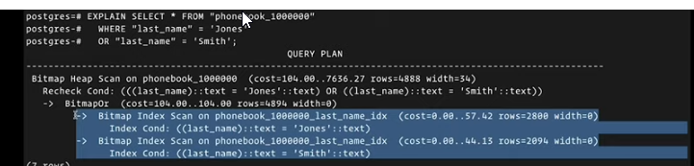

<https://www.postgresql.org/docs/9.6/sql-explain.html>

# Using EXPLAIN ANALYZE

If EXPLAIN isn't giving you the information you need, then EXPLAIN ANALYZE might

The structure of the output of EXPLAIN ANALYZE is really similar to EXPLAIN: we still have the query plan represented as a tree structure, but now Postgres has executed the query too.

This means that along with the cost estimates, we also get the real values. cost becomes actual time, and is a measurement in milliseconds.

The number of rows is also the real value. If these are too high or too low compared to the estimated values, it might hint to something wrong with the query planner, and that would have to be investigated on a case-by-case basis.

# Indexing Exercise 2: Indexes + Explain

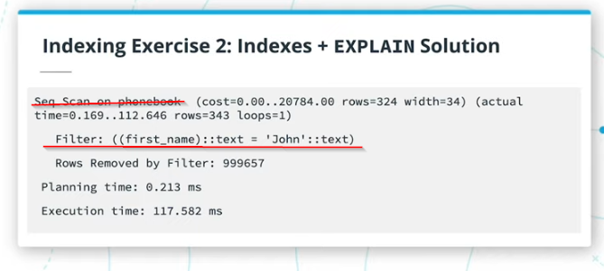

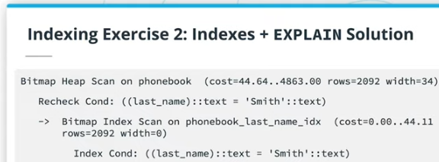

The tree structure tells us that this query plan contains two nodes that will happen sequentially. The fact that we see a bitmap index scan instead of a regular index scan can hint that this query is going to return more than "just a few rows" when compared to the total number of rows in that table. Otherwise, we might have expected Postgres to use an index scan. Note that these are my assumptions about the output, and since we're lacking a lot of information about the context of these outputs, you might not have drawn the same conclusions.

# Edge Case: Adding Too Many Indexes

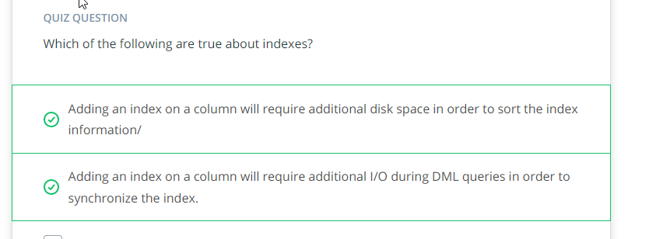

# Exercise: Creating a Complete Schema:

1. A movie has a title and a description, and zero or more categories associated to it.✔👋
2. A category is just a name, but that name has to be unique✔👋
3. Users can register to the system to rate movies: ✔👋
   1. A user's username has to be unique in a case-insensitive way. For instance, if a user registers with the username "Bob", then nobody can register with "bob" nor "BOB" ✔👋
   2. A user can only rate a movie once, and the rating is an integer between 0 and 100, inclusive✔👋
   3. In addition to rating movies, users can also "like" categories. ✔👋
4. The following queries need to execute quickly and efficiently. The database will contain ~6 million movies:
   1. Finding a movie by partially searching its name✔👋
   2. Finding a user by their username✔👋
   3. For a given user, find all the categories they like and movies they rated✔👋
   4. For a given movie, find all the users who rated it✔👋
   5. For a given category, find all the users who like it

*NOTE*: Unless you populate your database with millions of rows of realistic data, you won't be able to use EXPLAIN for this exercise.

#### Tables:

* 1. Movies
     + Id (primary key)
     + Title
     + Description
  2. Categories
     + Id (primary key)
     + name (UNIQUE)
  3. movie_category
     + id
     + movie_id (FOREIGN KEY)
     + catgegory_id (FOREIGN KEY)
  4. Users
     + Id (primary key)
     + name (UNIQUE(LOWERCASE(VARCHAR))
     + email (UNIQUE( (VARCHAR))
  5. movie_user
     + movie_id (FOREIGN KEY)
     + user_id (FOREIGN KEY)
     + rating (0 through 100)
  6. user_category
     + user_id
     + category_id
     + like boolean
  7. CREATING INDICES FOR 6 million movies RDBMS!
     + CREATE INDEX “moviesname” ON “movies” (“decscription”);

# [Case insensitive UNIQUE constraints in Postgres](http://shuber.io/case-insensitive-unique-constraints-in-postgres/)

<http://shuber.io/case-insensitive-unique-constraints-in-postgres/>

ALTER TABLE users ADD CONSTRAINT email_unique UNIQUE (LOWER(email));

ALTER TABLE “movies” ADD CONSTRAINT “usernameunq” UNIQUE(LOWER(username));

<https://www.postgresqltutorial.com/postgresql-create-table/>

CREATE TABLE accounts (

user_id serial PRIMARY KEY,

username VARCHAR ( 50 ) UNIQUE NOT NULL,

password VARCHAR ( 50 ) NOT NULL,

email VARCHAR ( 255 ) UNIQUE NOT NULL,

created_on TIMESTAMP NOT NULL,

last_login TIMESTAMP

);

CONSTRAINT fk_customer

FOREIGN KEY(customer_id)

REFERENCES customers(customer_id)

ON DELETE CASCADE

INSERT INTO table_name(column1, column2, …)

VALUES (value1, value2, …);

INSERT INTO links (url, name)

VALUES('https://www.postgresqltutorial.com','PostgreSQL Tutorial');

**CONSTRAINT valid_discount** CHECK (price > discounted_price)

## ========================================================================

## SCRATCH PAD JULY 11 2021

CREATE TABLE "movies" (

id SERIAL PRIMARY KEY,

title VARCHAR,

description VARCHAR

);⭐

CREATE TABLE "categories"

(

id SERIAL PRIMARY KEY,

name VARCHAR UNIQUE NOT NULL

); ⭐

CREATE TABLE "movie_categories"

(

~~id SERIAL PRIMARY KEY,~~

movie_id INTEGER REFERENCES movies,

category_id INTEGER,

CONSTRAINT "fkcategory"

FOREIGN KEY (category_id) REFERENCES "categories" ON DELETE CASCADE,

PRIMARY KEY (“movie_id”, “category_id”);

); ⭐

CREATE TABLE "users"

(

id SERIAL PRIMARY KEY,

name VARCHAR UNIQUE NOT NULL,

email VARCHAR UNIQUE NOT NULL,

); ⭐

CREATE TABLE "movie_user"

(

movie_id INTEGER,

user_id INTEGER,

rating INTEGER,

CONSTRAINT "ratingrange" CHECK (rating >= 0 AND rating <= 100),

FOREIGN KEY (movie_id) REFERENCES movies ON DELETE CASCADE,

FOREIGN KEY (user_id) REFERENCES "users" ON DELETE SET NULL

); ⭐

CREATE TABLE "user_category"

(

user_id INTEGER,

category_id INTEGER,

userlikes BOOLEAN,

FOREIGN KEY (user_id) REFERENCES "users" ON DELETE CASCADE,

FOREIGN KEY (category_id) REFERENCES "categories" ON DELETE CASCADE

); ⭐

SELECT categories.name

FROM user_category

INNER JOIN users ON users.id = user_category.user_id AND user_category.userlikes = true

INNER JOIN categories ON user_category.category_id = categories.id;

SELECT movies.title

FROM users

INNER JOIN movie_user ON users.id = movie_user.user_id

INNER JOIN movies ON movie_user.movie_id = movies.id;

SELECT users.name

FROM users

INNER JOIN movie_user ON users.id = movie_user.user_id

INNER JOIN movies ON movie_user.movie_id = movies.id;

SELECT users.name

FROM users

INNER JOIN user_category ON users.id = user_category.user_id

INNER JOIN movie_categories ON user_category.category_id = movie_categories.id;

# Glossary

| **Key Term** | **Definition** |
| --- | --- |
| Index | A data structure stored on disk and targeting one or more columns of a table. Due to the way it's sorted, an index can make it fast to find rows in a table when filtering on the target column(s). |
| Composite Index | An index that targets multiple columns. The order in which the columns are specified matters. |
| Sequential Scan | A database operation where every row of a table is visited in order to fulfill a particular query. |
| Query Planner | The part of Postgres that looks at a query to be executed, table statistics, and available resources to decide on a Query Plan. |
| Query Plan | The ordered series of steps that Postgres will follow in order to fulfill a query. |
| Query Plan Cost | A unitless measure of how much effort and resources will be required in order to fulfill a query. Only comparable to itself for a given query after making some changes to data and/or indexes. |
| Query Plan Node | A unit of work in a query plan, i.e. one of the steps required to fulfill a query. |

# INTRO TO NON-RELATIONAL DATABASE

## Relational vs. Non-Relational: Big Picture



## Overview: MongoDB and Redis

In this lesson, we'll be exploring two completely different non-relational databases: MongoDB and Redis. This will give us a taste for how varied the world of NoSQL is compared to that of relational databases.

First, we'll take a look at MongoDB, a document-oriented, schemaless NoSQL database that can scale horizontally.

Redis, a fast, in-memory key-value store that runs on a single machine. Redis is like the swiss-army knife of databases with its varied data types and operations, and is only limited by the amount of RAM available on a system.

# MongoDB: Getting Started

The first NoSQL database I'll be showing you is MongoDB - friends call it simply Mongo! As we previously mentioned, Mongo is a schema-less document store.

This means you don't need to create a schema or structure, you can simply start adding new documents to collections.

1. MongoDB has documents that go into collections!
2. MongoDB is schemaless.
3. ACID transactions: document level.
4. Mongo loves denormalization
5. Mongo can contain composite data
6. Documents can be nested within documents.

Mongo provides ACID transactions, but only at the single document level, up until recent - 4.2+ - versions.

Among other things that make it different from relational databases is that Mongo loves denormalized data.

What is a document?????

1. The so-called "documents" are stored in a format called BSON, which stands for binary JSON.
2. This is a format that expands on the popular JSON data-interchange format to make it more efficient for storage, and add more data types to it such as dates.
3. A BSON document is a series of fields which have values.
4. A field/value pair can be thought of as a single cell in a database table, a specific row/column combination.

Mongo shell is used within this course!

In terms of mongodb, we don’t really have a query language!

In the mongo shell, we write the code in javascript.

Demo of MongoDB Shell, using javascript language for scripting!

Global variable representing database is db.

Example of a db present is “test”.

>use example

>dn

example

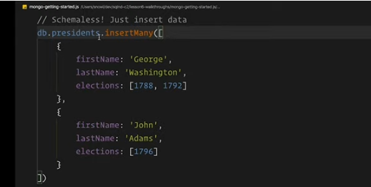

Every “object” in javascript world is a document!

db.presidents.find({})

db.presidents.find({}).pretty()

above example statement shows chaining functions!

## MongoDB: Basic Queries

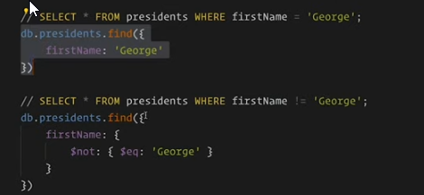

>>db.presidents.find(

{

Firstname: ‘George’

})

>>db.cars.find({

Modelname:{

$not: { $eq: ‘Ferrrari’}

}

})

‘Doing an OR requires a bit more gymnastics, using the $or operator and passing it an array of the things we want to "or":

{

"$or": [

{ "lastName": "Smith" },

{ "lastName": "Washington" }

]

}

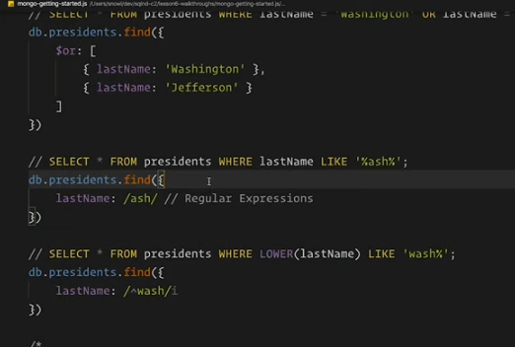

s. A SQL partial match — LIKE '%word%' — can be achieved using regular expressions. While this can be the topic of a lesson within itself, we cover the basics here:

1. WHERE "col" LIKE 'begin%' becomes { col: /^begin/ }
2. WHERE "col" LIKE '%middle%' becomes { col: /middle/ }
3. WHERE "col" LIKE 'end%' becomes { col: /end$/ }
4. WHERE LOWER("col") LIKE '%case insensitive%' becomes { col: /case insensitive/i } (note the i after the closing /)

## MongoDB: Further Data Manipulation

>db.comments.insertMany([

{ },

{},

{}

])

Different document can have different fields! Even within the same document!

>db.cars.find({ ‘model.vinumberpresen’ : true})

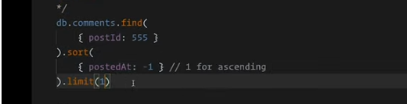

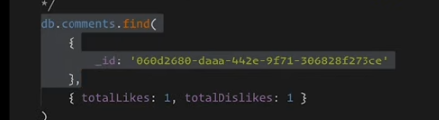d

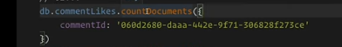

## Exercise Instructions

Connect to the MongoDB workspace [here](https://katacoda.com/ziad-saab/scenarios/querying-mongo). The test database will be preloaded with an events collection. First start by exploring the data in the collection. Then, write the appropriate queries to retrieve the following:

1. The total number of events in the collection
   1. db.events.countDocuments({})✔
2. The total number of events for the device with ID 8f5844d2-7ab3-478e-8ea7-4ea05ab9052e
   1. db.events.countDocuments({ deviceId: '8f5844d2-7ab3-478e-8ea7-4ea05ab9052e'}) ✔
   2. 240
3. The total number of events that came from a Firefox browser and happened on or after April 20th, 2019
   1. db.orders.countDocuments( { ord_dt: { $gt: new Date('01/01/2012') } }, { limit: 100 } )
   2. db.events.find({"browser.vendor": "firefox"}) ✔limi

db.events.countDocuments({"browser.vendor": "firefox", timestamp : {$gte: ISODate("2019-04-20T00:00:00.000Z")})

db.events.countDocuments({

'browser.vendor': 'firefox',

timestamp: { $gte: ISODate('2019-04-20') }

})

1. The list of the top 100 events that happened in Chrome on Windows, sorted in reverse chronological order

db.events.find( { "browser.vendor" : "chrome"}).limit(15).sort({ timestamp: -1})

You may need to research some additional MongoDB functions!

If you want to keep your answers to the exercise afterwards, we suggest saving them down locally into a text file or other similar file.

Db

## Sort

We can sort the results using the sort operator, like so:

db.spiders.find().sort({hairiness: 1})

This will sort the spiders in ascending order of hairiness. You can reverse the sort by passing -1.

db.spiders.find().sort({hairiness: -1})

## MongoDB: Basic Design Patterns

The document model is richer than a database table's row of discrete values, and the ACID guarantees provided at the document level suggest that documents should be at least somewhat denormalized, as well as contain potentially duplicative data. Moreover, the 16MB limit on documents means we can store a ton of information in a single one. This is all tied together by a recommendation from the MongoDB team, which goes against what we learned about normalized data in relational databases: "store data in the same way that it's going to be accessed".

In this video we looked at the polymorphism pattern.

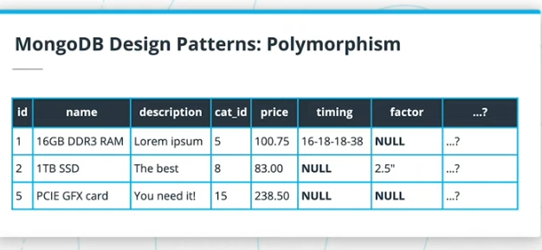

a single collection is being used to store a class of items that can have marked differences, such as computer hardware, storing this in a relational database table could end up generating lots of NULLs for every column that doesn't apply for a certain row.

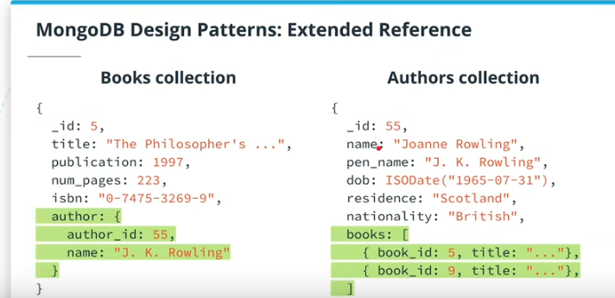

In Mongo, we can choose to do things differently with the extended reference pattern. The "reference" part simply means that we still need each book in the books collection to have a reference to the author who wrote it. But contrary to a normalized relational database schema, we can allow ourselves to duplicate some data from the authors collection as well, in an embedded document! Instead of duplicating the whole author information, we would simply duplicate that which is necessary for displaying a book in an eventual web view.

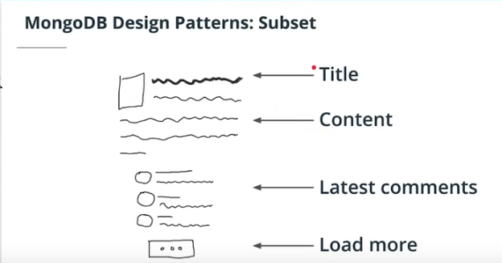

The subset pattern also flows from the recommendation to store data in the way it's going to be accessed, and also concerns two seemingly disparate collections. In the example, we looked at blog posts and comments, which, it can be argued, should go in separate posts and comments collections. Again in a relational database, the comments table would contain a post_id field linking the comment to the post for which it was made.

In Mongo, however, we can allow ourselves to split up the comments, based on our usage pattern: if a blog post page only displays the ten latest comments with a button to see more, we can decide to store this *subset* of the latest comments in the same document as the blog post! When a new comment gets inserted, we can add it at the top of the latestComments field of our blog post, and trim the last one from the bottom, then add it to the separate comments collection.

If our usage pattern is such that most users don't bother looking at comments, or only look at the latest few comments, then we can display a blog post page by only retrieving one single blog post document from the posts collection. Only for those few users who will want to dig deeper, will we then need to do separate requests for more comments. Again, this will save us from having to do expensive JOINs most of the time.

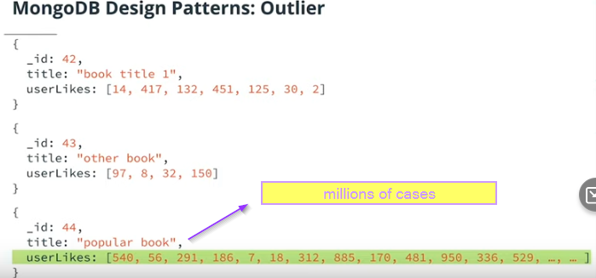

The outlier pattern is meant for when a small minority of documents in a collection -- the outliers -- would prevent the collection from working in its currently designed schema, e.g. due to the 16MB document limit. In the video, we looked at a book review site example. Where 99% or more of the books might have an acceptable number of "likes" that could simply be stored in an array in the book document, once in a blue moon comes a book so popular, that storing all its "likes" would go over the practical limits of an array in a single document.

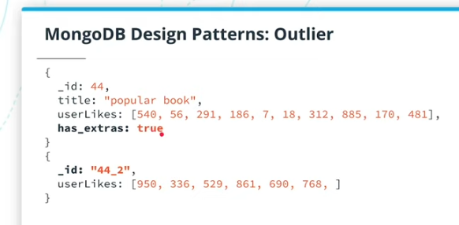

# Redis by Example

In the next few videos, we're going to be exploring Redis, a fast, in-memory key-value store. Storing values under string keys sounds deceptively simplistic, until you discover the wide variety of value types that are available in Redis! We're only going to explore a few, and while there's much more to Redis than we'll be able to cover, we'll also end up building the bases of a useful application with it!

In this video we look at the two most basic commands of Redis: GET and SET. GET key allows us to retrieve a key by its name, and SET key value allows us to assign a string value to a key

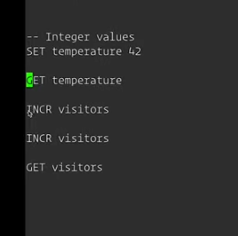

## Redis: Lists, Sets and Hashes

LISTS

Ordered values that go under the same key!

We can use a Redis list as a [stack](https://en.wikipedia.org/wiki/Stack_%28abstract_data_type%29) by calling the LPUSH command to insert items at the beginning of a list, and then LPOP to remove items that were added last.

We can also use a Redis list as a [queue](https://en.wikipedia.org/wiki/Queue_%28abstract_data_type%29) by calling the RPUSH command to insert items at the end of a list, and then LPOP again to remove items that were added first.’’

We can also check the number of items in a list by using LLEN, get a specific item by using LINDEX, and get any range of items by using LRANGE.

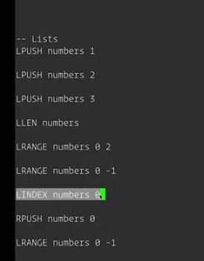

Moving on, in this video we've seen that redis allows us to store a list under a key. It's important to note that each Redis data type has its own commands, and GET and SET will NOT work on lists, only on strings and integers.

We can use a Redis list as a [stack](https://en.wikipedia.org/wiki/Stack_%28abstract_data_type%29) by calling the LPUSH command to insert items at the beginning of a list, and then LPOP to remove items that were added last.

We can also use a Redis list as a [queue](https://en.wikipedia.org/wiki/Queue_%28abstract_data_type%29) by calling the RPUSH command to insert items at the end of a list, and then LPOP again to remove items that were added first.

We can also check the number of items in a list by using LLEN, get a specific item by using LINDEX, and get any range of items by using LRANGE.

s

LRANGE mylist 0 -1

Gets you full range of members in list!

REDIS SETS ARE DONE using:

SADD myset A J Q LA

SCARD myset

SMEMBERS myset

SET IS UNORDERED!

1. While lists contain ordered items, Redis has another data structure which can store multiple items: sets.
2. Sets differ from lists in that there is no ordering to their elements, and a given element can only appear once in the set: if you try to re-add it, nothing will happen.
3. Since there is no ordering to the elements of a set, the SADD command is used to add one or more elements to a set, and SPOP will remove a random element from the set.
4. We can use SCARD to find out the number of elements - called the cardinality - of a set, and SISMEMBER to find out whether an element belongs to a set or not.
5. Follow this link for the full documentation on [Redis set commands](https://redis.io/commands#set).

REDIS HASH

1. The last Redis data type we learn about in this course is the hash.
2. A hash is its own key-value structure stored under a single key.
3. You may think of it as a database row with the columns being the keys, but where the values can only be strings or integers.
4. A hash is useful for storing multiple pieces of information about a single entity.
5. For example, if we have a key person, we can set that person's first and last names using HMSET person first_name John last_name Smith.
6. We can also use HSET to set a single value in a hash. HGETALL hash_key will return all the keys/values for a given hash.
7. We can remove a person's first name from the hash using HDEL person first_name.

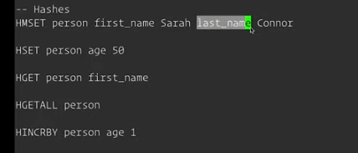

HMSET AND HSET

HGET

HGETALL

HINCRBY … … .

# Redis: Building Something Useful

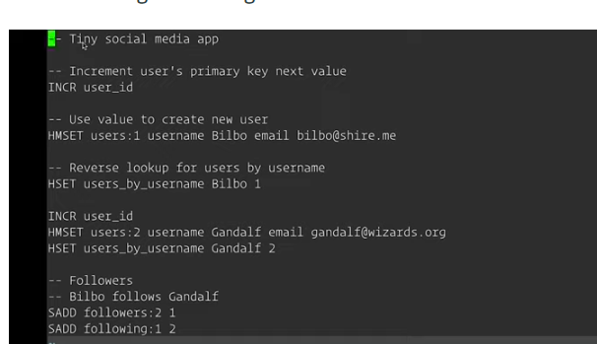4

To store an entity like a user, we used the following pattern:

1. INCR a value entity_id where entity is e.g. users. This acts like a Postgres SERIAL or sequence. Take note of the new value.
2. Use that value in order to create a new hash of the form entity:XX where entity is e.g. users, and XX is the newly incremented value
3. Store all the fields that we need for the entity under the hash with key entity:XX, using the HMSET command.

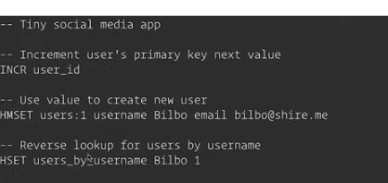

If we need to access an entity by something other than its sequence ID, we store a reference to that in a manually created "index" using a hash. For example, if we need to access entity users by its field username, then create a hash users_by_username, where the keys will be the username, and the value will be the ID. This will allow us to do an HGET users_by_username SomeUsername42, which will return the ID of that user, then follow with an HGETALL users:42 to get all the user properties.

Keeping with the : pattern, we see that storing related data like one-many or many-many relations can be done using sets. For example, while in a relational database we would have a table of followers linking two users who are following each other; this would be represented as two different keys per user in Redis: following:XX and followers:XX. Since a user can only follow another user once, we use a Redis Set in order to store the IDs of followers. We can then retrieve those followers using SMEMBERS, or check if a user is following/being followed by another one using SISMEMBER.

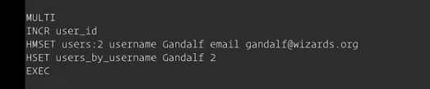

# Exercise: Redis

Connect to the Redis workspace [here](https://katacoda.com/ziad-saab/scenarios/redis-exercise). This workspace is similar to the one you used for the first MongoDB exercise: it will be pre-loaded with some data, and will drop you right into a Redis command-line interface. First, explore all the data in the Redis instance. Then, answer the following:

1. How is the system currently storing the primary keys used for users and books?
   1. Using a hash called ids
      1. With key value for users
      2. With key value for books
2. What is the name of the user with ID 3?
   1. some user
3. What would be the ID of the next book?
   1. 4
4. Notice that books have authors in common. Fix that by creating a new entity called authors. Add the authors to the system, and then modify the books to refer to authors by their ID instead of their name.
5. Devise a strategy that would allow users to search for books in a partial-match, case-insensitive way.

If you want to keep your answers to the exercise afterwards, we suggest saving them down locally into a text file or other similar file.

KEYS *

HGETALL ids

S

# Glossary

| **Key Term** | **Definition** |
| --- | --- |
| NoSQL | A term to designate databases that don't use the relational model. |
| MongoDB | A document-oriented, schemaless NoSQL database that can scale horizontally. |
| Redis | A fast, in-memory key-value store that runs on a single machine. |
| Linear Scaling | When talking about a computer system, its ability to double its resources while keeping the costs in check. |
| BSON | Binary JSON, a format that MongoDB uses to store data. It expands on JSON by making it more efficient to store and add more data types like dates. |
| CRUD | Create, Read, Update, Delete. An acronym often used to refer to manipulating data. |

# Course Conclusion

With this new knowledge, you are now ready to take on the project part of this course! You are going to be building the data schema and manipulations for a social news website called Udiddit.

Since your project will be reviewed by highly qualified mentors other than myself, I'd like to take this last opportunity to thank you for following this course with me, and let you know that it's been a great pleasure building it and delivering it to you.

# FINAL Project Introduction and Instructions

1. Udiddit is a social news aggregator, content rating, and discussions website.
   1. On Udiddit, registered users are able to link to external content or post their own text content about various topics, ranging from common topics such as photography and food, to more arcane ones such as horse masks or birds with arms.
   2. In turn, other users can comment on these posts, and each user is allowed to cast a vote about each post, either in an up (like) or down (dislike) direction
2. Unfortunately, due to some time constraints before the initial launch of the site, the data model stored in Postgres hasn’t been well thought out, and is starting to show its flaws.
   1. You’ve been brought in for two reasons:
      1. first, to make an assessment of the situation and take steps to fix all the issues with the current data model,
      2. and then, once successful, to improve the current system by making it more robust and adding some web analytics.

## Instructions

All your tasks are outlined in a single Google Docs document [here](https://docs.google.com/document/d/1eQ3jsuU55Vyu6iuKpIqqR0_cC8spVNwM-wyqwtLcGgQ/copy), which you should make a copy from (do not request access). A Word version of this template has also been attached at the bottom of this page. To complete the project, you’ll have to make your own copy of this document to document your findings and steps. This document will constitute your final submission for the project.

You need to complete the following in the template:

* Part I: Investigate the existing schema
* Part II: Create the DDL for your new schema
* Part III: Migrate the provided data

### Project Workspace

Accompanying this document is a SQL Workspace, which contains a dump of all the current data Udiddit has been gathering. You’ll be able to use this workspace to test your queries against real-life data. There are two important things you need to know about this SQL Workspace:

The data is also attached at the bottom of this page in bad_db.sql if you'd like to use it outside of the workspace.

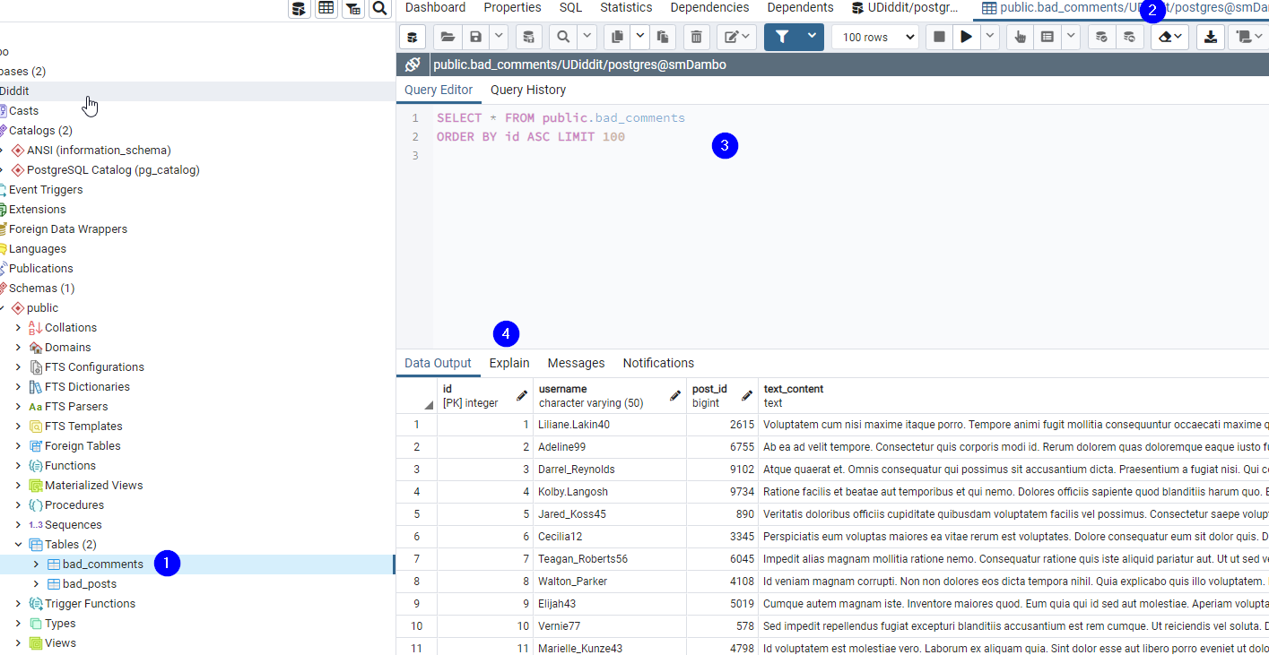

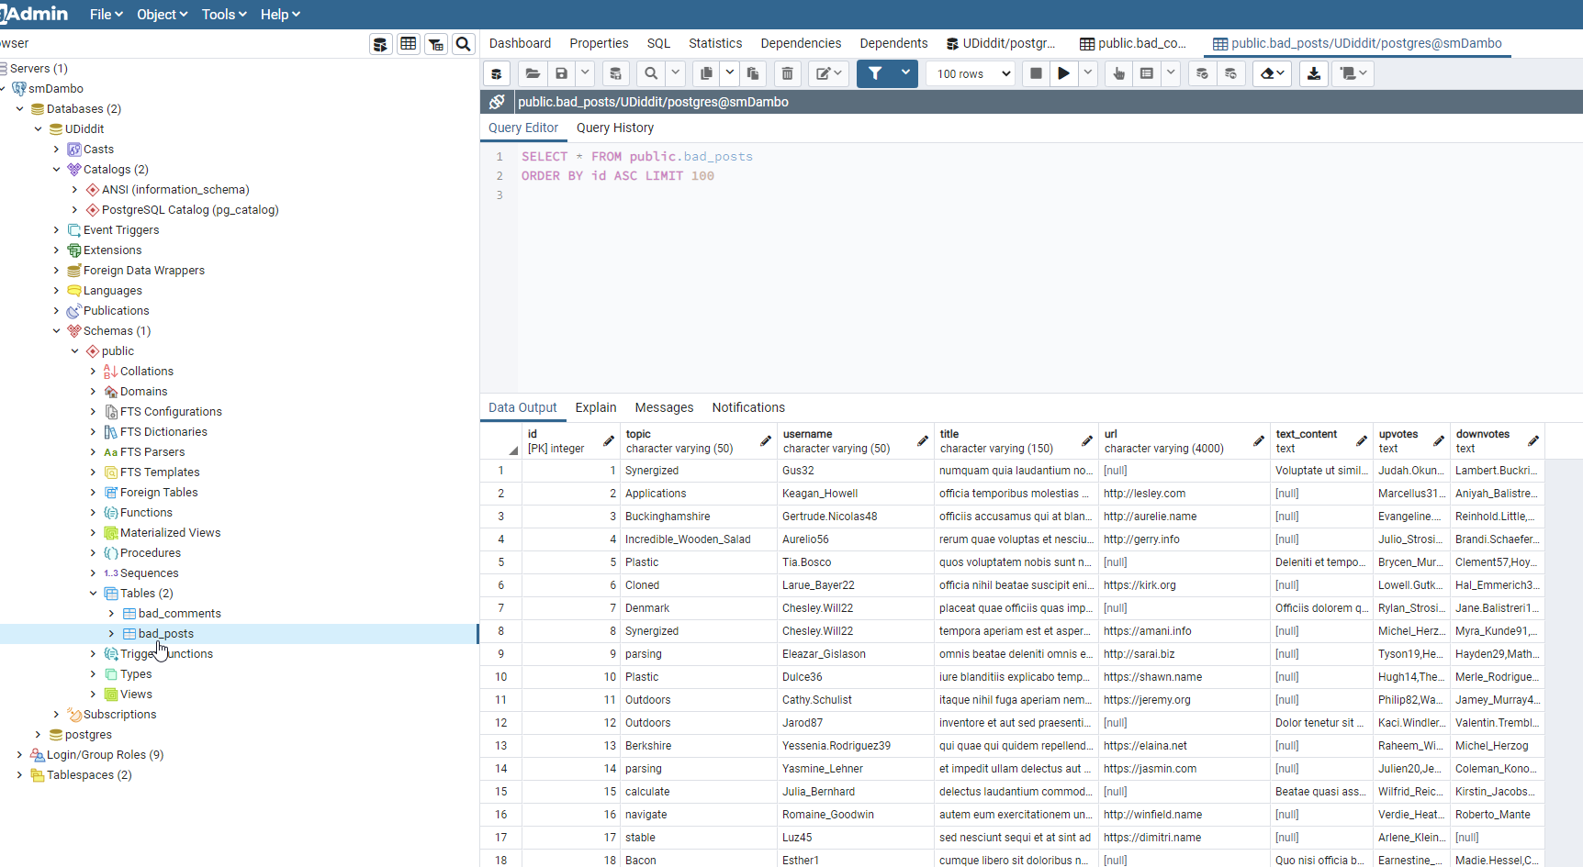

## Part I: Investigate the existing schema

As a first step, investigate this schema and some of the sample data in the project’s SQL workspace. Then, in your own words, outline three (3) specific things that could be improved about this schema. Don’t hesitate to outline more if you want to stand out!

1. Investigate the existing schema
   * postgres=# \dt
   * List of relations
   * Schema | Name | Type | Owner
   * --------+--------------+-------+----------
   * public | bad_comments | table | postgres
   * public | bad_posts | table | postgres
2. There are 2 tables:
   * bad_comments
   * bad_posts
3. Make up of table: bad_comments

* Table "public.bad_comments"
* Column | Type | Modifiers
* --------------+-----------------------+-----------------------------------------------------------
* id | integer | not null default nextval('bad_comments_id_seq'::regclass)
* username | character varying(50) |
* post_id | bigint |
* text_content | text |
* Indexes:
* "bad_comments_pkey" PRIMARY KEY, btree (id)

I notice a few things.

There are multiple rows for the same user. Meaning duplicate

Primary key present as id.

|  |
| --- |
| A few things that could be improved about the schema.   1. Normalize table “bad_comments” by migrating username column out of the table and create another table called users that has fields “userid” primary key and user name. Therefore insert a new column called userid within “bad_comments” that is a foreign key referencing table “users”. 2. post_id within “bad_comments” should be a foreign key reference to table “bad_posts”. 3. Normalize “bad_posts” by removing username column, and adding userid foreignkey referencing “users” table. 4. Within table “bad_posts” the field topic could also be a foreignkey field referencing a separate new table called “topics” with primary key id and “topic name” |

## Part II: Create the DDL for your new schema

Having done this initial investigation and assessment, your next goal is to dive deep into the heart of the problem and create a new schema for Udiddit. Your new schema should at least reflect fixes to the shortcomings you pointed to in the previous exercise. To help you create the new schema, a few guidelines are provided to you:

1. Guideline #1: here is a list of features and specifications that Udiddit needs in order to support its website and administrative interface:
   1. Allow new users to register:✔✔
      1. Each username has to be unique ✔
      2. Usernames can be composed of at most 25 characters ✔
      3. Usernames can’t be empty ✔
      4. We won’t worry about user passwords for this project✔
   2. Allow registered users to create new topics: ✔✔
      1. Topic names have to be unique. ✔
      2. The topic’s name is at most 30 characters ✔
      3. The topic’s name can’t be empty✔
      4. Topics can have an optional description of at most 500 characters. ✔
   3. Allow registered users to create new posts on existing topics: ✔✔
      1. Posts have a required title of at most 100 characters ✔
      2. The title of a post can’t be empty. ✔
      3. Posts should contain either a URL or a text content, **but not both**.❓
      4. If a topic gets delete d, all the posts associated with it should be automatically deleted too. ✔
      5. If the user who created the post gets deleted, then the post will remain, but it will become dissociated from that user. ✔
   4. Allow registered users to comment on existing posts: ✔
      1. A comment’s text content can’t be empty. ✔
      2. Contrary to the current linear comments, the new structure should allow comment threads at arbitrary levels. ✔
      3. If a post gets deleted, all comments associated with it should be automatically deleted too. ✔
      4. If the user who created the comment gets deleted, then the comment will remain, but it will become dissociated from that user. ✔
      5. If a comment gets deleted, then all its descendants in the thread structure should be automatically deleted too. ✔
   5. Make sure that a given user can only vote once on a given post: ✔
      1. Hint: you can store the (up/down) value of the vote as the values 1 and -1 respectively.
      2. If the user who cast a vote gets deleted, then all their votes will remain, but will become dissociated from the user.
      3. If a post gets deleted, then all the votes for that post should be automatically deleted too.
2. Guideline #2: here is a list of queries that Udiddit needs in order to support its website and administrative interface. Note that you don’t need to produce the DQL for those queries: they are only provided to guide the design of your new database schema. ✔✔
   1. List all users who haven’t logged in in the last year. ✔
   2. List all users who haven’t created any post. ? OUTER JOIN? CROSS JOIN? ✔
   3. Find a user by their username. ✔
   4. List all topics that don’t have any posts. ✔
   5. Find a topic by its name. ✔
   6. List the latest 20 posts for a given topic. ✔
   7. List the latest 20 posts made by a given user. ✔
   8. Find all posts that link to a specific URL, for moderation purposes.
   9. List all the top-level comments (those that don’t have a parent comment) for a given post. ✔ ✔
   10. List all the direct children of a parent comment. ✔✔
   11. List the latest 20 comments made by a given user. ✔✔
   12. Compute the score of a post, defined as the difference between the number of upvotes and the number of downvotes ✔✔ (CALCULATED VALUE?) USE SELECT COUNT(*) FROM … BLA WHERE …BLABLA
3. Guideline #3: you’ll need to use normalization, various constraints, as well as indexes in your new database schema. You should use named constraints and indexes to make your schema cleaner. ADD CONSTRAINT ✔✔
4. Guideline #4: your new database schema will be composed of five (5) tables that should have an auto-incrementing id as their primary key. ✔✔

Once you’ve taken the time to think about your new schema, write the DDL for it in the space provided here:

PSEUDOCODE

CREATE TABLE "users"

id INTEGER PRIMARY KEY

username VARCHAR(50) - UNIQUE, NOT NULL, NOT '' DISNTINCT CHECK

Lastlogged : Datetime

CREATE TABLE "topics"

topicId PRIMARY KEY

name VARCHAR(30)

CANNOT BE NULL, CANNOT BE '', DISTINCT

Description VARCHAR(500)

CREATE TABLE "posts"

id - primary key? incremental

Title VARCHAR(100)

CANNOT BE EMPTY, CANNOT BE NULL

topicId INTERGER FOREIGN KEY REFERENCES "topics" CASCADE DELETEALL

userId INTEGER FOREIGN KEY REFERENCES "users" CASCADE NULL?

CREATE TABLE "comments"

id - prinmary key incremental

Text varchar(500) NOT NULL NOT EMPTY

commentid : INTEGER primary key

postid FOREIGN KEY REFERENCES "posts" CASCADE DELETEALL

topicid:FOREIGN KEY REFERENCES "topics"

userIDl:FOREIGN KEY REFERENCES "users" CASCADE null

parentid : INTEGER - previousthread how to link it to previous thread - for cascaded deletion??

CREATE TABLE "votes"

userId - FOREIGN KEY REFERENCES "users" CASCADE NULL

postid - FOREIGN KEY REFERENCES "posts" CASCADE DELETE

primary key - postid userid

vote - ordinal (1,-1)

CHECK (vote = 1 OR vote = -1)

==========================================================================================================

EXAMPLES NEEDED TO FILL OUT SYNTAX IN POSTGRESQL

CREATE TABLE products (

product_no integer,

name text,

price numeric,

CHECK (price > 0),

discounted_price numeric,

CHECK (discounted_price > 0),

CHECK (price > discounted_price)

);

CREATE TABLE airlines

{

airmfgId INTEGER REFERENCES "airmfgcomp" ON DELETE CASCADE

}

CREATE TABLE order_items (

product_no integer REFERENCES products ON DELETE RESTRICT,

order_id integer REFERENCES orders ON DELETE CASCADE,

quantity integer,

PRIMARY KEY (product_no, order_id)

);

Restricting and cascading deletes are the two most common options.

RESTRICT prevents deletion of a referenced row

NO ACTION means that if any referencing rows still exist when the constraint is checked, an error is raised;

this is the default behavior if you do not specify anything.

CASCADE specifies that when a referenced row is deleted, row(s) referencing it should be automatically deleted as well.

There are two other options: SET NULL and SET DEFAULT. These cause the referencing column(s) in the referencing row(s)

to be set to nulls or their default values, respectively, when the referenced row is deleted.

ON DELETE NULL

ON DELETE DEFAULT

SELECT * FROM mytable ORDER BY record_date ASC LIMIT 5

OFFSET (SELECT COUNT(*) FROM mytable) - 5;

Why don't you just order the opposite way?

SELECT * FROM mytable ORDER BY record_date DESC LIMIT 5;

If you don't want to flip back correctly in the application, you can nest a query and flip them twice:

SELECT *

FROM (SELECT * FROM mytable ORDER BY record_date DESC LIMIT 5)

ORDER BY record_date ASC;

## Part III: Migrate the provided data

Now that your new schema is created, it’s time to migrate the data from the provided schema in the project’s SQL Workspace to your own schema. This will allow you to review some DML and DQL concepts, as you’ll be using INSERT...SELECT queries to do so. Here are a few guidelines to help you in this process:

1. Topic descriptions can all be empty✔
2. Since the bad_comments table doesn’t have the threading feature, you can migrate all comments as top-level comments, i.e. without a parent
   1. Migrate to comments table
3. You can use the Postgres string function **regexp_split_to_table** to unwind the comma-separated votes values into separate rows
4. Don’t forget that some users only vote or comment, and haven’t created any posts. You’ll have to create those users too.
5. The order of your migrations matter! For example, since posts depend on users and topics, you’ll have to migrate the latter first.
6. Tip: You can start by running only SELECTs to fine-tune your queries, and use a LIMIT to avoid large data sets. Once you know you have the correct query, you can then run your full INSERT...SELECT query.
7. **NOTE**: The data in your SQL Workspace contains thousands of posts and comments. The DML queries may take at least 10-15 seconds to run.

Write the DML to migrate the current data in bad_posts and bad_comments to your new database schema:

|  |
| --- |
|  |

# 10 Best Database Design Practices

This makes database design an important step of developing a software and it is essential that developers design a database that is efficient. So why does database design matter and what is a ‘good’ database design? Let’s find out in this article.

# Why Does Database Design Matter?

1. For example, think of an online clothing store’s website where you want to order a shirt from.
2. Now the process of ordering a shirt from this website may seem simple but there is a lot of exchange of information involved.
3. Such as, when you first browse the website it shows you a list of their product categories and all the available products, their prices, available sizes, colors, and all the other relevant information.
4. The website retrieves this data from the database in which it is stored.
5. When you select an item of your choice and proceed to purchase it, the website asks you for your personal details, shipping address, payment details, and confirms your order.
6. Now the new data produced in this process such as customer details, order details, purchase and payment, is added and updated in the same database.

# 10 Best Database Design Practices

1. Take Everyone’s Perspective into Account
2. Select a Database Type That Fits Your Needs
3. Databases that use SQL are most popular for structured data.
4. Whereas, NoSQL databases are better for machine learning, web analytics, and [IoT](https://internetofthingsagenda.techtarget.com/definition/Internet-of-Things-IoT) (Internet of Things) because of features such as higher scalability, flexibility, and speed.
5. Define and Label Tables and Columns Consistently
6. Normalization Is Key
   1. Normalization of a database stands for the process of organizing all the information within the database to avoid data replication and redundancy. In simple terms, normalization means to distribute the data into multiple smaller related tables instead of storing all the data in one large table.
7. Documentation of Database Design Is Important
8. Think of Long-Term Needs
   1. Good database design is a scalable one, which means that it can endure high workload and keep the application running even if the usage is increased.
9. Code and Use Stored Procedures
   1. Not using stored procedures is a common database design mistake. Stored procedures are prepared codes that come handy when you have to manipulate the data. For example, if there is a SQL query that you use often, then to make your task easier you can code that query into a stored procedure instead of writing it over and over again.
10. Spend Time on Database Modelling and Design